**A Project Report on**

**HOSPITAL MANAGEMENT SYSTEM**

*Submitted in partial fulfilment*

*for the award of the Degree in*

**BACHELOR OF COMPUTER APPLICATION**

***By***

1.Tandel Maitri K.

Roll No.:25

UniversityNo.: 20079

2.Tandel Sonali G.

Roll No.:30

UniversityNo.: 20084

**( GROUP NO : 12 )**

**Under the guidance of**

**PROF. MANISH DODIYA**

**COMPUTER SCIENCE DEPARTMENT,**

**Dolat-Usha Institute Of Applied Sciences And Dhiru-Sarla Institute of Management & Commerce, Valsad**

**\* 2024-2025 \***





**Computer Department**

**CERTIFICATE**

**This is to certify that the project work titled "HOSPITAL MANAGEMENT SYSTEM WEBSITE " has been satisfactorily completed by Ms. TANDEL MAITRI and MS. TANDEL SONALI in partial full-fillment of the requirements for the award of the degree of Bachelor of Computer Science(semester-6) during the academic year 2024-2025.**

**We acknowledge their hard work, honesty, and discipline throughout the training and project work in our organization. The project was carried out under our supervision and guidance.**

**_____________ _ ________________**

**I/C Principal and HOD Project Internal Guide**

**Project Certified Date : ___________**

**At T.Y.B.Sc. (CS) Examination**

**Examiners:**

**1. ________________**

**2. ________________**

**ABSTRACT**

Hospital Management System is an organized computerized system designed and programmed to deal with day-to-day operations and management of the hospital activities. The program can look after inpatients, outpatients, records, database treatments, status illness. It also maintains hospital information such as ward id, doctors in charge and department administering. The major problem for the patient nowadays to get report after consultation , many hospital managing reports in their system. In this project we are going to provide the extra facility to store the report in the database and make available from anywhere in the world.

**ACKNOWLEDGEMENT**

We would like to express our sincere gratitude to **Prof. Manish Dodiya** for his invaluable guidance, continuous support, and encouragement throughout the development of our **Hospital Management System** project. His insights and suggestions have been instrumental in shaping this work.

We also extend our heartfelt thanks to our **Head of Department (HOD)** and all the faculty members for their valuable guidance and motivation. Their support has played a crucial role in helping us complete this project successfully.

A special note of appreciation to our **parents**, whose constant encouragement and belief in us kept us motivated. Lastly, we are grateful to our **friends** for their assistance and valuable feedback. This project would not have been possible without the collective efforts of all.

**Thank you!**

**TABLE OF CONTENT**

**Chapter 1**

Introduction …………………………………………………………………………………7-8

1.1 Overview

1.2 Objective

**Chapter 2**

Requirements and Analysis ……………………………………………………………….…...8

2.1 Hardware Requirements

2.2 Technology Uses

2.3 Modules

Admin Module

Patient Module

Doctor Module

2.4 Data Flow Diagram(DFD)……………….………………………………………………...10

DFD 0 Level

DFD 1 level

DFD 2 level (Admin)

DFD 2 level (Doctor)

DFD 2 level (Patient)

2.5 Entity Relationship Diagram (ER –Diagram)…………………………………….………12

**Chapter 3**

Database Design ……………………………………………………………………………...13

3.1 Data Dictionary

**Chapter 4**

Program code ………………………………………………………..…………………….18

4.1 Coding And Output

4.2 Testing Approach

**Chapter 5**

Results and Discussion..………………………………………………………..…………158

5.1 Future Scope

**Chapter 6**

Conclusion….………………………..……………………………………………………159

**CHAPTER 1**

**INTRODUCTION**

* 1. **Overview**

The **Project Hospital Management System (HMS)** is a comprehensive software solution designed to streamline hospital operations, improve patient care, and optimize administrative processes. It facilitates **patient registration, record-keeping, appointment scheduling** etc.

**Features of the Hospital Management System**

1. **Patient Registration & Record Management:**
   * Assigns a **unique patient ID** for easy tracking.
   * Stores patient details, including medical history, treatment records, and prescriptions.
   * Provides **quick access** to patient records, reducing paperwork and improving efficiency.
2. **Doctor & Appointment Management:**
   * Allows users to check **doctor availability** and schedule appointments.
   * Helps in managing **doctor-patient assignments** effectively.
   * Ensures smooth coordination between doctors, patients, and hospital staff.
3. **Search & Data Retrieval:**
   * Users can search for **patients, doctors** using their unique IDs.
   * Helps in quickly retrieving **patient history, doctor schedules.**
4. **User-Friendly Interface:**
   * Designed with an **intuitive and easy-to-use interface** for hospital staff.
   * Enhances hospital workflow and reduces manual workload.
   1. **Objective**

**Define Hospital** – A hospital is a place where patients receive medical treatment, care, and diagnosis from healthcare professionals.

**Patient Record Management** – The system stores and manages details of patients, including their personal information, medical history, and treatment records.

**Diagnosis Information** – Keeps a record of the diagnosis provided to each patient, ensuring accurate medical history tracking.

**Immunization Records** – Maintains records of vaccinations and immunizations given to children and patients for future reference.

**CHAPTER 2**

**REQUIREMENTS AND ANALYSIS**

* 1. **Hardware Requirement**

**Processor:** Intel **i5**

**RAM:** Up to **8GB** RAM

**Storage:** Up to **512GB**

* 1. **Technology Uses**

**Frontend:** HTML, CSS, JavaScript

**Backend:** PHP, Java

**Database:** MySQL

* 1. **Modules**

**Admin Module**

Manages hospital operations, users, and system settings.

Adds, updates, and deletes doctor and patient records.

Controls user access and security.

Generate reports.

**Doctor Module:**

Views assigned patients and updates treatment details.

Search patients by email or name.

Records diagnosis and prescriptions.

Manages appointment schedules.

**Patient Module**

Registers new patients and maintains medical history.

Schedules appointments with doctors.

Stores immunization and diagnosis records.

* 1. **Data Flow Diagram(DFD)**

**DFD 0 Level**

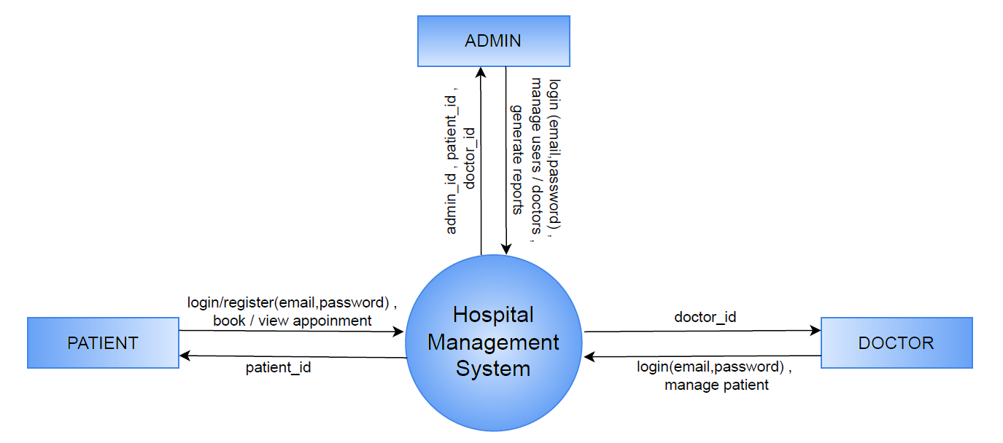

**DFD 1 level**

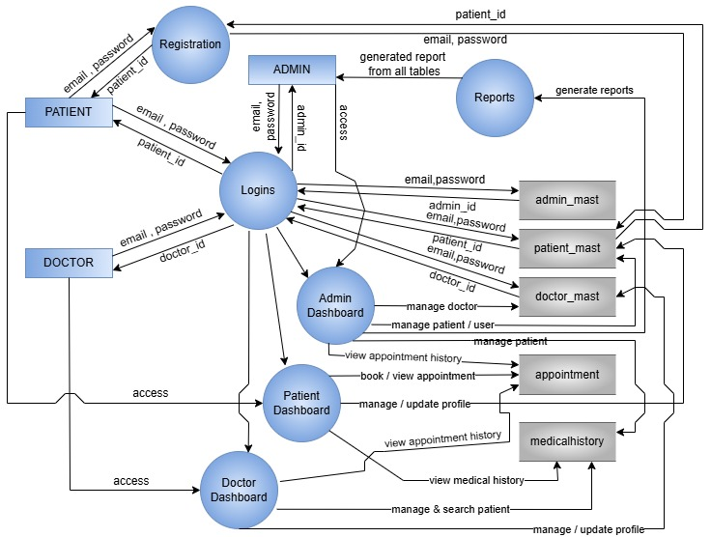

**DFD 2 level(Admin)**

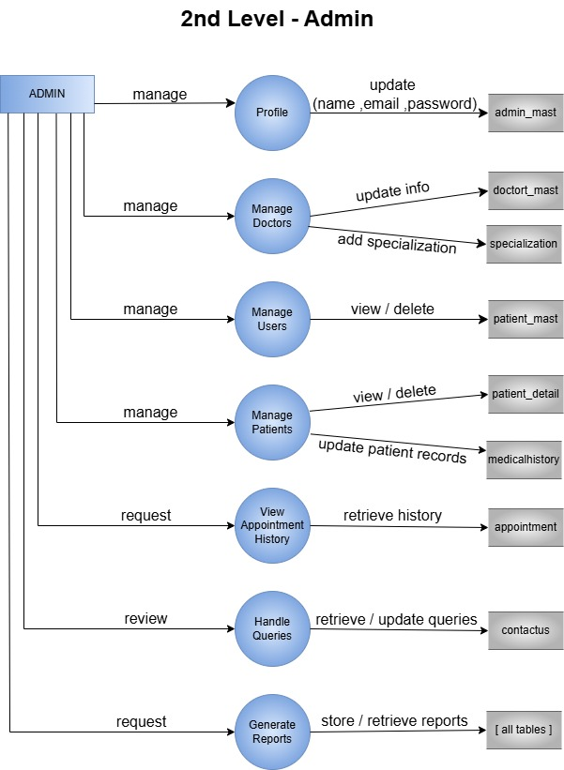

**DFD 2 level(Doctor)**

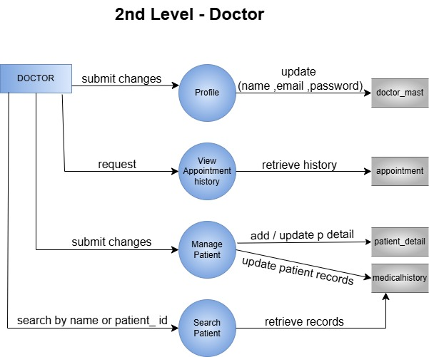

**DFD 2 level(Patient)**

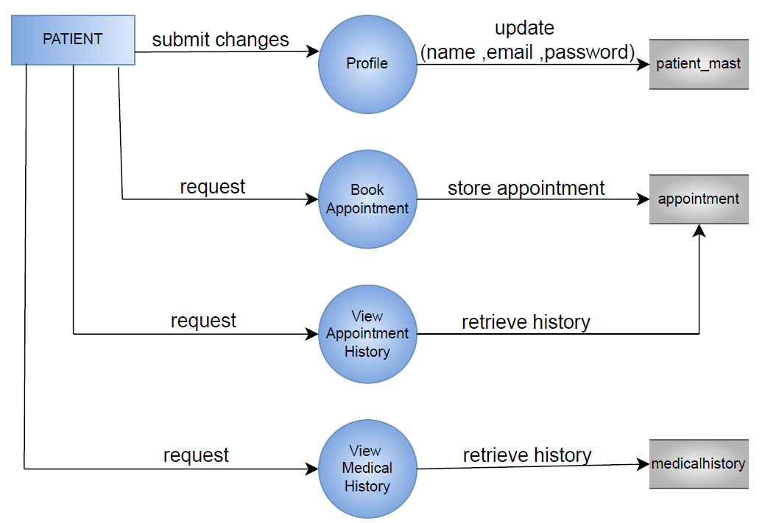

* 1. **Entity Relationship Diagram (ER –Diagram)**

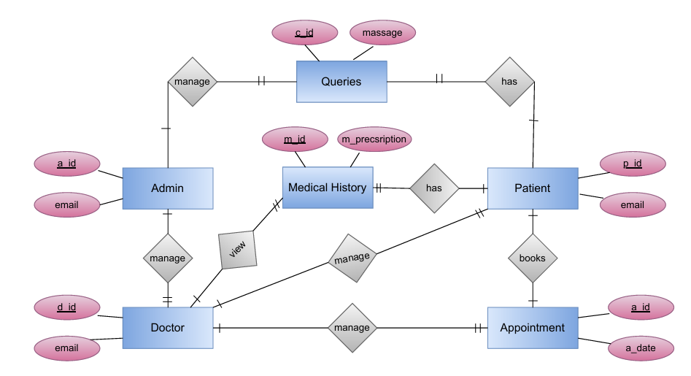

**CHAPTER 3**

**DATABASE DESIGN**

**3.1 Data Dictionary**

**Admin_mast**

|  |  |  |  |  |
| --- | --- | --- | --- | --- |
| Field | Type | Key | Default | Extra |
| a_id | int(11) | PRIMARYKEY | NULL | auto_increment |
| name | varchar(20) |  | NULL |  |
| email | varchar(100) |  | NULL |  |
| Password | varchar(255) |  | NULL |  |

**Doctor_mast**

|  |  |  |  |  |
| --- | --- | --- | --- | --- |
| Field | Type | Key | Default | Extra |
| d_id | int(11) | PRIMARYKEY | NULL | auto_increment |
| name | varchar(20) |  | NULL |  |
| specialization | text |  | NULL |  |
| docfees | int(11) |  | NULL |  |
| contact | varchar(10) |  | NULL |  |
| email | varchar(100) |  | NULL |  |
| password | varchar(255) |  | NULL |  |

**Patient_mast**

|  |  |  |  |  |
| --- | --- | --- | --- | --- |
| Field | Type | Key | Default | Extra |
| p_id | int(11) | PRIMARYKEY | NULL | auto_increment |
| fullname | varchar(100) |  | NULL |  |
| address | varchar(255) |  | NULL |  |
| city | varchar(100) |  | NULL |  |
| gender | varchar(50) |  | NULL |  |
| email | varchar(100) |  | NULL |  |
| password | varchar(255) |  | NULL |  |
| created_at | timestamp |  | current_timestamp() |  |

**Patient_detail**

|  |  |  |  |  |
| --- | --- | --- | --- | --- |
| Field | Type | Key | Default | Extra |
| p_detail_id | int(11) | PRIMARYKEY | *NULL* | auto_increment |
| d_id | int(11) |  | *NULL* |  |
| p_name | varchar(100) |  | *NULL* |  |
| p_email | varchar(100) |  | *NULL* |  |
| contact_no | varchar(10) |  | *NULL* |  |
| p_gender | varchar(50) |  | *NULL* |  |
| p_add | varchar(100) |  | *NULL* |  |
| p_age | int(11) |  | *NULL* |  |
| p_medhis | varchar(100) |  | *NULL* |  |
| created_at | timestamp |  | current_timestamp() |  |

**Appointment**

|  |  |  |  |  |
| --- | --- | --- | --- | --- |
| Field | Type | Key | Default | Extra |
| a_id | int(11) | PRIMARYKEY | NULL | auto_increment |
| specilization | varchar(100) |  | NULL |  |
| d_id | int(11) |  | NULL |  |
| p_id | int(11) |  | NULL |  |
| fees | int(11) |  | NULL |  |
| a_date | varchar(255) |  | NULL |  |
| a_time | varchar(255) |  | NULL |  |
| postingdate | timestamp |  | current_timestamp() |  |
| userstatus | int(11) |  | NULL |  |
| d_status | int(11) |  | NULL |  |

**Specilization**

|  |  |  |  |  |
| --- | --- | --- | --- | --- |
| Field | Type | Key | Default | Extra |
| s_id | int(11) | PRIMARY KEY | NULL | auto_increment |
| specilization | varchar(50) |  | NULL |  |
| created_at | timestamp |  | current_timestamp() |  |

**Pages**

|  |  |  |  |  |
| --- | --- | --- | --- | --- |
| Field | Type | Key | Default | Extra |
| id | int(11) | PRIMARYKEY | *NULL* | auto_increment |
| img | varchar(100) |  | *NULL* |  |
| type | varchar(100) |  | *NULL* |  |
| category | varchar(20) |  | *NULL* |  |
| description | text |  | *NULL* |  |

**Medical_history**

|  |  |  |  |  |
| --- | --- | --- | --- | --- |
| Field | Type | Key | Default | Extra |
| m_id | int(10) | PRIMARY KEY | NULL | auto_increment |
| p_detail_id | int(10) |  | NULL |  |
| Bp | varchar(200) |  | NULL |  |
| Bs | varchar(200) |  | NULL |  |
| weight | varchar(100) |  | NULL |  |
| temperature | varchar(200) |  | NULL |  |
| m_prescription | mediumtext |  | NULL |  |
| created_at | timestamp |  | current_timestamp() | ondatecurrent_timestamp() |

**Contactus**

|  |  |  |  |  |
| --- | --- | --- | --- | --- |
| Field | Type | Key | Default | Extra |
| c_id | int(11) | PRIMARYKEY | *NULL* | auto_increment |
| name | varchar(100) |  | *NULL* |  |
| email | varchar(100) |  | *NULL* |  |
| mobile | text |  | *NULL* |  |
| message | varchar(255) |  | *NULL* |  |
| created_at | timestamp |  | current_timestamp() |  |

**CHAPTER 4**

**PROGRAM CODE**

**4.1 Coding And Output**

**Database Connectivity**

<?php

    $conn = new mysqli("localhost","root","","project_hms");

    if(mysqli_error($conn))

        die ("Connection Error..!");

?>

**Header**



<!DOCTYPE html>

<html lang="en">

<head>

    <meta charset="UTF-8">

    <meta name="viewport" content="width=device-width, initial-scale=1.0">

    <title>Hospital Management System</title>

    <link rel="website icon" href="img/logo1.jpg" type="jpg">

    <link rel="stylesheet" href="css/style.css">

    <link href="https://cdnjs.cloudflare.com/ajax/libs/font-awesome/5.15.4/css/all.min.css" rel="stylesheet">

</head>

<body>

    <header class="header">

        <div class="logo">HMS</div>

        <nav>

            <ul>

                <li><a href="index.php">Home</a></li>

                <li><a href="services.php">Services</a></li>

                <li><a href="gallery.php">Gallery</a></li>

                <li><a href="logins.php">Logins</a></li>

            </ul>

        </nav>

    </header>

**Footer**



<section class="footer" id="footer">

        <div class="footer-box">

            <h2 style="text-align:left;">HMS<span> Health Care</span></h2>

            <p class="p" style="text-align: left;">Streamlining hospital operations with efficient management solutions, ensuring better patient care and seamless administration.</p>

            <div class="social">

                <a href="#"><i class='fa fa-facebook'></i></a>

                <a href="#"><i class='fa fa-twitter'></i></a>

                <a href="#"><i class='fa fa-instagram'></i></a>

            </div>

        </div>

        <div class="footer-box">

            <h3>Info</h3>

            <li><a href="aboutus.php">About Us</a></li>

            <li><a href="logins.php">Logins</a></li>

            <li><a href="gallery.php">Gallery</a></li>

            <li><a href="contactus.php">Contact Us</a></li>

        </div>

        <div class="footer-box contact-info">

            <h3>Contact Us</h3>

            <span>Email : hmsonline3111@gmail.com </span><br>

            <span>Mobile No.: 7682431160</span><br>

            <span>Valsad - 396001, Gujarat , India</span>

        </div>

    <div class="copyright">

        <p style="margin-top: 1%; text-align:center; margin-bottom:-0.25%">© 2025 Hospital Management System ❤</p>

    </div>

</section>

**Main Index**



<?php

    include("header.php");

    include("database.php");

?>

<style>

.hero-section {

    position: relative;

    overflow: hidden;

    width: 100%;

}

.hero-overlay {

    position: absolute;

    top: 500px;

    left: 360px;

    color: white;

    font-size: 2em;

    z-index: 2;

}

.hero-image {

    width: 100%;

    height: 540px;

    object-fit: cover;

    display: none;

}

.slider img:first-child {

    display: block;

}

.left-arrow, .right-arrow {

    position: absolute;

    top: 50%;

    transform: translateY(-50%);

    font-size: 3em;

    color: white;

    background-color: rgba(0, 0, 0, 0.5);

    padding: 10px;

    cursor: pointer;

    z-index: 3;

}

.left-arrow {

    left: 10px;

}

.right-arrow {

    right: 10px;

}

.left-arrow:hover, .right-arrow:hover {

    background-color: rgba(0, 0, 0, 0.7);

}

</style>

<section class="hero-section">

    <div class="hero-overlay">

        <h1>Hospital Management System</h1>

    </div>

    <div class="slider">

        <?php

        // Fetch images from pages table where type is 'ad'

        $query = "SELECT img FROM pages WHERE type='ad'";

        $query_run = mysqli_query($conn, $query);

        if (mysqli_num_rows($query_run) > 0) {

            while ($row = mysqli_fetch_assoc($query_run)) {

                echo "<img src='img/{$row['img']}' alt='Hospital Management System' class='hero-image'>";

            }

        } else {

            echo "<p>No advertisements available.</p>";

        }

        ?>

    </div>

    <span class="left-arrow" onclick="moveSlide(-1)">&#10094;</span>

    <span class="right-arrow" onclick="moveSlide(1)">&#10095;</span>

</section>

<script>

let slideIndex = 0;

function moveSlide(step) {

    const slides = document.querySelectorAll('.hero-image');

    slides[slideIndex].style.display = 'none';

    slideIndex += step;

    if (slideIndex < 0) {

        slideIndex = slides.length - 1;

    } else if (slideIndex >= slides.length) {

        slideIndex = 0;

    }

    slides[slideIndex].style.display = 'block';

}

document.addEventListener("DOMContentLoaded", function() {

    const slides = document.querySelectorAll('.hero-image');

    if (slides.length > 0) {

        slides[0].style.display = 'block';

    }

});

</script>

    <section class="logins-section">

        <h2>Logins</h2>

        <div class="login-cards">

            <div class="login-card">

                <img src="img/patient.jpg" alt="Patient Login"><br>

                <p class="log">Patient Login</p>

                <a href="patient_login.php"><Button class="logBtn">Click Here</Button></a>

            </div>

            <div class="login-card">

                <img src="img/doctor.jpg" alt="Doctor Login"><br>

                <p class="log">Doctor Login</p>

                <a href="doctor_login.php"><Button class="logBtn">Click Here</Button></a>

            </div>

            <div class="login-card">

                <img src="img/admin.jpg" alt="Admin Login"><br>

                <p class="log">Admin Login</p>

                <a href="admin_login.php"><Button class="logBtn">Click Here</Button></a>

            </div>

        </div>

    </section>

    <section class="features-section">

        <h2>Our Key Features</h2>

        <div class="feature-list">

            <div class="feature-item">

                <i class="fas fa-heartbeat"></i>

                <p>Cardiology</p>

            </div>

            <div class="feature-item">

                <i class="fas fa-ribbon"></i>

                <p>Orthopaedic</p>

            </div>

            <div class="feature-item">

                <i class="fab fa-monero"></i>

                <p>Neurology</p>

            </div>

            <div class="feature-item">

                <i class="fas fa-capsules"></i>

                <p>Pharma Pipeline</p>

            </div>

            <div class="feature-item">

                <i class="fas fa-prescription-bottle-alt"></i>

                <p>Pharma Team</p>

            </div>

            <div class="feature-item">

                <i class="far fa-thumbs-up"></i>

                <p>High-Quality Treatments</p>

            </div>

        </div>

    </section>

    <section class="about-section">

    <div class="about-container">

    <?php

    $query = "SELECT * FROM pages WHERE type='about' LIMIT 1";

    $query_run = mysqli_query($conn, $query);

    if (mysqli_num_rows($query_run) > 0) {

        $row = mysqli_fetch_assoc($query_run);

        ?>

        <img src="img/<?php echo $row['img']; ?>" alt="About Hospital" class="about-image">

        <div class="about-content">

            <h2 class="about-title">About Our Hospital</h2>

            <p class="about-description"><?php echo $row['description']; ?></p>

        </div>

        <?php

    } else {

        echo "<p>No about information available.</p>";

    }

    ?>

</div>

    <section class="gallery-section">

        <h2 style="color: rgb(82, 136, 191);">Our Gallery</h2>

        <div class="gallery-grid">

            <?php

                $query = "SELECT * FROM pages WHERE type='gallery' ORDER BY RAND() LIMIT 4";

                $query_run = mysqli_query($conn, $query);

                $check_product = mysqli_num_rows($query_run) > 0;

                if ($check_product) {

                    while ($row = mysqli_fetch_array($query_run)) {

                        ?>

                        <img src="img/<?php echo $row['img']; ?>" alt="">

                        <?php

                    }

                }

            ?>

        </div>

    </section>

<?php

    include("footer.php");

?>

**Gallery**



<?php

    include("header.php");

    include("database.php");

?>

<!DOCTYPE html>

<html lang="en">

<head>

    <meta charset="UTF-8">

    <meta name="viewport" content="width=device-width, initial-scale=1.0">

    <link rel="stylesheet" href="style.css">

    <title>Gallery</title>

    <style>

        .hospital-gallery-container {

            max-width: 1200px;

            margin: 0 auto;

            padding: 20px;

            text-align: center;

        }

        .gallery-title {

            color:rgb(52, 95, 139);

            margin-bottom: 20px;

        }

        .filter-buttons {

            margin-bottom: 20px;

        }

        .filter-buttons button {

            background-color:rgb(118, 166, 213);

            color: #fff;

            border: none;

            padding: 10px 15px;

            border-radius: 5px;

            cursor: pointer;

            margin: 0 5px;

            transition: background-color 0.3s ease;

        }

        .filter-buttons button:hover {

            background-color:rgb(80, 116, 151);

        }

        .hospital-gallery {

            display: grid;

            grid-template-columns: repeat(auto-fill, minmax(250px, 1fr));

            gap: 20px;

        }

        .gallery-item {

            display: none;

            background-color: #fff;

            border-radius: 8px;

            box-shadow: 0 4px 8px rgba(0, 0, 0, 0.1);

            overflow: hidden;

            transition: transform 0.3s ease-in-out;

        }

        .gallery-item img {

            width: 100%;

            height: auto;

            display: block;

            object-fit: cover;

        }

        .gallery-item p {

            padding: 10px;

            background-color: #ecf0f1;

            font-size: 16px;

            color: #2c3e50;

        }

        .gallery-item:hover {

            transform: scale(1.025);

        }

    </style>

    <script>

        function filterGallery(type) {

            const items = document.querySelectorAll('.gallery-item');

            items.forEach(item => {

                if (type === 'all' || item.classList.contains(type)) {

                    item.style.display = 'block';

                } else {

                    item.style.display = 'none';

                }

            });

        }

        document.addEventListener('DOMContentLoaded', () => {

            filterGallery('all');

        });

    </script>

</head>

<body>

    <div class="hospital-gallery-container">

        <h1 class="gallery-title">Hospital Gallery</h1>

        <div class="filter-buttons">

        <?php

            $category_query = "SELECT DISTINCT category FROM pages WHERE type='gallery' AND category != ''";

            $category_result = mysqli_query($conn, $category_query);

            if (mysqli_num_rows($category_result) > 0) {

                echo '<button onclick="filterGallery(\'all\')">All</button>';

                $unique_categories = [];

                while ($category_row = mysqli_fetch_assoc($category_result)) {

                    $category = strtolower(trim($category_row['category']));

                    if (!in_array($category, $unique_categories)) {

                        $unique_categories[] = $category;

                        $category_name = ucfirst($category);

                        echo "<button onclick=\"filterGallery('$category')\">$category_name</button>";

                    }

                }

            }

        ?>

        </div>

        <div class="hospital-gallery">

            <?php

                $query = "SELECT * FROM pages WHERE type='gallery'";

                $query_run = mysqli_query($conn, $query);

                if (mysqli_num_rows($query_run) > 0) {

                    while ($row = mysqli_fetch_array($query_run)) {

                        $category = strtolower($row['category']);

                        ?>

                        <div class="gallery-item <?php echo $category; ?>">

                            <img src="img/<?php echo $row['img']; ?>" alt="">

                        </div>

                        <?php

                    }

                }

            ?>

        </div>

    </div>

</body>

</html>

<?php

    include("footer.php");

?>

**Logins**

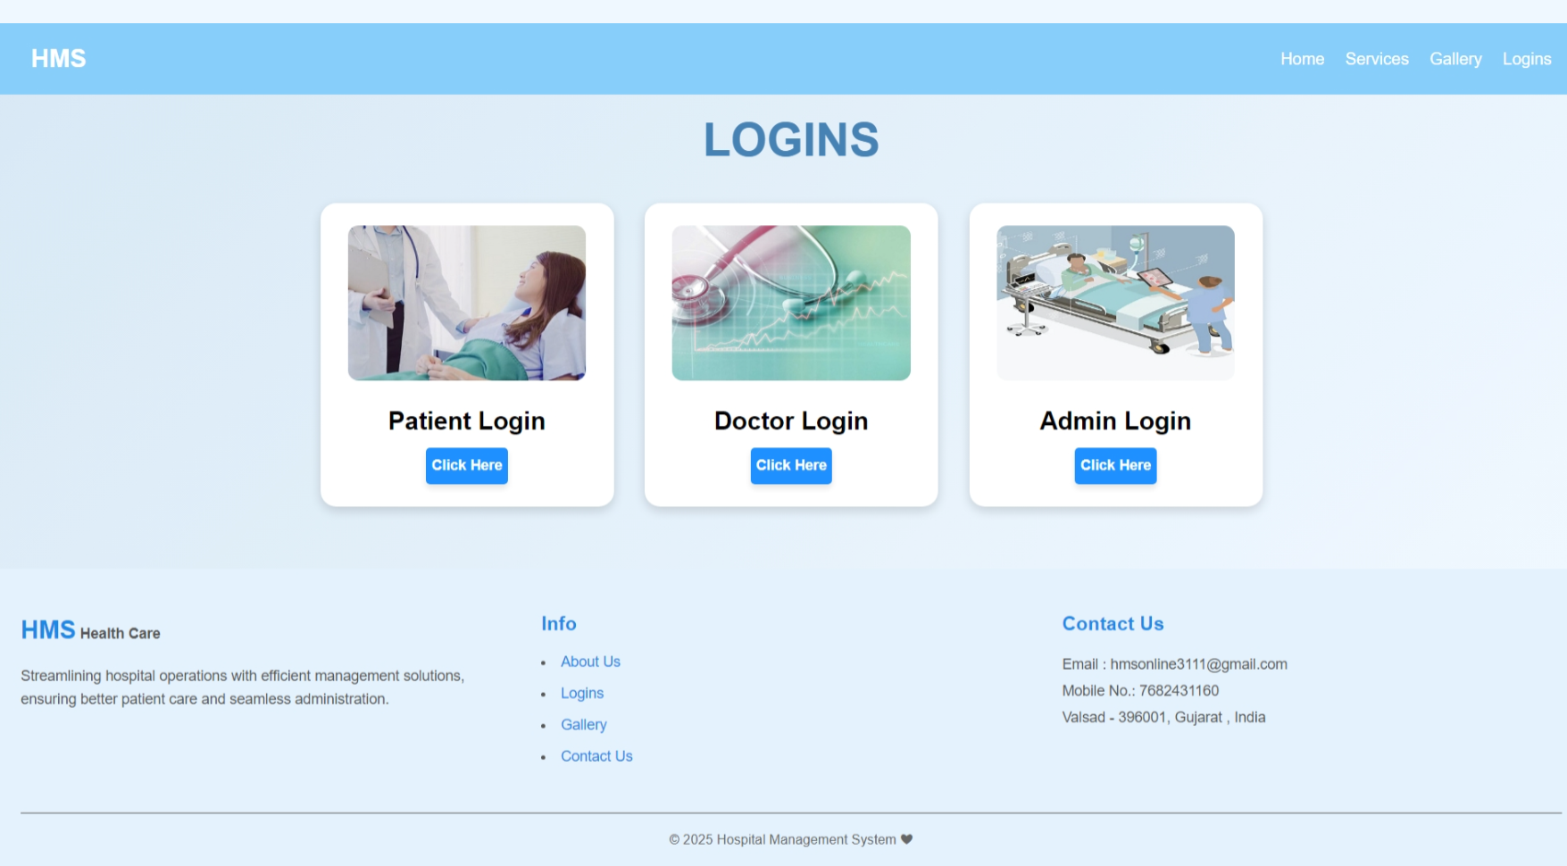

<?php

    include("header.php");

?>

    <section class="logins-section">

        <h2 style="margin-top: -2%;">Logins</h2>

        <div class="login-cards">

            <div class="login-card">

                <img src="img/patient.jpg" alt="Patient Login"><br>

                <p class="log">Patient Login</p>

                <a href="patient_login.php"><Button class="logBtn">Click Here</Button></a>

            </div>

            <div class="login-card">

                <img src="img/doctor.jpg" alt="Doctor Login"><br>

                <p class="log">Doctor Login</p>

                <a href="doctor_login.php"><Button class="logBtn">Click Here</Button></a>

            </div>

            <div class="login-card">

                <img src="img/admin.jpg" alt="Admin Login"><br>

                <p class="log">Admin Login</p>

                <a href="admin_login.php"><Button class="logBtn">Click Here</Button></a>

            </div>

        </div>

    </section>

<?php

    include("footer.php");

?>

**Contact Us**

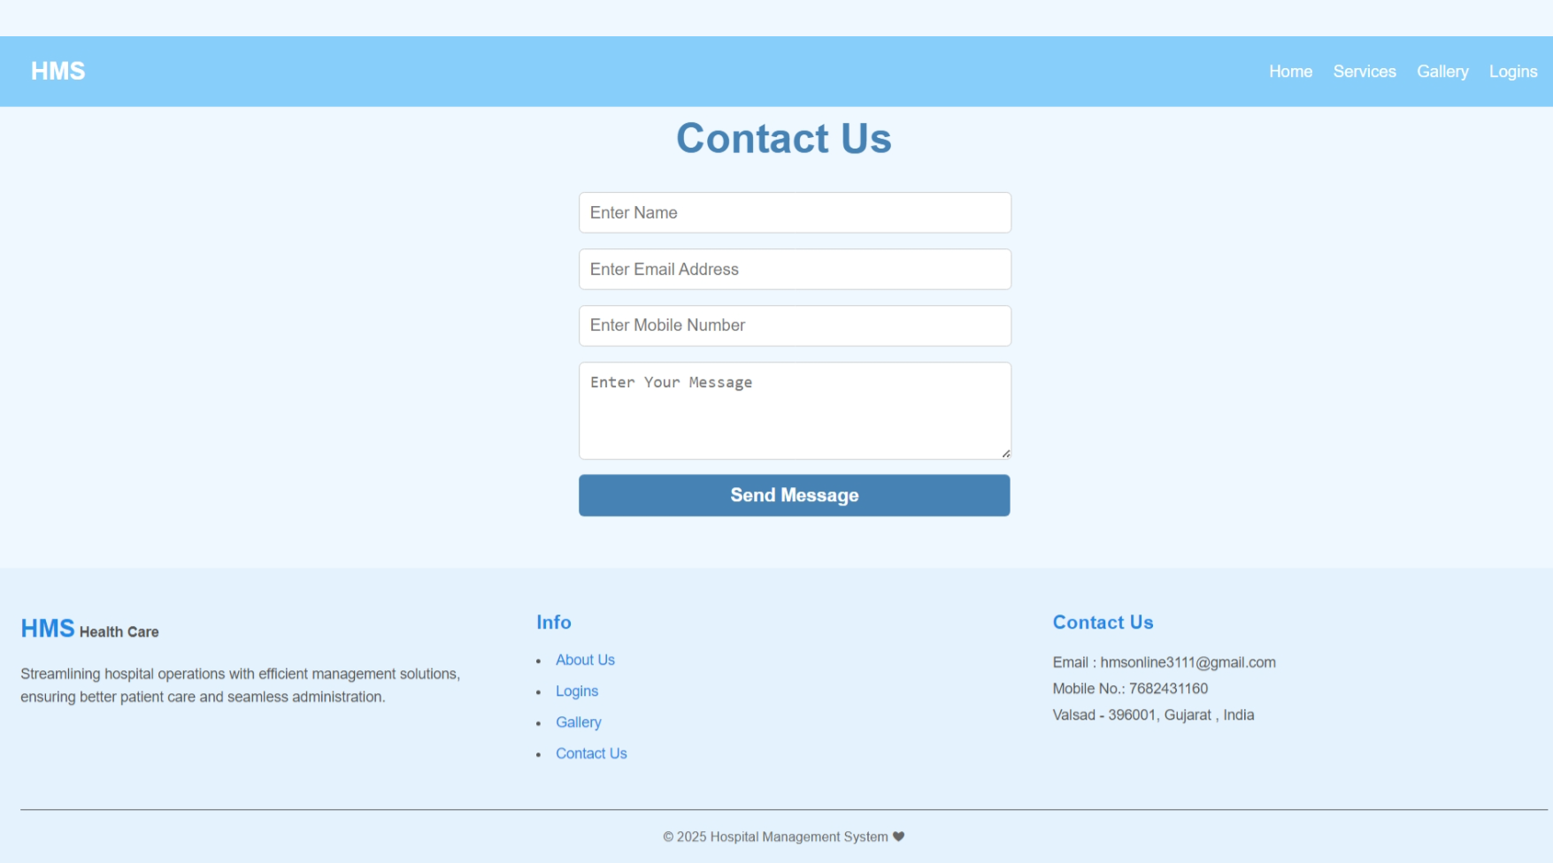<?php

include("header.php");

include("database.php");

if ($_SERVER["REQUEST_METHOD"] == "POST") {

    $name = $_POST['name'];

    $email = $_POST['email'];

    $mobile = $_POST['mobile'];

    $message = $_POST['message'];

    $sql = "INSERT INTO contactus (name, email, mobile, message) VALUES ('$name', '$email', '$mobile', '$message')";

    if ($conn->query($sql) === TRUE) {

        echo "<script>alert('Message sent successfully!');</script>";

    } else {

        echo "<script>alert('Error: " . $conn->error . "');</script>";

    }

}

?>

<!DOCTYPE html>

<html lang="en">

<head>

    <meta charset="UTF-8">

    <meta name="viewport" content="width=device-width, initial-scale=1.0">

    <title>Document</title>

    <link rel="stylesheet" href="css/style.css">

</head>

<body>

    <section class="contact-section">

        <h2 style="margin-top: -1%;">Contact Us</h2>

        <form class="contact-form" action="" method="post">

            <input type="text" name="name" placeholder="Enter Name" required>

            <input type="email" name="email" placeholder="Enter Email Address" required>

            <input type="tel" name="mobile" placeholder="Enter Mobile Number" required>

            <textarea name="message" rows="4" placeholder="Enter Your Message" required></textarea>

            <button type="submit" style="width: 105%;">Send Message</button>

        </form>

    </section>

    <?php

        include("footer.php");

    ?>

</body>

</html>

**Admin Login**

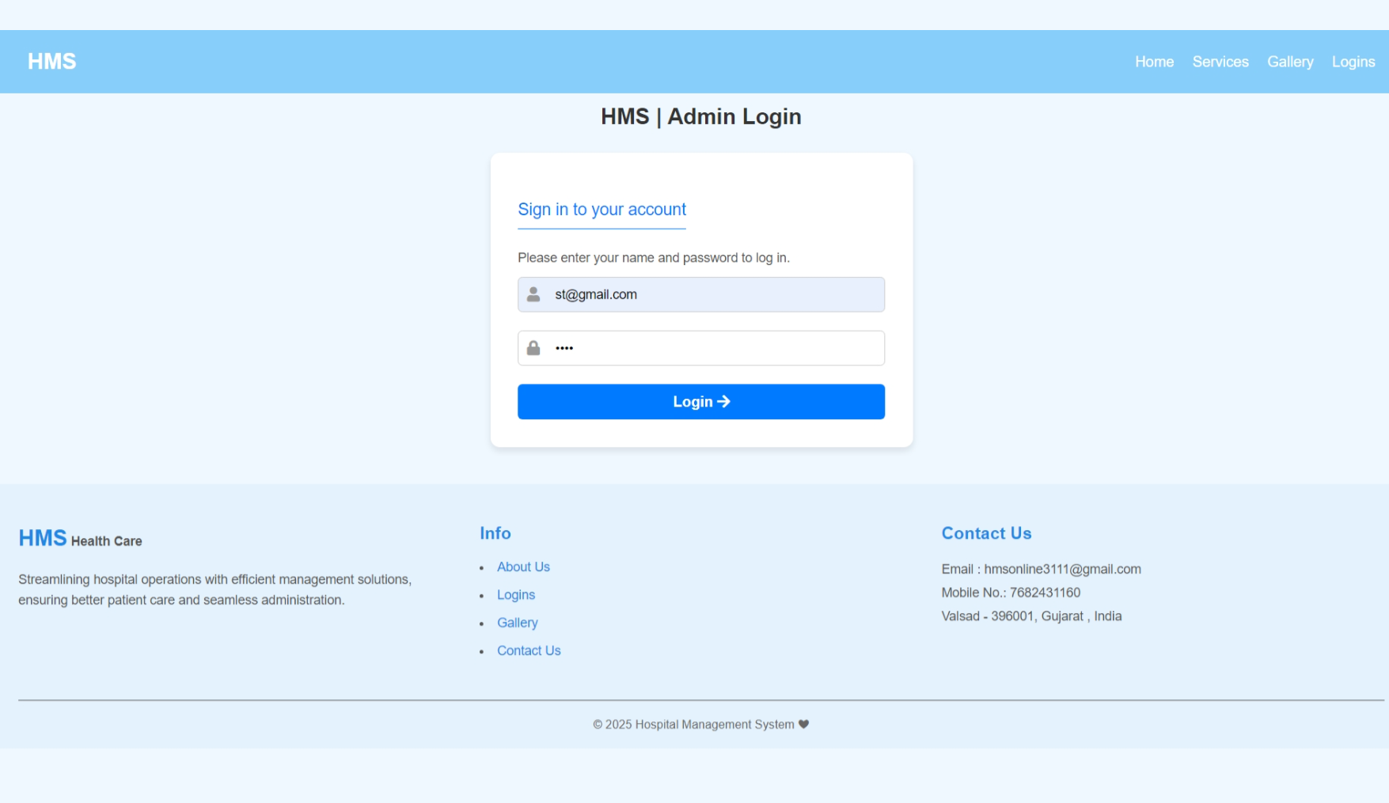

<?php

    session_start();

    include("header.php");

?>

<!DOCTYPE html>

<html lang="en">

<head>

    <meta charset="UTF-8">

    <meta name="viewport" content="width=device-width, initial-scale=1.0">

    <title>HMS | Admin Login</title>

    <link href="https://cdnjs.cloudflare.com/ajax/libs/font-awesome/5.15.4/css/all.min.css" rel="stylesheet">

    <link rel="stylesheet" href="css/rl_style.css">

</head>

<body>

    <section class="login-container" style="margin-bottom: -23%;">

    <h1>HMS | Admin Login</h1>

        <div class="login-box" style="margin-bottom: 25%;">

            <form method="POST" action="<?php echo htmlspecialchars($_SERVER["PHP_SELF"])?>">

                <p class="p2">Sign in to your account</p>

                <p class="p1">Please enter your name and password to log in.</p>

                <div class="input-group">

                    <label for="email">

                        <i class="fa fa-user"></i>

                    </label>

                    <input type="email" id="email" name="email" placeholder="Email" required>

                </div>

                <div class="input-group">

                    <label for="password">

                        <i class="fa fa-lock"></i>

                    </label>

                    <input type="password" id="password" name="password" placeholder="Password" required>

                </div>

                <button type="submit" class="login-btn">Login <i class="fa fa-arrow-right"></i></button>

                <?php

                    include("database.php");

                    if($_SERVER["REQUEST_METHOD"]=="POST")

                    {

                        $email = filter_input(INPUT_POST,"email",FILTER_SANITIZE_SPECIAL_CHARS);

                        $password = filter_input(INPUT_POST,"password",FILTER_SANITIZE_SPECIAL_CHARS);

                        if(!empty($email) && !empty($password))

                        {

                            $sql = "SELECT * FROM admin_mast WHERE email = '$email'";

                            $result = mysqli_query($conn, $sql);

                            if (mysqli_num_rows($result) > 0) {

                                $user = mysqli_fetch_assoc($result);

                                if ($password === $user["password"]){

                                    $_SESSION['admin_id']=$user['a_id'];

                                    $_SESSION['admin_name']=$user['name'];

                                    header("location:admin_index.php");

                                    exit;

                                }

                            }

                        }

                    }

                    mysqli_close($conn);

                ?>

            </form>

        </div>

    </section>

    <?php

        include("footer.php");

    ?>

</body>

</html>

**Admin Account**

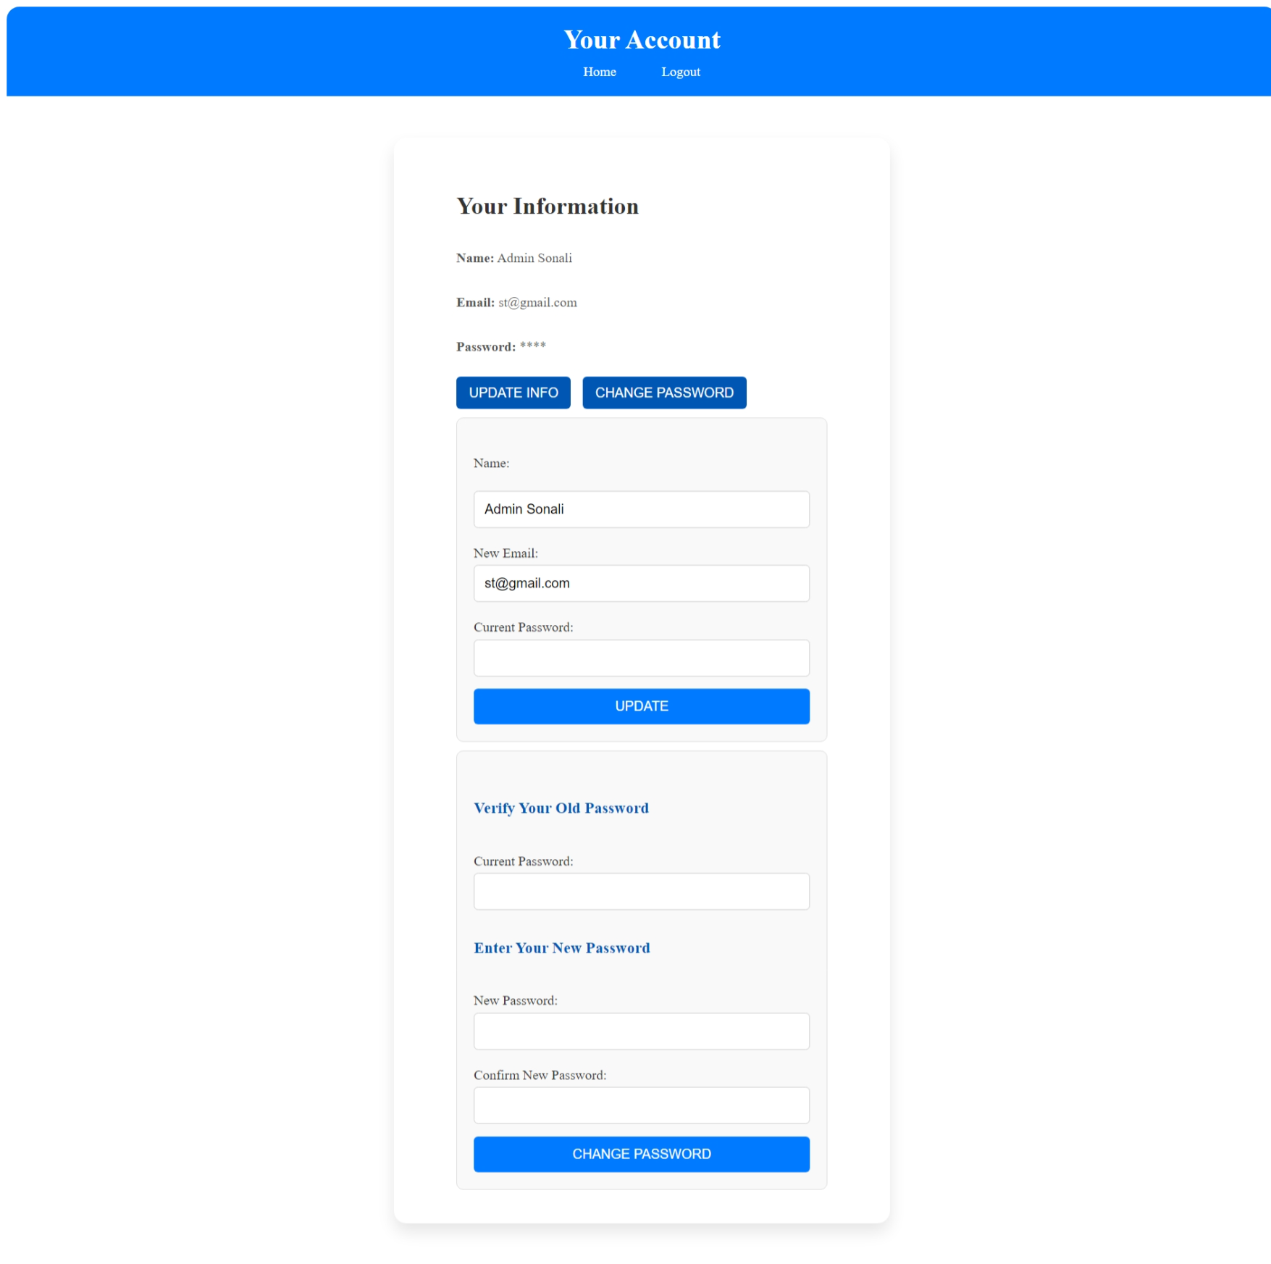

<?php

session_start();

include("database.php");

if (!isset($_SESSION['admin_id'])) {

    header("Location: admin_login.php");

    exit();

}

$admin_id = $_SESSION['admin_id'];

$query = "SELECT * FROM admin_mast WHERE a_id = '$admin_id'";

$result = mysqli_query($conn, $query);

if ($result && mysqli_num_rows($result) > 0) {

    $admin = mysqli_fetch_assoc($result);

} else {

    echo "Admin not found.";

    exit();

}

$message = "";

if ($_SERVER["REQUEST_METHOD"] == "POST" && isset($_POST['update'])) {

    $name = trim($_POST['name']);

    $new_email = trim($_POST['email']);

    $password = trim($_POST['password']);

    $name = mysqli_real_escape_string($conn, $name);

    $new_email = mysqli_real_escape_string($conn, $new_email);

    $password = mysqli_real_escape_string($conn, $password);

    if ($password === $admin['password']) {

        $update_query = "UPDATE admin_mast SET name='$name', email='$new_email' WHERE a_id='$admin_id'";

        if (mysqli_query($conn, $update_query)) {

            $message = "Account details updated successfully!";

            $result = mysqli_query($conn, $query);

            if ($result && mysqli_num_rows($result) > 0) {

                $doctor = mysqli_fetch_assoc($result);

            }

        } else {

            $message = "Error updating account details.";

        }

    } else {

        $message = "Incorrect password. Please try again.";

    }

}

if ($_SERVER["REQUEST_METHOD"] == "POST" && isset($_POST['change_password'])) {

    $password = trim($_POST['password']);

    $new_password = trim($_POST['new_password']);

    $confirm_password = trim($_POST['confirm_password']);

    $password = mysqli_real_escape_string($conn, $password);

    $new_password = mysqli_real_escape_string($conn, $new_password);

    $confirm_password = mysqli_real_escape_string($conn, $confirm_password);

    if ($password === $admin['password']) {

        if ($new_password === $confirm_password) {

            $update_query = "UPDATE admin_mast SET password='$new_password' WHERE a_id='$admin_id'";

            if (mysqli_query($conn, $update_query)) {

                $message = "Password updated successfully!";

            } else {

                $message = "Error updating password.";

            }

        } else {

            $message = "New passwords do not match!";

        }

    } else {

        $message = "Incorrect current password!";

    }

}

?>

<!DOCTYPE html>

<html lang="en">

<head>

    <meta charset="UTF-8">

    <meta name="viewport" content="width=device-width, initial-scale=1.0">

    <title>Account</title>

    <link rel="website icon" href="img/logo1.jpg" type="jpg">

    <link rel="stylesheet" href="css/account_style.css">

</head>

<body>

    <header>

        <h2>Your Account</h2>

        <nav>

            <a href="admin_index.php">Home</a>&nbsp;&nbsp;&nbsp;&nbsp;&nbsp;

            <a href="logout.php">Logout</a>

        </nav>

    </header>

    <div class="container">

        <section class="sec">

            <h2>Your Information</h2><br>

            <p><strong>Name:</strong> <?php echo htmlspecialchars($admin['name']); ?></p><br>

            <p><strong>Email:</strong> <?php echo htmlspecialchars($admin['email']); ?></p><br>

            <p><strong>Password:</strong> <?php echo str_repeat('*', strlen($admin['password'])); ?></p><br>

            <button class="btn1" onclick="toggleForm('update-info-form')">Update Info</button>

            <button class="btn1" onclick="toggleForm('change-password-form')">Change Password</button>

            <form method="POST" id="update-info-form" class="form-section">

                <br><label for="name">Name:</label><br>

                <input type="text" id="name" name="name" class="ipt1" value="<?php echo htmlspecialchars($admin['name']); ?>" required><br>

                <label for="email">New Email:</label>

                <input type="email" id="email" name="email" class="email-pass" value="<?php echo htmlspecialchars($admin['email']); ?>" required><br>

                <label for="password">Current Password:</label>

                <input type="password" id="password" class="email-pass" name="password" required><br>

                <button type="submit" class="btn" name="update">Update</button><br>

            </form>

            <form method="POST" id="change-password-form" class="form-section">

                <br><h3>Verify Your Old Password</h3><br>

                <label for="password">Current Password:</label>

                <input type="password" id="password" class="email-pass" name="password" required><br>

                <h3>Enter Your New Password</h3><br>

                <label for="new_password">New Password:</label>

                <input type="password" id="new_password" class="ipt" name="new_password" required><br>

                <label for="confirm_password">Confirm New Password:</label>

                <input type="password" id="confirm_password" class="ipt" name="confirm_password" required><br>

                <button type="submit" class="btn" name="change_password">Change Password</button>

            </form>

        </section>

    </div>

    <?php

    if($message){

        echo "<script type='text/javascript'>alert('$message');</script>";

    }

    ?>

    <script>

        function toggleForm(formId) {

            var form = document.getElementById(formId);

            if (form.style.display === "none" || form.style.display === "") {

                form.style.display = "block";

            } else {

                form.style.display = "none";

            }

        }

    </script>

</body>

</html>

**Admin Header**

<?php

    session_start();

    if(isset($_SESSION['admin_name'])){

        $admin_name = $_SESSION['admin_name'];

    }else{

        header("Location: admin_login.php");

    }

?>

<!DOCTYPE html>

<html lang="en">

<head>

    <meta charset="UTF-8">

    <meta name="viewport" content="width=device-width, initial-scale=1.0">

    <title>Hospital Management System</title>

    <link rel="website icon" href="img/logo1.jpg" type="jpg">

    <link href="https://cdnjs.cloudflare.com/ajax/libs/font-awesome/5.15.4/css/all.min.css" rel="stylesheet">

    <link rel="stylesheet" href="css/style.css">

    <style>

        * {

        margin: 0;

        padding: 0;

        box-sizing: border-box;

        font-family: Arial, sans-serif;

        }

        body {

            display: flex;

            background-color: #f0f8ff;

        }

        .sidebar {

            width: 250px;

            height: 100vh;

            background:rgb(66, 134, 206);

            color: white;

            padding: 20px;

        }

        .sidebar h2 {

            text-align: center;

            margin-bottom: 20px;

        }

        .sidebar ul {

            list-style: none;

            padding: 0;

        }

        .sidebar ul li {

            padding: 15px;

        }

        .sidebar ul li a {

            color: white;

            text-decoration: none;

            display: block;

        }

        .sidebar ul li a:hover {

            background:rgb(94, 142, 193);

            border-radius: 5px;

        }

        .main-content {

            flex: 1;

            padding:5px;

        }

        header {

            display: flex;

            justify-content: space-between;

            align-items: center;

            background: white;

            box-shadow: 0px 2px 10px rgba(0, 0, 0, 0.1);

        }

        .dashboard {

            margin-top: 20px;

        }

        .cards {

            display: flex;

            /*justify-content: space-between;*/

            gap: 20px;

            margin-left: 2%;

        }

        .card {

            background: white;

            padding: 20px;

            text-align: center;

            width: 30%;

            border-radius: 10px;

            box-shadow: 0px 4px 10px rgba(0, 0, 0, 0.1);

        }

        .card img {

            width: 50px;

            margin-bottom: 10px;

        }

        .card a {

            display: block;

            margin-top: 10px;

            color:rgb(50, 128, 210);

            text-decoration: none;

        }

        .card a:hover {

            text-decoration: underline;

        }

        .dropdown {

            position: relative;

            display: inline-block;

        }

        .dropbtn {

            margin-left: -19%;

            margin-top: -10%;

            margin-bottom: -10%;

            padding: 10px 20px;

            font-size: 16px;

            border: none;

            cursor: pointer;

        }

        .dropdown-content {

            display: none;

            position: absolute;

            background-color:rgb(255, 255, 255);

            min-width: 160px;

            box-shadow: 0px 8px 16px rgba(0, 0, 0, 0.2);

            z-index: 1;

        }

        .dropdown-content a {

            color:black;

            padding: 6px 16px;

            text-decoration: none;

            display: block;

        }

        .dropdown:hover .dropdown-content {

            display: block;

        }

    </style>

</head>

<body>

<div class="sidebar">

<ul>

    <li><a href="admin_index.php">Dashboard</a></li>

    <li class="dropdown">

        <a href="#" class="dropbtn">

            Doctors <i class="fas fa-caret-down"></i>

        </a>

        <div class="dropdown-content">

            <a href="dr_specialization.php" style="color: black; border-radius:0;width:183px;">Add Specialization</a>

            <a href="a_add_doctor.php" style="color: black; border-radius:0;">Add Doctor</a>

            <a href="a_manage_doctor.php" style="color: black; border-radius:0;">Manage Doctor</a>

        </div>

    </li>

    <li class="dropdown">

        <a href="#" class="dropbtn">

            Users <i class="fas fa-caret-down"></i>

        </a>

        <div class="dropdown-content">

            <a href="a_manage_user.php" style="color: black; border-radius:0;">Manage User</a>

        </div>

    </li>

    <li class="dropdown">

        <a href="#" class="dropbtn">

            Patients <i class="fas fa-caret-down"></i>

        </a>

        <div class="dropdown-content">

            <a href="a_manage_patient.php" style="color: black; border-radius:0;">Manage Patient</a>

        </div>

    </li>

    <li><a href="a_appointment_history.php">Appointment History</a></li>

    <li class="dropdown">

        <a href="#" class="dropbtn">

            Queries <i class="fas fa-caret-down"></i>

        </a>

        <div class="dropdown-content">

            <a href="a_read_query.php" style="color: black; border-radius:0;">Read Query</a>

        </div>

    </li>

    <li class="dropdown">

        <a href="#" class="dropbtn">

            Reports <i class="fas fa-caret-down"></i>

        </a>

        <div class="dropdown-content">

            <a href="a_report.php" style="color: black; border-radius:0;width:183px">B/w Dates Reports</a>

        </div>

    </li>

    <li class="dropdown">

        <a href="#" class="dropbtn">

            Pages <i class="fas fa-caret-down"></i>

        </a>

        <div class="dropdown-content">

            <a href="a_ad.php" style="color: black; border-radius:0;">Advertisement</a>

            <a href="a_aboutus.php" style="color: black; border-radius:0;">About Us</a>

            <a href="a_gallery.php" style="color: black; border-radius:0;">Gallery</a>

        </div>

    </li>

    <li><a href="logout.php" onclick="return confirmLogout()">Logout</a></li>

</ul>

</div>

    <div class="main-content">

        <header>

            <h2>&nbsp;&nbsp;Hospital Management System</h2>

            <div class="user-info" style="font-weight: bold; margin-right:1%;">

            <i class="fas fa-user"></i>&nbsp;&nbsp;<?php echo $admin_name; ?>

            </div>

        </header>

**Admin Dashboard**

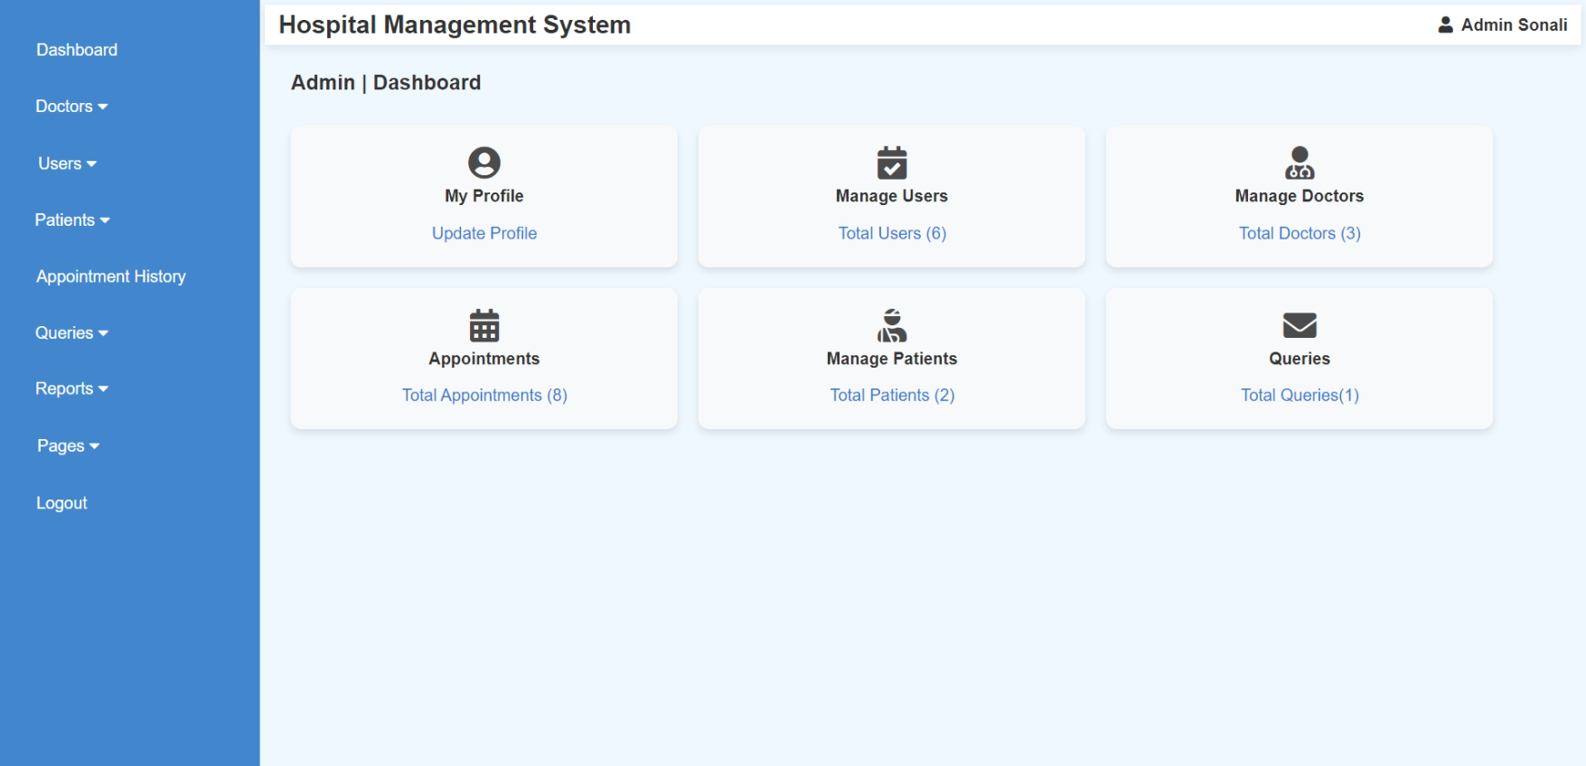

<?php

include("admin_header.php");

include('database.php');

if (!isset($_SESSION['admin_name'])) {

    header('Location: admin_login.php');

    exit();

}

$admin_name = $_SESSION['admin_name'];

$patientCount = 0;

$doctorCount = 0;

$appointmentCount = 0;

$queryCount = 0;

try {

    $result = $conn->query("SELECT COUNT(*) AS total FROM patient_mast");

    $userCount = $result->fetch_assoc()['total'];

    $result = $conn->query("SELECT COUNT(*) AS total FROM doctor_mast");

    $doctorCount = $result->fetch_assoc()['total'];

    $result = $conn->query("SELECT COUNT(*) AS total FROM appointment");

    $appointmentCount = $result->fetch_assoc()['total'];

    $result = $conn->query("SELECT COUNT(*) AS total FROM patient_detail");

    $patientCount = $result->fetch_assoc()['total'];

    $result = $conn->query("SELECT COUNT(*) AS total FROM contactus");

    $queryCount = $result->fetch_assoc()['total'];

} catch (Exception $e) {

    echo "Error: " . $e->getMessage();

}

?>

<section class="dashboard">

    <h3 style="margin-left: 2%; font-size:20px;">Admin | Dashboard</h3>

    <br>

    <div class="cards" style="display: flex; flex-wrap: wrap; gap: 20px; margin-left: 2%;">

        <div class="card" style="text-align: center; padding: 20px; background: #f8f9fa; border-radius: 10px; box-shadow: 0 4px 8px rgba(0, 0, 0, 0.1);">

            <i class="fas fa-user-circle fa-2x" style="opacity: 0.9;"></i><br>

            <h4>My Profile</h4>

            <a href="admin_account.php">Update Profile</a>

        </div>

        <div class="card" style="text-align: center; padding: 20px; background: #f8f9fa; border-radius: 10px; box-shadow: 0 4px 8px rgba(0, 0, 0, 0.1);">

            <i class="fas fa-calendar-check fa-2x" style="opacity: 0.9;"></i>

            <h4>Manage Users</h4>

            <a href="a_manage_user.php">Total Users (<?= $userCount ?>)</a>

        </div>

        <div class="card" style="text-align: center; padding: 20px; background: #f8f9fa; border-radius: 10px; box-shadow: 0 4px 8px rgba(0, 0, 0, 0.1);">

            <i class="fas fa-user-md fa-2x" style="opacity: 0.9;"></i>

            <h4>Manage Doctors</h4>

            <a href="a_manage_doctor.php">Total Doctors (<?= $doctorCount ?>)</a>

        </div>

        <div class="card" style="text-align: center; padding: 20px; background: #f8f9fa; border-radius: 10px; box-shadow: 0 4px 8px rgba(0, 0, 0, 0.1);">

            <i class="fas fa-calendar-alt fa-2x" style="opacity: 0.9;"></i>

            <h4>Appointments</h4>

            <a href="a_appointment_history.php">Total Appointments (<?= $appointmentCount ?>)</a>

        </div>

        <div class="card" style="text-align: center; padding: 20px; background: #f8f9fa; border-radius: 10px; box-shadow: 0 4px 8px rgba(0, 0, 0, 0.1);">

            <i class="fas fa-user-injured fa-2x" style="opacity: 0.9;"></i>

            <h4>Manage Patients</h4>

            <a href="a_manage_patient.php">Total Patients (<?= $patientCount ?>)</a>

        </div>

        <div class="card" style="text-align: center; padding: 20px; background: #f8f9fa; border-radius: 10px; box-shadow: 0 4px 8px rgba(0, 0, 0, 0.1);">

            <i class="fas fa-envelope fa-2x" style="opacity: 0.9;"></i>

            <h4>Queries</h4>

            <a href="a_read_query.php">Total Queries(<?= $queryCount ?>)</a>

        </div>

    </div>

</section>

</body>

</html>

**Admin (Manage Doctor)**

* **Add Specialization**

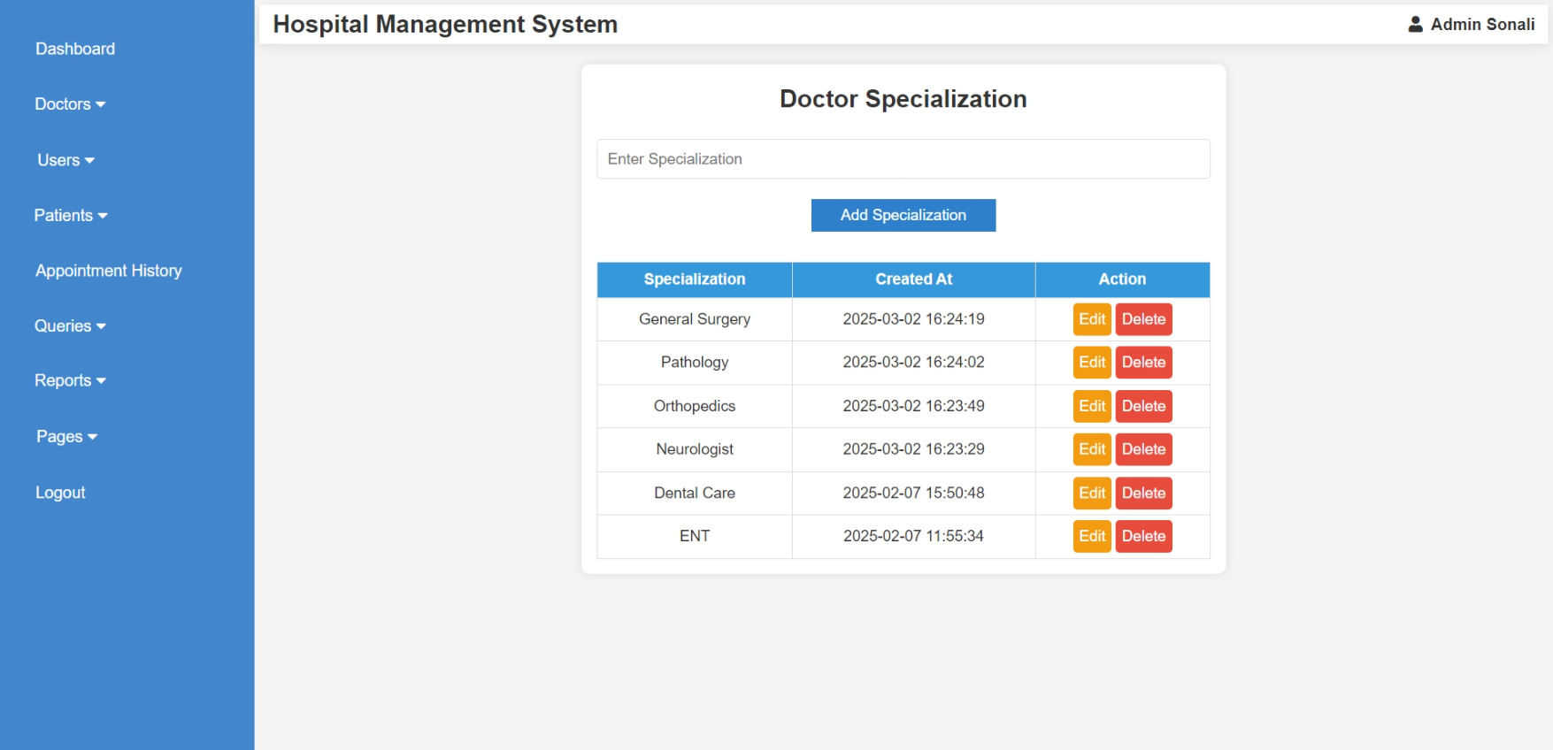

<?php

ob_start();

include("admin_header.php");

include("database.php");

if ($_SERVER["REQUEST_METHOD"] == "POST" && isset($_POST['add_specialization'])) {

$specialization = mysqli_real_escape_string($conn, $_POST['specialization']);

if (!empty($specialization)) {

$query = "INSERT INTO specilization (specilization) VALUES ('$specialization')";

mysqli_query($conn, $query);

}

}

if ($_SERVER["REQUEST_METHOD"] == "POST" && isset($_POST['update_specialization'])) {

$s_id = intval($_POST['s_id']);

$updated_specialization = mysqli_real_escape_string($conn, $_POST['updated_specialization']);

if (!empty($updated_specialization)) {

$update_query = "UPDATE specilization SET specilization='$updated_specialization' WHERE s_id=$s_id";

mysqli_query($conn, $update_query);

header("Location: dr_specialization.php");

exit();

}

}

if (isset($_GET['delete_id'])) {

$s_id = intval($_GET['delete_id']);

$delete_query = "DELETE FROM specilization WHERE s_id = $s_id";

mysqli_query($conn, $delete_query);

header("Location: dr_specialization.php");

exit();

}

$query = "SELECT * FROM specilization ORDER BY created_at DESC";

$result = mysqli_query($conn, $query);

ob_end_flush();

?>

<!DOCTYPE html>

<html lang="en">

<head>

<meta charset="UTF-8">

<meta name="viewport" content="width=device-width, initial-scale=1.0">

<title>Doctor Specialization</title>

<link rel="stylesheet" href="css/doctor_appointments.css">

<script>

function showEditForm(id, specialization) {

document.getElementById("edit-form").style.display = "block";

document.getElementById("s_id").value = id;

document.getElementById("updated_specialization").value = specialization;

}

</script>

</head>

<body>

<div class="container">

<h2>Doctor Specialization</h2>

<form method="POST">

<input type="text" name="specialization" placeholder="Enter Specialization" required>

<div class="btn-container">

<button type="submit" name="add_specialization" class="btn btn-add">Add Specialization</button>

</div>

</form>

<table>

<tr>

<th>Specialization</th>

<th>Created At</th>

<th>Action</th>

</tr>

<?php while ($row = mysqli_fetch_assoc($result)) { ?>

<tr>

<td><?php echo $row['specilization']; ?></td>

<td><?php echo $row['created_at']; ?></td>

<td>

<a href="javascript:void(0);" class="btn btn-edit" onclick="showEditForm('<?php echo $row['s_id']; ?>', '<?php echo htmlspecialchars($row['specilization']); ?>')">Edit</a>

<a href="dr_specialization.php?delete_id=<?php echo $row['s_id']; ?>" class="btn btn-delete" onclick="return confirm('Are you sure?');">Delete</a>

</td>

</tr>

<?php } ?>

</table>

<div id="edit-form" class="edit-form">

<h3>Edit Specialization</h3>

<form method="POST">

<input type="hidden" name="s_id" id="s_id">

<input type="text" name="updated_specialization" id="updated_specialization" required>

<button type="submit" name="update_specialization" class="btn btn-edit">Update</button>

</form>

</div>

</div>

</body>

</html>

* **Add Doctor**

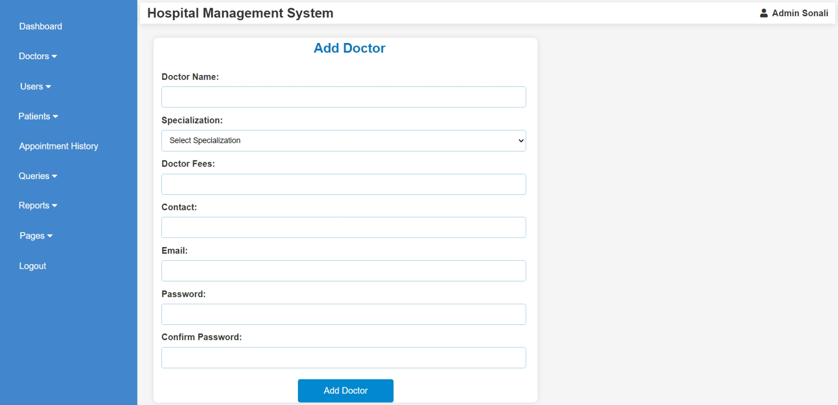

<?php

include("database.php");

include("admin_header.php");

if ($_SERVER["REQUEST_METHOD"] == "POST") {

    $name = $_POST['name'];

    $specilization = $_POST['specilization'];

    $docfees = $_POST['docfees'];

    $contact = $_POST['contact'];

    $email = $_POST['email'];

    $password = $_POST['password'];

    $confirm_password = $_POST['confirm_password'];

    if ($password !== $confirm_password) {

        echo "<script>alert('Passwords do not match!');</script>";

    } else {

        $sql = "INSERT INTO doctor_mast (name, specilization, docfees, contact, email, password)

                VALUES ('$name', '$specilization', '$docfees', '$contact', '$email', '$password')";

        if (mysqli_query($conn, $sql)) {

            echo "<script>alert('Doctor added successfully!');</script>";

        } else {

            echo "<script>alert('Error: " . mysqli_error($conn) . "');</script>";

        }

    }

}

?>

<!DOCTYPE html>

<html lang="en">

<head>

    <meta charset="UTF-8">

    <meta name="viewport" content="width=device-width, initial-scale=1.0">

    <title>Add Doctor</title>

    <style>

        body {

            font-family: Arial, sans-serif;

            background: #f5f5f5;

            display: flex;

            justify-content: center;

            align-items: center;

            height: 100vh;

            margin: 0;

        }

        .form-container {

            background: white;

            border-radius: 8px;

            box-shadow: 0px 0px 10px rgba(0, 0, 0, 0.1);

            width: 700px;

            text-align: center;

            margin-top: 2%;

            margin-left: 2%;

        }

        .form-title {

            color: #0277bd;

            margin-bottom: 20px;

            margin-left: 2%;

        }

        .form-label {

            display: block;

            margin-top: 10px;

            font-weight: bold;

            text-align: left;

            margin-left: 2%;

        }

        .form-input, .form-select {

            width: 95%;

            padding: 10px;

            margin-top: 5px;

            border: 1px solid #90caf9;

            border-radius: 4px;

            font-size: 14px;

            margin-left: -1%;

        }

        .form-button {

            width: 25%;

            padding: 12px;

            background: #0288d1;

            color: white;

            border: none;

            border-radius: 4px;

            margin-top: 20px;

            cursor: pointer;

            font-size: 16px;

        }

        .form-button:hover {

            background: #01579b;

        }

        .form-message {

            text-align: center;

            font-size: 16px;

            margin-top: 10px;

            color: red;

        }

    </style>

</head>

<body>

<div class="form-container">

    <h2 class="form-title">Add Doctor</h2>

    <form method="POST">

        <label class="form-label">Doctor Name:</label>

        <input type="text" name="name" class="form-input" required>

        <label class="form-label">Specialization:</label>

        <select name="specilization" class="form-select" required>

            <option value="">Select Specialization</option>

            <?php

            $result = mysqli_query($conn, "SELECT DISTINCT specilization FROM specilization");

            while ($row = mysqli_fetch_assoc($result)) {

                echo "<option value='" . $row['specilization'] . "'>" . $row['specilization'] . "</option>";

            }

            ?>

        </select>

        <label class="form-label">Doctor Fees:</label>

        <input type="number" name="docfees" class="form-input" required>

        <label class="form-label">Contact:</label>

        <input type="text" name="contact" class="form-input" required>

        <label class="form-label">Email:</label>

        <input type="email" name="email" class="form-input" required>

        <label class="form-label">Password:</label>

        <input type="password" name="password" class="form-input" required>

        <label class="form-label">Confirm Password:</label>

        <input type="password" name="confirm_password" class="form-input" required>

        <button type="submit" class="form-button">Add Doctor</button>

    </form>

</div>

</body>

</html>

* **Manage Doctor (Edit Doctor Details)**

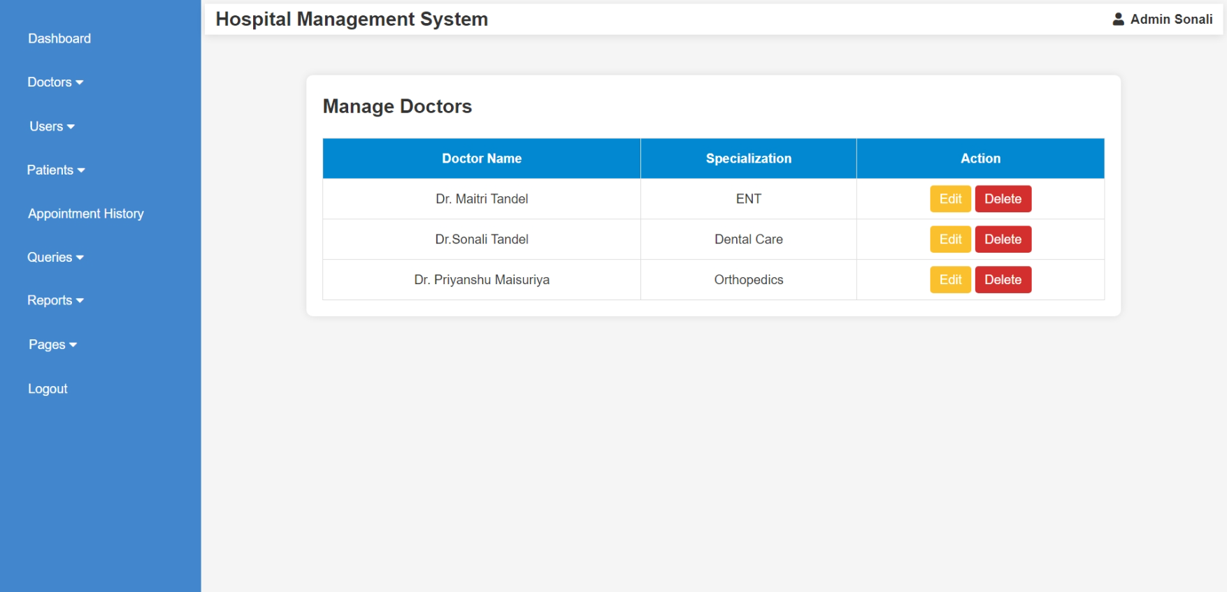

<?php

include("database.php");

include("admin_header.php");

$sql = "SELECT d_id, name, specilization FROM doctor_mast";

$result = mysqli_query($conn, $sql);

?>

<!DOCTYPE html>

<html lang="en">

<head>

    <meta charset="UTF-8">

    <meta name="viewport" content="width=device-width, initial-scale=1.0">

    <title>Manage Doctors</title>

    <style>

        body {

            font-family: Arial, sans-serif;

            background: #f5f5f5;

        }

        .table-container {

            width: 80%;

            margin: auto;

            background: white;

            padding: 20px;

            border-radius: 8px;

            box-shadow: 0px 0px 10px rgba(0, 0, 0, 0.1);

            margin-top: 50px;

        }

        table {

            width: 100%;

            border-collapse: collapse;

            margin-top: 20px;

        }

        th, td {

            padding: 12px;

            border: 1px solid #ddd;

            text-align: center;

        }

        th {

            background: #0288d1;

            color: white;

        }

        .action-btn {

            padding: 8px 12px;

            color: white;

            border: none;

            border-radius: 4px;

            cursor: pointer;

            text-decoration: none;

        }

        .edit-btn {

            background: #fbc02d;

        }

        .delete-btn {

            background: #d32f2f;

        }

        .edit-btn:hover {

            background: #f57f17;

        }

        .delete-btn:hover {

            background: #b71c1c;

        }

    </style>

</head>

<body>

    <div class="table-container">

        <h2>Manage Doctors</h2>

        <table>

            <tr>

                <th>Doctor Name</th>

                <th>Specialization</th>

                <th>Action</th>

            </tr>

            <?php while ($row = mysqli_fetch_assoc($result)) { ?>

                <tr>

                    <td><?= $row['name'] ?></td>

                    <td><?= $row['specilization'] ?></td>

                    <td>

                        <a href="a_edit_doctor.php?d_id=<?= $row['d_id'] ?>" class="action-btn edit-btn">Edit</a>

                        <a href="a_delete_doctor.php?d_id=<?= $row['d_id'] ?>" class="action-btn delete-btn" onclick="return confirm('Are you sure you want to delete this doctor?');">Delete</a>

                    </td>

                </tr>

            <?php } ?>

        </table>

    </div>

</body>

</html>

* + **Edit Doctor Details**

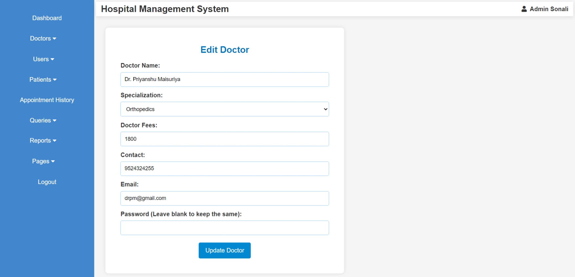

<?php

include("database.php");

include("admin_header.php");

if (isset($_GET['d_id'])) {

    $d_id = $_GET['d_id'];

    $query = "SELECT * FROM doctor_mast WHERE d_id = $d_id";

    $result = mysqli_query($conn, $query);

    $doctor = mysqli_fetch_assoc($result);

}

if ($_SERVER["REQUEST_METHOD"] == "POST") {

    $name = $_POST['name'];

    $specilization = $_POST['specilization'];

    $docfees = $_POST['docfees'];

    $contact = $_POST['contact'];

    $email = $_POST['email'];

    $password = $_POST['password'];

    $password_query = $password ? ", password='" . password_hash($password, PASSWORD_DEFAULT) . "'" : "";

    $update_sql = "UPDATE doctor_mast SET

                    name='$name',

                    specilization='$specilization',

                    docfees='$docfees',

                    contact='$contact',

                    email='$email'

                    $password_query

                    WHERE d_id=$d_id";

    if (mysqli_query($conn, $update_sql)) {

        echo "<script>alert('Doctor updated successfully!'); window.location.href='a_manage_doctor.php';</script>";

    } else {

        echo "<script>alert('Error updating doctor: " . mysqli_error($conn) . "');</script>";

    }

}

?>

<!DOCTYPE html>

<html lang="en">

<head>

    <meta charset="UTF-8">

    <meta name="viewport" content="width=device-width, initial-scale=1.0">

    <title>Edit Doctor</title>

    <style>

        body {

            font-family: Arial, sans-serif;

            background: #f5f5f5;

            text-align: center;

        }

        .form-container {

            background: white;

            padding: 40px;

            border-radius: 8px;

            box-shadow: 0px 0px 10px rgba(0, 0, 0, 0.1);

            width: 400px;

            margin: auto;

            margin-top: 30px;

            width: 50%;

            margin-left: 2%;

        }

        .form-title {

            color: #0277bd;

        }

        .form-label {

            display: block;

            text-align: left;

            font-weight: bold;

            margin-top: 10px;

        }

        .form-input, .form-select {

            width: 100%;

            padding: 10px;

            margin-top: 5px;

            border: 1px solid #90caf9;

            border-radius: 4px;

            font-size: 14px;

        }

        .form-button {

            width: 25%;

            padding: 12px;

            background: #0288d1;

            color: white;

            border: none;

            border-radius: 4px;

            margin-top: 20px;

            cursor: pointer;

            font-size: 16px;

        }

        .form-button:hover {

            background: #01579b;

        }

    </style>

</head>

<body>

    <div class="form-container">

        <h2 class="form-title">Edit Doctor</h2>

        <form method="POST">

            <label class="form-label">Doctor Name:</label>

            <input type="text" name="name" class="form-input" value="<?= $doctor['name'] ?>" required>

            <label class="form-label">Specialization:</label>

            <select name="specilization" class="form-select" required>

                <option value="">Select Specialization</option>

                <?php

                $result = mysqli_query($conn, "SELECT DISTINCT specilization FROM specilization");

                while ($row = mysqli_fetch_assoc($result)) {

                    $selected = ($row['specilization'] == $doctor['specilization']) ? "selected" : "";

                    echo "<option value='" . $row['specilization'] . "' $selected>" . $row['specilization'] . "</option>";

                }

                ?>

            </select>

            <label class="form-label">Doctor Fees:</label>

            <input type="number" name="docfees" class="form-input" value="<?= $doctor['docfees'] ?>" required>

            <label class="form-label">Contact:</label>

            <input type="text" name="contact" class="form-input" value="<?= $doctor['contact'] ?>" required>

            <label class="form-label">Email:</label>

            <input type="email" name="email" class="form-input" value="<?= $doctor['email'] ?>" required>

            <label class="form-label">Password (Leave blank to keep the same):</label>

            <input type="password" name="password" class="form-input">

            <button type="submit" class="form-button">Update Doctor</button>

        </form>

    </div>

</body>

</html>

**Admin (Manage User)**

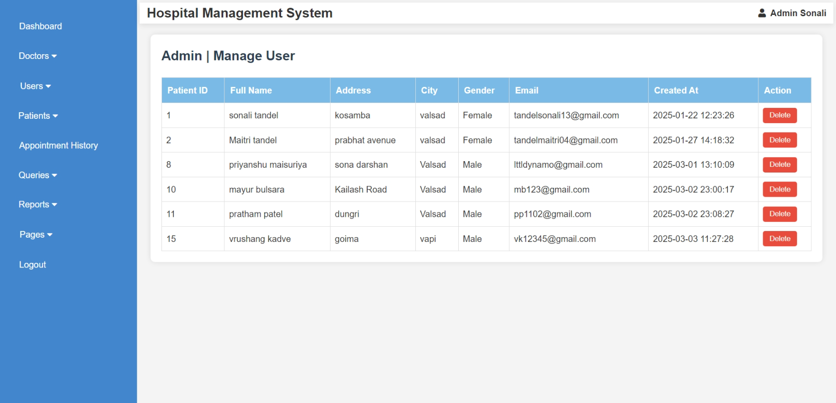

<?php

    include("admin_header.php");

    include('database.php');

    if (isset($_POST['delete']) && isset($_POST['p_id'])) {

        $p_id = $_POST['p_id'];

        $p_id = mysqli_real_escape_string($conn, $p_id);

        $query = "DELETE FROM patient_mast WHERE p_id = '$p_id'";

        $result = mysqli_query($conn, $query);

        if ($result) {

            echo "";

        } else {

            echo "<p>Error deleting patient: " . mysqli_error($conn) . "</p>";

        }

    }

    $query = "SELECT * FROM patient_mast";

    $result = mysqli_query($conn, $query);

?>

<style>

    body {

        font-family: Arial, sans-serif;

        background-color: #f4f4f4;

        margin: 0;

        padding: 0;

    }

    section.dashboard {

        margin: 20px;

        padding: 20px;

        background-color: #fff;

        border-radius: 8px;

        box-shadow: 0 0 10px rgba(0, 0, 0, 0.1);

    }

    h3 {

        color: #2c3e50;

        font-size: 24px;

        margin-bottom: 20px;

    }

    table {

        width: 100%;

        border-collapse: collapse;

        margin-top: 20px;

    }

    table, th, td {

        border: 1px solid #ddd;

    }

    th {

        background-color:rgb(121, 187, 230);

        color: white;

        padding: 10px;

        text-align: left;

    }

    td {

        padding: 8px;

        text-align: left;

    }

    td input[type="submit"] {

        background-color: #e74c3c;

        color: white;

        border: none;

        padding: 6px 12px;

        cursor: pointer;

        border-radius: 4px;

        transition: background-color 0.3s ease;

    }

    td input[type="submit"]:hover {

        background-color: #c0392b;

    }

    @media screen and (max-width: 768px) {

        table, th, td {

            font-size: 14px;

        }

        td input[type="submit"] {

            padding: 4px 8px;

        }

    }

</style>

<section class="dashboard">

<h3>Admin | Manage User</h3>

<table border="1">

<thead>

    <tr>

        <th>Patient ID</th>

        <th>Full Name</th>

        <th>Address</th>

        <th>City</th>

        <th>Gender</th>

        <th>Email</th>

        <th>Created At</th>

        <th>Action</th>

    </tr>

</thead>

<tbody>

    <?php

    if (mysqli_num_rows($result) > 0) {

        while ($row = mysqli_fetch_assoc($result)) {

            echo "<tr>

                    <td>{$row['p_id']}</td>

                    <td>{$row['fullname']}</td>

                    <td>{$row['address']}</td>

                    <td>{$row['city']}</td>

                    <td>{$row['gender']}</td>

                    <td>{$row['email']}</td>

                    <td>{$row['created_at']}</td>

                    <td>

                        <form method='POST' action='' onsubmit='return confirmDelete()' style='display:inline;'>

                            <input type='hidden' name='p_id' value='{$row['p_id']}'>

                            <input type='submit' name='delete' value='Delete'>

                        </form>

                    </td>

                </tr>";

        }

    } else {

        echo "<tr><td colspan='8'>No patients found.</td></tr>";

    }

    ?>

</tbody>

</table>

</section>

<script>

    function confirmDelete() {

        return confirm('Are you sure you want to delete this patient?');

    }

</script>

</body>

</html>

**Admin (Manage Patient & View Patient Detail)**

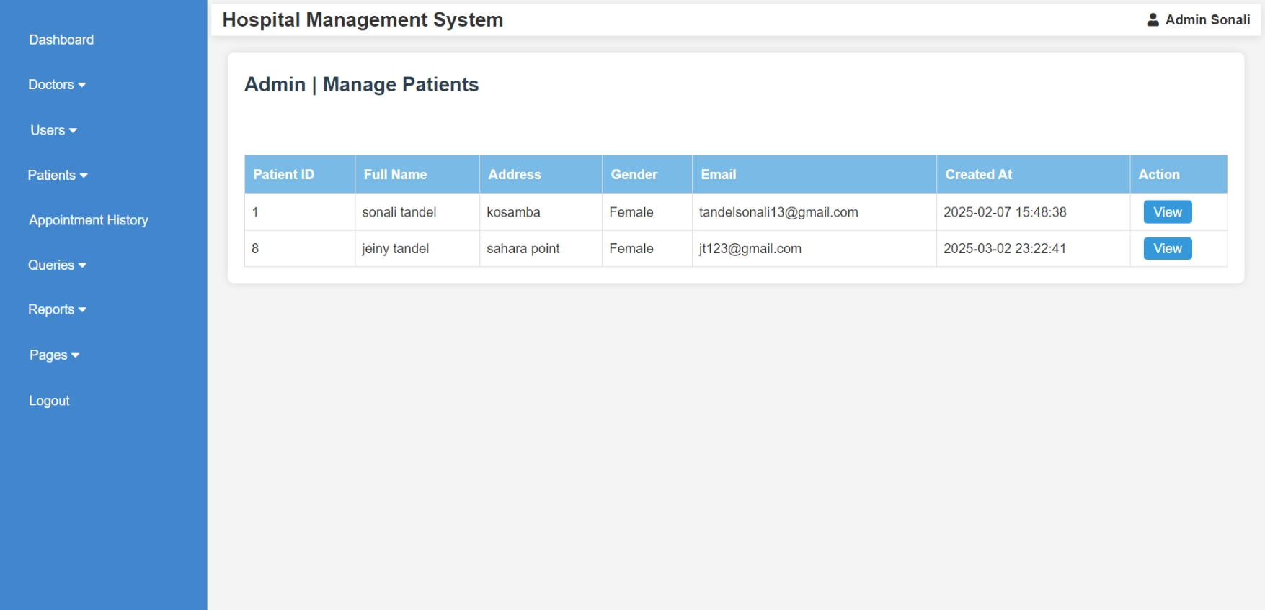

<?php

include("admin_header.php");

include('database.php');

if (!isset($_SESSION['admin_id'])) {

    header('Location: admin_login.php');

    exit;

}

$admin_id = intval($_SESSION['admin_id']);

$query = "SELECT DISTINCT p_detail_id, p_name, p_add, p_email, p_gender, created_at

          FROM patient_detail ";

$result = mysqli_query($conn, $query);

?>

<!DOCTYPE html>

<html lang="en">

<head>

    <meta charset="UTF-8">

    <meta name="viewport" content="width=device-width, initial-scale=1.0">

    <title>Manage Patients</title>

    <style>

        body {

            font-family: Arial, sans-serif;

            background-color: #f4f4f4;

            margin: 0;

            padding: 0;

        }

        section.dashboard {

            margin: 20px;

            padding: 20px;

            background-color: #fff;

            border-radius: 8px;

            box-shadow: 0 0 10px rgba(0, 0, 0, 0.1);

        }

        h3 {

            color: #2c3e50;

            font-size: 24px;

            margin-bottom: 20px;

        }

        table {

            width: 100%;

            border-collapse: collapse;

            margin-top: 20px;

        }

        table, th, td {

            border: 1px solid #ddd;

        }

        th {

            background-color: rgb(121, 187, 230);

            color: white;

            padding: 10px;

            text-align: left;

        }

        td {

            padding: 8px;

            text-align: left;

        }

        td input[type="submit"] {

            background-color: #e74c3c;

            color: white;

            border: none;

            padding: 6px 12px;

            cursor: pointer;

            border-radius: 4px;

            transition: background-color 0.3s ease;

        }

        td input[type="submit"]:hover {

            background-color: #c0392b;

        }

        .view-btn, .edit-btn {

            background-color: #3498db;

            color: white;

            padding: 1px 12px;

            text-decoration: none;

            border-radius: 4px;

            margin-left: 8px;

            display: inline-block;

        }

        .edit-btn {

            background-color: #f39c12;

        }

        @media screen and (max-width: 768px) {

            table, th, td {

                font-size: 14px;

            }

            td input[type="submit"] {

                padding: 4px 8px;

            }

        }

    </style>

</head>

<body>

<section class="dashboard">

<h3>Admin | Manage Patients</h3><br>

<table border="1">

<thead>

    <tr>

        <th>Patient ID</th>

        <th>Full Name</th>

        <th>Address</th>

        <th>Gender</th>

        <th>Email</th>

        <th>Created At</th>

        <th>Action</th>

    </tr>

</thead>

<tbody>

    <?php

    if ($result && mysqli_num_rows($result) > 0) {

        while ($row = mysqli_fetch_assoc($result)) {

            echo "<tr>

                    <td>{$row['p_detail_id']}</td>

                    <td>{$row['p_name']}</td>

                    <td>{$row['p_add']}</td>

                    <td>{$row['p_gender']}</td>

                    <td>{$row['p_email']}</td>

                    <td>{$row['created_at']}</td>

                    <td>

                        <a href='a_view_patient.php?p_detail_id={$row['p_detail_id']}' class='view-btn'>View</a>

                    </td>

                </tr>";

        }

    } else {

        echo "<tr><td colspan='7'>No patients found.</td></tr>";

    }

    ?>

</tbody>

</table>

</section>

<script>

    function confirmDelete() {

        return confirm('Are you sure you want to delete this patient?');

    }

</script>

</body>

</html>

* + **View Patient Details**

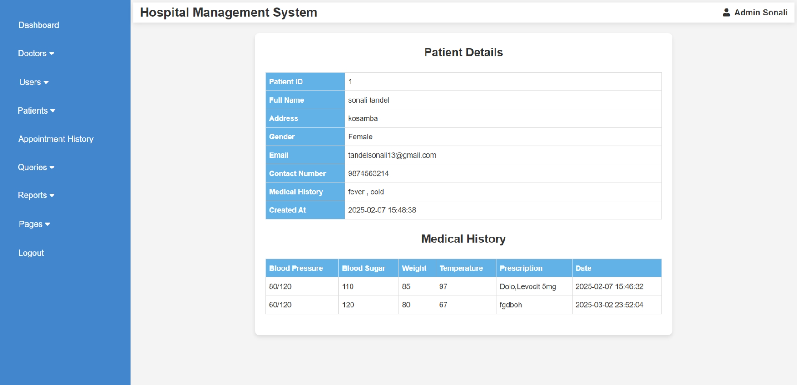

<?php

ob_start();

include("admin_header.php");

include('database.php');

if (!isset($_SESSION['admin_id'])) {

    header('Location:admin_login.php');

    exit;

}

$admin_id = intval($_SESSION['admin_id']);

if (isset($_GET['p_detail_id'])) {

    $p_detail_id = intval($_GET['p_detail_id']);

    $query = "SELECT * FROM patient_detail WHERE p_detail_id = '$p_detail_id'";

    $result = mysqli_query($conn, $query);

    if ($result && mysqli_num_rows($result) > 0) {

        $row = mysqli_fetch_assoc($result);

    } else {

        echo "<p>Patient not found or access denied.</p>";

        exit;

    }

} else {

    echo "<p>Invalid request.</p>";

    exit;

}

ob_end_flush();

?>

<!DOCTYPE html>

<html lang="en">

<head>

    <meta charset="UTF-8">

    <meta name="viewport" content="width=device-width, initial-scale=1.0">

    <title>Patient Details</title>

    <style>

    body {

        font-family: Arial, sans-serif;

        background-color: #f4f4f4;

        margin: 0;

        padding: 0;

    }

    .container {

        background: #fff;

        padding: 20px;

        border-radius: 8px;

        box-shadow: 0 4px 8px rgba(0, 0, 0, 0.1);

        max-width: 800px;

        width: 100%;

        margin: 20px auto;

    }

    h3 {

        text-align: center;

        color: #333;

        font-size: 22px;

        margin-bottom: 20px;

    }

    table {

        width: 100%;

        border-collapse: collapse;

        margin-bottom: 20px;

    }

    th, td {

        border: 1px solid #ddd;

        padding: 6px;

        font-size: 14px;

        text-align: left;

    }

    th {

        background-color: rgb(99, 178, 231);

        color: white;

        font-weight: bold;

    }

    .toggle-btn {

        display: block;

        margin: 20px auto;

        padding: 10px 16px;

        background-color: #3498db;

        color: white;

        border: none;

        border-radius: 4px;

        cursor: pointer;

        font-size: 16px;

        transition: 0.3s;

    }

    .toggle-btn:hover {

        background-color: #2980b9;

    }

    @media (max-width: 600px) {

        .container {

            padding: 15px;

        }

        th, td {

            padding: 8px;

        }

        .toggle-btn {

            width: 100%;

        }

    }

    </style>

</head>

<body>

<div class="container">

    <h3>Patient Details</h3>

    <table>

        <tr><th style="width: 20%;">Patient ID</th><td><?php echo $row['p_detail_id']; ?></td></tr>

        <tr><th>Full Name</th><td><?php echo $row['p_name']; ?></td></tr>

        <tr><th>Address</th><td><?php echo $row['p_add']; ?></td></tr>

        <tr><th>Gender</th><td><?php echo $row['p_gender']; ?></td></tr>

        <tr><th>Email</th><td><?php echo $row['p_email']; ?></td></tr>

        <tr><th>Contact Number</th><td><?php echo $row['contact_no']; ?></td></tr>

        <tr><th>Medical History</th><td><?php echo $row['p_medhis']; ?></td></tr>

        <tr><th>Created At</th><td><?php echo $row['created_at']; ?></td></tr>

    </table>

    <h3>Medical History</h3>

    <?php

    $medical_query = "SELECT * FROM medical_history WHERE p_detail_id = '$p_detail_id'";

    $medical_result = mysqli_query($conn, $medical_query);

    if (mysqli_num_rows($medical_result) > 0) { ?>

        <table>

            <tr>

                <th>Blood Pressure</th>

                <th>Blood Sugar</th>

                <th>Weight</th>

                <th>Temperature</th>

                <th>Prescription</th>

                <th>Date</th>

            </tr>

            <?php while ($med_row = mysqli_fetch_assoc($medical_result)) { ?>

                <tr>

                    <td><?php echo $med_row['bp']; ?></td>

                    <td><?php echo $med_row['bs']; ?></td>

                    <td><?php echo $med_row['weight']; ?></td>

                    <td><?php echo $med_row['temperature']; ?></td>

                    <td><?php echo $med_row['m_prescription']; ?></td>

                    <td><?php echo $med_row['created_at']; ?></td>

                </tr>

            <?php } ?>

        </table>

    <?php } else { ?>

        <p>No medical history available.</p>

    <?php } ?>

</div>

</body>

</html>

**Admin View Appointment History**

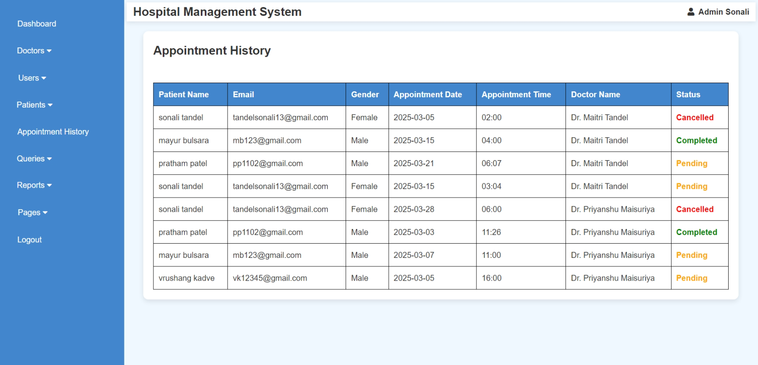 <?php

    include("admin_header.php");

    include('database.php');

    if (!isset($_SESSION['admin_id'])) {

        header('Location: admin_login.php');

        exit;

    }

    $query = "SELECT a.a_id, p.fullname AS patient_name, p.email, p.gender, a.a_date, a.a_time, a.d_status,

                     d.name AS doctor_name

              FROM appointment a

              JOIN patient_mast p ON a.p_id = p.p_id

              JOIN doctor_mast d ON a.d_id = d.d_id";

    $result = mysqli_query($conn, $query);

?>

<!DOCTYPE html>

<html lang="en">

<head>

    <meta charset="UTF-8">

    <meta name="viewport" content="width=device-width, initial-scale=1.0">

    <title>Appointment History</title>

    <link rel="stylesheet" href="css/style.css">

    <style>

        body {

            font-family: Arial, sans-serif;

            background-color: #f0f8ff;

        }

        .container {

            width: 98%;

            margin: 20px auto;

            background: white;

            padding: 20px;

            border-radius: 10px;

            box-shadow: 0px 4px 10px rgba(0, 0, 0, 0.1);

        }

        table {

            width: 100%;

            border-collapse: collapse;

            margin-top: 20px;

        }

        table, th, td {

            border: 1px solid black;

        }

        th, td {

            padding: 10px;

            text-align: left;

        }

        th {

            background-color: rgb(66, 134, 206);

            color: white;

        }

        .status-form select {

            padding: 5px;

        }

        .status-form button {

            padding: 5px 10px;

            background-color: #4CAF50;

            color: white;

            border: none;

            cursor: pointer;

        }

        .status-form button:hover {

            background-color: #45a049;

        }

    </style>

</head>

<body>

    <div class="container">

        <h2>Appointment History</h2><br>

        <table>

            <tr>

                <th>Patient Name</th>

                <th>Email</th>

                <th>Gender</th>

                <th>Appointment Date</th>

                <th>Appointment Time</th>

                <th>Doctor Name</th>

                <th>Status</th>

            </tr>

            <?php while ($row = mysqli_fetch_assoc($result)) { ?>

                <tr>

                    <td><?php echo htmlspecialchars($row['patient_name']); ?></td>

                    <td><?php echo htmlspecialchars($row['email']); ?></td>

                    <td><?php echo htmlspecialchars($row['gender']); ?></td>

                    <td><?php echo htmlspecialchars($row['a_date']); ?></td>

                    <td><?php echo htmlspecialchars($row['a_time']); ?></td>

                    <td><?php echo htmlspecialchars($row['doctor_name']); ?></td>

                    <td class="status-text" style="font-weight: bold;

                        <?php

                            if ($row['d_status'] == 1) {

                                echo 'color: green;';

                            } elseif ($row['d_status'] == 0) {

                                echo 'color: orange;';

                            } else {

                                echo 'color: red;';

                            }

                        ?>">

                        <?php

                            echo ($row['d_status'] == 1) ? 'Completed' :

                                (($row['d_status'] == 0) ? 'Pending' : 'Cancelled');

                        ?>

                    </td>

                </tr>

                            <?php } ?>

        </table>

    </div>

</body>

</html>

**Admin Handle Queries (Read Query)**

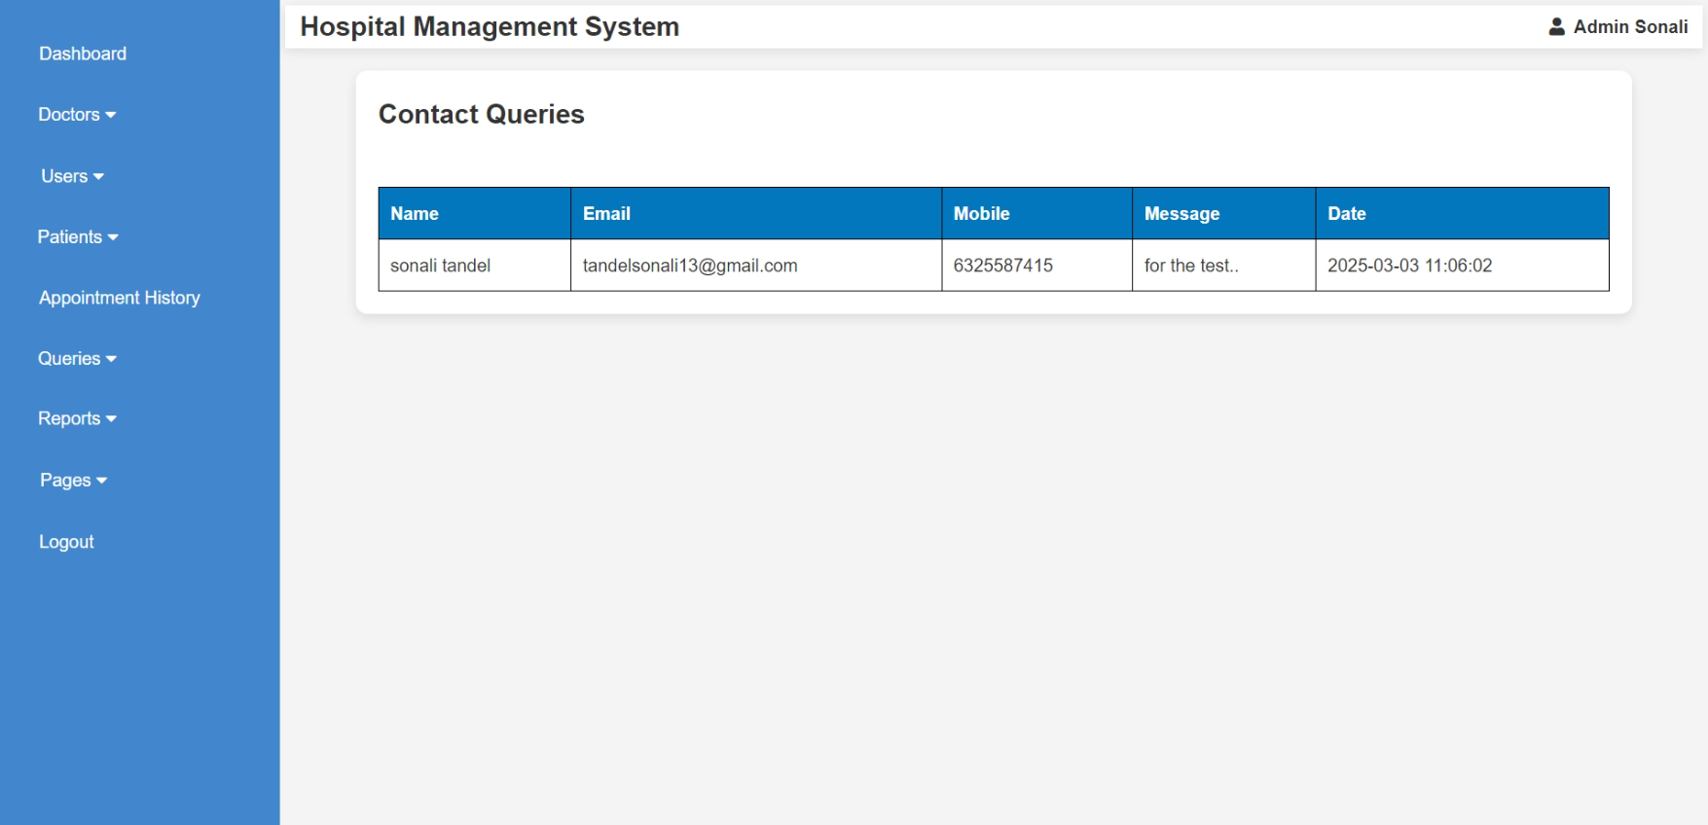 <?php

include("admin_header.php");

include("database.php");

$query = "SELECT * FROM contactus ORDER BY created_at DESC";

$result = mysqli_query($conn, $query);

?>

<!DOCTYPE html>

<html lang="en">

<head>

    <meta charset="UTF-8">

    <meta name="viewport" content="width=device-width, initial-scale=1.0">

    <title>Contact Queries</title>

    <link rel="stylesheet" href="css/style.css">

    <style>

        body {

            font-family: Arial, sans-serif;

            background-color: #f4f4f4;

        }

        .container {

            width: 90%;

            margin: 20px auto;

            background: white;

            padding: 20px;

            border-radius: 10px;

            box-shadow: 0px 4px 10px rgba(0, 0, 0, 0.1);

        }

        table {

            width: 100%;

            border-collapse: collapse;

            margin-top: 20px;

        }

        th, td {

            border: 1px solid black;

            padding: 10px;

            text-align: left;

        }

        th {

            background-color: #0277bd;

            color: white;

        }

    </style>

</head>

<body>

    <div class="container">

        <h2>Contact Queries</h2><br>

        <table>

            <tr>

                <th>Name</th>

                <th>Email</th>

                <th>Mobile</th>

                <th>Message</th>

                <th>Date</th>

            </tr>

            <?php while ($row = mysqli_fetch_assoc($result)) { ?>

                <tr>

                    <td><?php echo htmlspecialchars($row['name']); ?></td>

                    <td><?php echo htmlspecialchars($row['email']); ?></td>

                    <td><?php echo htmlspecialchars($row['mobile']); ?></td>

                    <td><?php echo htmlspecialchars($row['message']); ?></td>

                    <td class="timestamp"><?php echo htmlspecialchars($row['created_at']); ?></td>

                </tr>

            <?php } ?>

        </table>

    </div>

</body>

</html>

**Admin View Reports (B/w Dates Reports)**

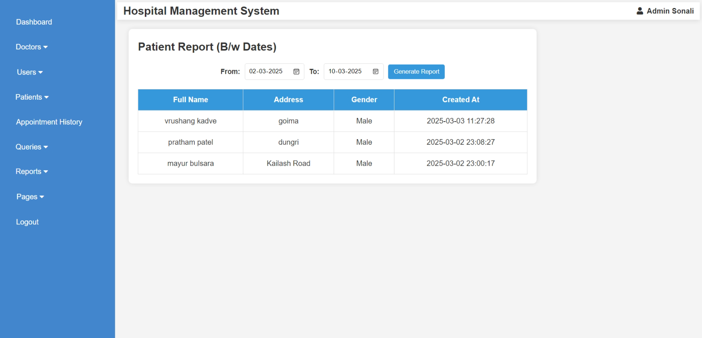<?php

include("admin_header.php");

include("database.php");

$from_date = "";

$to_date = "";

$result = null;

if ($_SERVER["REQUEST_METHOD"] == "POST" && isset($_POST['filter'])) {

    $from_date = $_POST['from_date'];

    $to_date = $_POST['to_date'];

    if (!empty($from_date) && !empty($to_date)) {

        $query = "SELECT * FROM patient_mast WHERE created_at BETWEEN ? AND ? ORDER BY created_at DESC";

        $stmt = mysqli_prepare($conn, $query);

        mysqli_stmt_bind_param($stmt, "ss", $from_date, $to_date);

        mysqli_stmt_execute($stmt);

        $result = mysqli_stmt_get_result($stmt);

    } else {

        echo "<script>alert('Please select both dates!');</script>";

    }

}

?>

<!DOCTYPE html>

<html lang="en">

<head>

    <meta charset="UTF-8">

    <meta name="viewport" content="width=device-width, initial-scale=1.0">

    <title>Patient Report (B/w Dates)</title>

    <style>

        body {

            font-family: Arial, sans-serif;

            background-color: #f4f4f4;

            margin: 0;

            padding: 0;

        }

        .container {

            width: 70%;

            margin: 20px auto;

            padding: 20px;

            background: white;

            box-shadow: 0px 0px 10px rgba(0, 0, 0, 0.1);

            border-radius: 8px;

            margin-left: 2%;

        }

        form {

            display: flex;

            justify-content: center;

            align-items: center;

            gap: 10px;

            margin-bottom: 20px;

        }

        label {

            font-size: 15px;

            font-weight: bold;

        }

        input[type="date"] {

            padding: 8px;

            border: 1px solid #ddd;

            border-radius: 4px;

        }

        button {

            padding: 8px 12px;

            background: #3498db;

            color: white;

            border: none;

            cursor: pointer;

            border-radius: 4px;

        }

        button:hover {

            opacity: 0.8;

        }

        table {

            width: 100%;

            border-collapse: collapse;

        }

        th, td {

            border: 1px solid #ddd;

            padding: 10px;

            text-align: center;

        }

        th {

            background: #3498db;

            color: white;

        }

        .no-data {

            text-align: center;

            font-size: 16px;

            color: red;

            margin-top: 10px;

        }

    </style>

</head>

<body>

<div class="container">

    <h2 style="margin-bottom: 2%;">Patient Report (B/w Dates)</h2>

    <form method="POST">

        <label>From: </label>

        <input type="date" name="from_date" value="<?php echo $from_date; ?>" required>

        <label>To: </label>

        <input type="date" name="to_date" value="<?php echo $to_date; ?>" required>

        <button type="submit" name="filter">Generate Report</button>

    </form>

    <?php if ($result && mysqli_num_rows($result) > 0) { ?>

        <table>

            <tr>

                <th>Full Name</th>

                <th>Address</th>

                <th>Gender</th>

                <th>Created At</th>

            </tr>

            <?php while ($row = mysqli_fetch_assoc($result)) { ?>

            <tr>

                <td><?php echo $row['fullname']; ?></td>

                <td><?php echo $row['address']; ?></td>

                <td><?php echo $row['gender']; ?></td>

                <td><?php echo $row['created_at']; ?></td>

            </tr>

            <?php } ?>

        </table>

    <?php } elseif ($_SERVER["REQUEST_METHOD"] == "POST") { ?>

        <p class="no-data">No records found for the selected dates.</p>

    <?php } ?>

</div>

</body>

</html>

**Admin Handle Pages**

* **Advertisement**

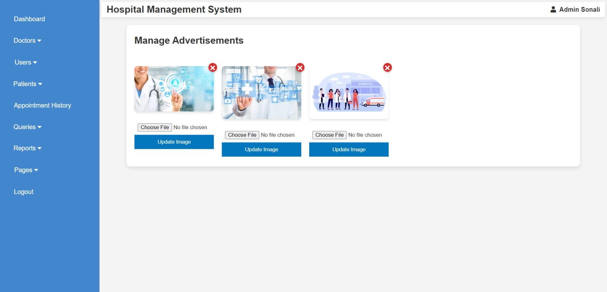<?php

ob_start();

include("admin_header.php");

include("database.php");

$ads = mysqli_query($conn, "SELECT * FROM pages WHERE type='ad'");

if ($_SERVER["REQUEST_METHOD"] == "POST" && isset($_POST['update_id']) && isset($_FILES['new_img'])) {

$id = intval($_POST['update_id']);

if (!empty($_FILES['new_img']['name'])) {

$new_img = basename($_FILES['new_img']['name']);

move_uploaded_file($_FILES['new_img']['tmp_name'], "img/" . $new_img);

$updateQuery = "UPDATE pages SET img='$new_img' WHERE id=$id AND type='ad'";

mysqli_query($conn, $updateQuery);

header("Location: a_ad.php");

exit;

}

}

if (isset($_GET['delete_id'])) {

$id = intval($_GET['delete_id']);

$deleteQuery = "DELETE FROM pages WHERE id = $id AND type='ad'";

mysqli_query($conn, $deleteQuery);

header("Location: a_ad.php");

exit;

}

ob_end_flush();

?>

<!DOCTYPE html>

<html lang="en">

<head>

<meta charset="UTF-8">

<meta name="viewport" content="width=device-width, initial-scale=1.0">

<title>Manage Advertisements</title>

<link rel="stylesheet" href="css/style.css">

<style>

body { font-family: Arial, sans-serif; background-color: #f4f4f4; }

.container { width: 90%; margin: 20px auto; background: white; padding: 20px; border-radius: 10px; box-shadow: 0px 4px 10px rgba(0, 0, 0, 0.1); }

.ads { display: flex; flex-wrap: wrap; gap: 20px; margin-top: 20px; }

.ad-item { position: relative; width: 200px; text-align: center; }

.ad-item img { width: 100%; border-radius: 8px; box-shadow: 0px 4px 6px rgba(0, 0, 0, 0.1); }

.update-form { margin-top: 10px; }

.update-form input { width: 100%; padding: 8px; margin-top: 5px; }

.update-form button { background-color: #0277bd; color: white; padding: 10px; border: none; cursor: pointer; width: 100%; margin-bottom: 5px; }

.update-form button:hover { background-color: #02569b; }

.delete-icon {

position: absolute;

top: -8px;

right: -8px;

background-color: #d32f2f;

color: white;

border: none;

font-size: 15px;

font-weight: bold;

width: 22px;

height: 22px;

border-radius: 50%;

cursor: pointer;

display: flex;

align-items: center;

justify-content: center;

box-shadow: 0px 2px 5px rgba(0, 0, 0, 0.2);

}

.delete-icon:hover { background-color: #b71c1c; }

</style>

</head>

<body>

<div class="container">

<h2>Manage Advertisements</h2><br>

<div class="ads">

<?php while ($row = mysqli_fetch_assoc($ads)) { ?>

<div class="ad-item">

<a href="a_ad.php?delete_id=<?php echo $row['id']; ?>" onclick="return confirm('Are you sure you want to delete this ad?');">

<button class="delete-icon">✖</button>

</a>

<img src="img/<?php echo htmlspecialchars($row['img']); ?>" alt="Advertisement">

<form method="POST" enctype="multipart/form-data" class="update-form">

<input type="hidden" name="update_id" value="<?php echo $row['id']; ?>">

<input type="file" name="new_img" required>

<button type="submit">Update Image</button>

</form>

</div>

<?php } ?>

</div>

</div>

</body>

</html>

* **About Us**

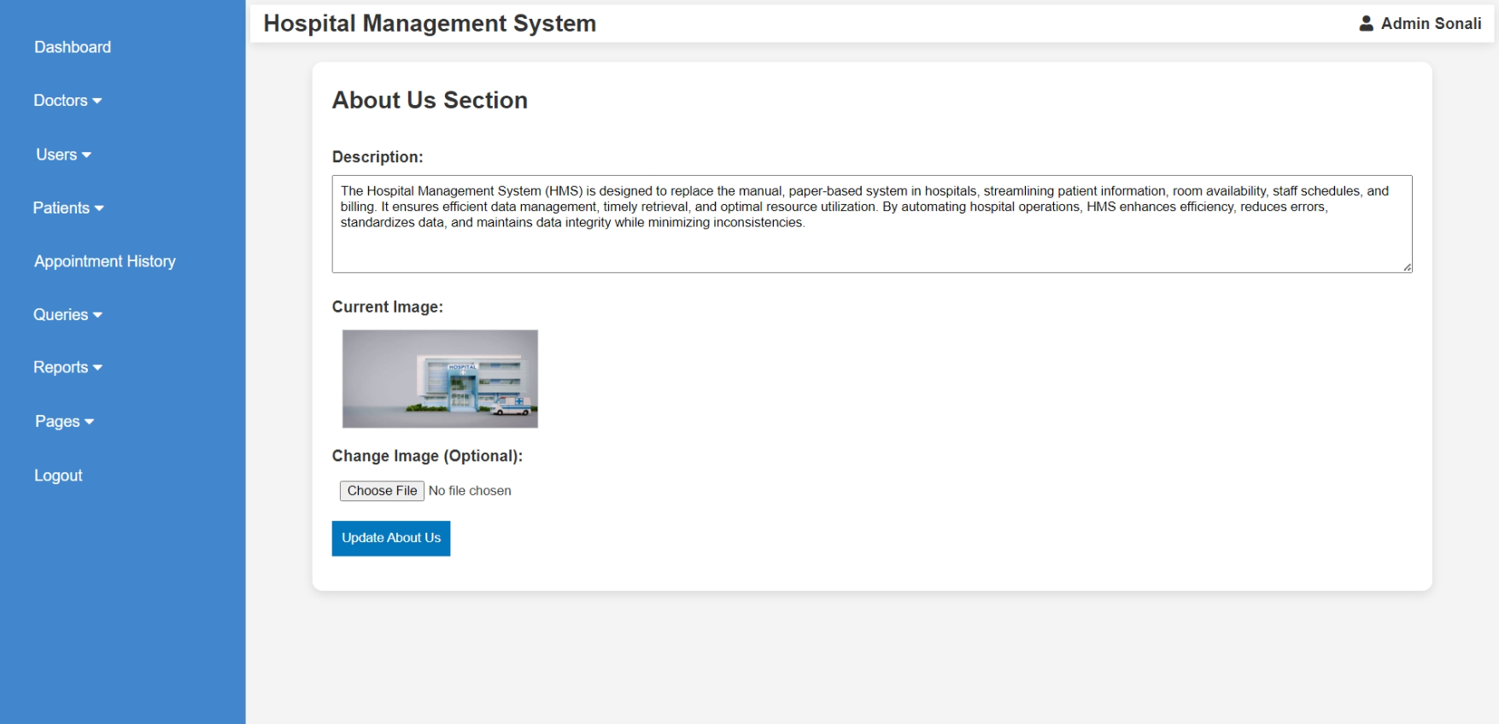<?php

ob_start();

include("admin_header.php");

include("database.php");

$query = "SELECT * FROM pages WHERE type='about' LIMIT 1";

$result = mysqli_query($conn, $query);

$row = mysqli_fetch_assoc($result);

if ($_SERVER["REQUEST_METHOD"] == "POST") {

$description = mysqli_real_escape_string($conn, $_POST['description']);

$img = $row['img'];

if (!empty($_FILES['img']['name'])) {

$img = basename($_FILES['img']['name']);

move_uploaded_file($_FILES['img']['tmp_name'], "img/" . $img);

}

$updateQuery = "UPDATE pages SET description='$description', img='$img' WHERE type='about'";

mysqli_query($conn, $updateQuery);

header("Location: a_aboutus.php");

exit;

}

ob_end_flush();

?>

<!DOCTYPE html>

<html lang="en">

<head>

<meta charset="UTF-8">

<meta name="viewport" content="width=device-width, initial-scale=1.0">

<title>Edit About Us</title>

<link rel="stylesheet" href="css/style.css">

<style>

body { font-family: Arial, sans-serif; background-color: #f4f4f4; }

.container { width: 90%; margin: 20px auto; background: white; padding: 20px; border-radius: 10px; box-shadow: 0px 4px 10px rgba(0, 0, 0, 0.1); }

.form-group { margin-bottom: 15px; }

.form-group label { display: block; font-weight: bold; }

.form-group input, .form-group textarea { width: 100%; padding: 8px; margin-top: 5px; height: 100px; }

.form-group button { background-color: #0277bd; color: white; padding: 10px; border: none; cursor: pointer; }

.form-group button:hover { background-color: #02569b; }

.image-preview { margin-top: 10px; display: flex; align-items: center; }

.image-preview img { width: 200px; height: auto; margin-left: 10px; border: 1px solid #ccc; }

</style>

</head>

<body>

<div class="container">

<h2>About Us Section</h2><br>

<form method="POST" enctype="multipart/form-data">

<div class="form-group">

<label>Description:</label>

<textarea name="description" required><?php echo htmlspecialchars($row['description']); ?></textarea>

</div>

<div class="form-group">

<label>Current Image:</label>

<div class="image-preview">

<?php if (!empty($row['img'])) { ?>

<img src="img/<?php echo htmlspecialchars($row['img']); ?>" alt="Image">

<?php } else { echo "No Image"; } ?>

</div>

</div>

<div class="form-group">

<label>Change Image (Optional):</label>

<input type="file" name="img" style="margin-bottom: -6%;">

</div>

<div class="form-group">

<button type="submit">Update About Us</button>

</div>

</form>

</div>

</body>

</html>

* **Gallery**

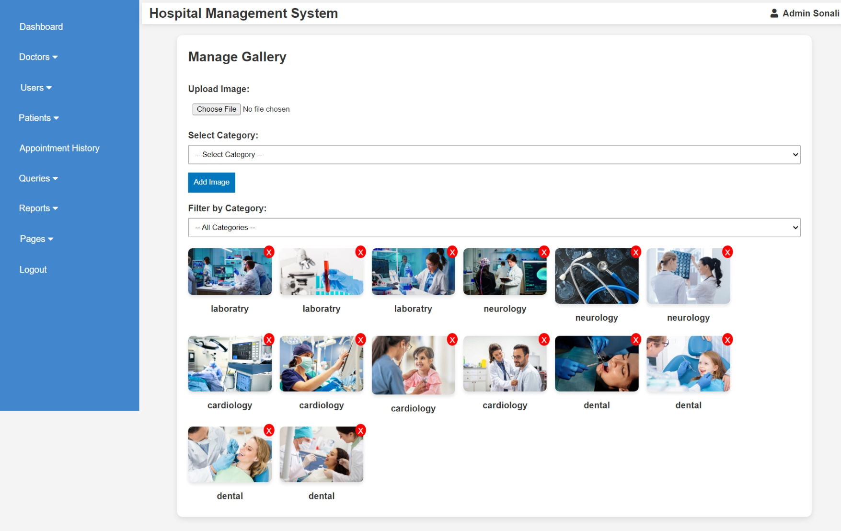

<?php

ob_start();

include("admin_header.php");

include("database.php");

$categories = mysqli_query($conn, "SELECT DISTINCT category FROM pages WHERE type='gallery'");

if ($_SERVER["REQUEST_METHOD"] == "POST" && isset($_FILES['img'])) {

if (!empty($_FILES['img']['name']) && !empty($_POST['category'])) {

$img = basename($_FILES['img']['name']);

$category = mysqli_real_escape_string($conn, $_POST['category']);

move_uploaded_file($_FILES['img']['tmp_name'], "img/" . $img);

$insertQuery = "INSERT INTO pages (img, category, type) VALUES ('$img', '$category', 'gallery')";

mysqli_query($conn, $insertQuery);

header("Location: a_gallery.php");

exit;

}

}

if (isset($_GET['delete'])) {

$id = intval($_GET['delete']);

$imgQuery = "SELECT img FROM pages WHERE id = $id AND type='gallery'";

$imgResult = mysqli_query($conn, $imgQuery);

$imgRow = mysqli_fetch_assoc($imgResult);

if (!empty($imgRow['img']) && file_exists("img/" . $imgRow['img'])) {

unlink("img/" . $imgRow['img']);

}

$deleteQuery = "DELETE FROM pages WHERE id = $id AND type='gallery'";

mysqli_query($conn, $deleteQuery);

header("Location: a_gallery.php");

exit;

}

$selected_category = isset($_GET['category']) ? mysqli_real_escape_string($conn, $_GET['category']) : "";

$query = "SELECT * FROM pages WHERE type='gallery'";

if (!empty($selected_category)) {

$query .= " AND category = '$selected_category'";

}

$query .= " ORDER BY id DESC";

$result = mysqli_query($conn, $query);

ob_end_flush();

?>

<!DOCTYPE html>

<html lang="en">

<head>

<meta charset="UTF-8">

<meta name="viewport" content="width=device-width, initial-scale=1.0">

<title>Manage Gallery</title>

<link rel="stylesheet" href="css/style.css">

<style>

body { font-family: Arial, sans-serif; background-color: #f4f4f4; }

.container { width: 90%; margin: 20px auto; background: white; padding: 20px; border-radius: 10px; box-shadow: 0px 4px 10px rgba(0, 0, 0, 0.1); }

.form-group { margin-bottom: 15px; }

.form-group label { display: block; font-weight: bold; }

.form-group input, .form-group select { width: 100%; padding: 8px; margin-top: 5px; }

.form-group button { background-color: #0277bd; color: white; padding: 10px; border: none; cursor: pointer; }

.form-group button:hover { background-color: #02569b; }

.gallery { display: flex; flex-wrap: wrap; gap: 15px; margin-top: 20px; }

.gallery-item { position: relative; width: 150px; }

.gallery-item img { width: 100%; border-radius: 8px; box-shadow: 0px 4px 6px rgba(0, 0, 0, 0.1); }

.delete-btn { position: absolute; top: -5px; right: -5px; background: red; color: white; padding: 5px; border: none; cursor: pointer; font-size: 14px; border-radius: 50%; height: 23px; }

</style>

</head>

<body>

<div class="container">

<h2>Manage Gallery</h2><br>

<form method="POST" enctype="multipart/form-data">

<div class="form-group">

<label>Upload Image:</label>

<input type="file" name="img" required>

</div>

<div class="form-group">

<label>Select Category:</label>

<select name="category" required>

<option value="">-- Select Category --</option>

<?php while ($cat = mysqli_fetch_assoc($categories)) { ?>

<option value="<?php echo htmlspecialchars($cat['category']); ?>">

<?php echo htmlspecialchars($cat['category']); ?>

</option>

<?php } ?>

</select>

</div>

<div class="form-group">

<button type="submit">Add Image</button>

</div>

</form>

<form method="GET">

<div class="form-group">

<label>Filter by Category:</label>

<select name="category" onchange="this.form.submit()">

<option value="">-- All Categories --</option>

<?php

mysqli_data_seek($categories, 0);

while ($cat = mysqli_fetch_assoc($categories)) {

$selected = ($cat['category'] == $selected_category) ? 'selected' : '';

echo "<option value='" . htmlspecialchars($cat['category']) . "' $selected>" . htmlspecialchars($cat['category']) . "</option>";

}

?>

</select>

</div>

</form>

<div class="gallery">

<?php while ($row = mysqli_fetch_assoc($result)) { ?>

<div class="gallery-item">

<img src="img/<?php echo htmlspecialchars($row['img']); ?>" alt="Gallery Image">

<p style="text-align: center; margin: 5px 0; font-weight: bold;">

<?php echo htmlspecialchars($row['category']); ?>

</p>

<a href="a_gallery.php?delete=<?php echo $row['id']; ?>" onclick="return confirm('Are you sure you want to delete this image?')">

<button class="delete-btn">X</button>

</a>

</div>

<?php } ?>

</div>

</div>

</body>

</html>

**Doctor Login**

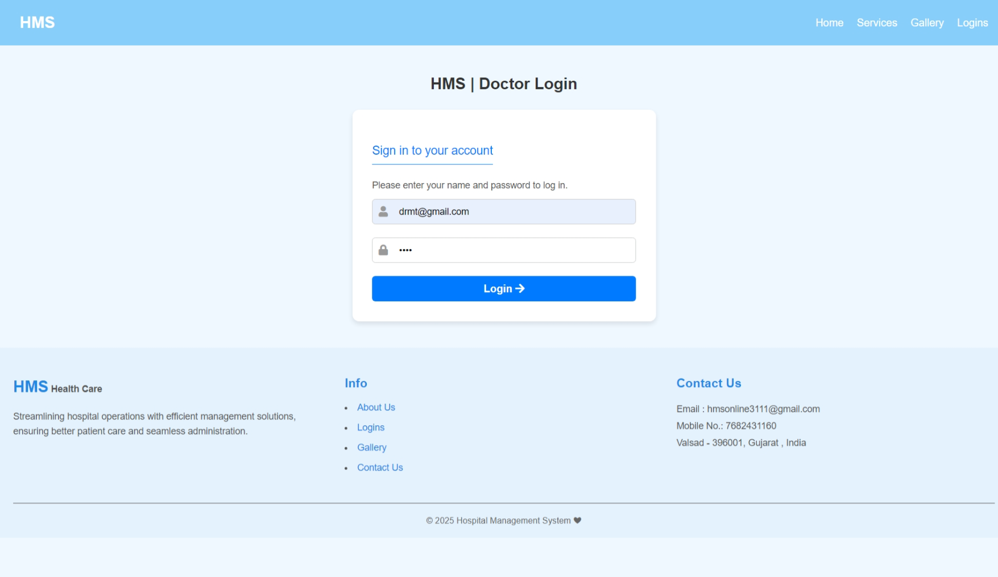<?php

    session_start();

    include("header.php");

?>

<!DOCTYPE html>

<html lang="en">

<head>

    <meta charset="UTF-8">

    <meta name="viewport" content="width=device-width, initial-scale=1.0">

    <title>HMS | Doctor Login</title>

    <link href="https://cdnjs.cloudflare.com/ajax/libs/font-awesome/5.15.4/css/all.min.css" rel="stylesheet">

    <link rel="stylesheet" href="css/rl_style.css">

</head>

<body>

    <section class="login-container" style="margin-bottom: -23%;">

    <h1>HMS | Doctor Login</h1>

        <div class="login-box" style="margin-bottom: 25%;">

            <form method="POST" action="<?php echo htmlspecialchars($_SERVER["PHP_SELF"])?>">

                <p class="p2">Sign in to your account</p>

                <p class="p1">Please enter your name and password to log in.</p>

                <div class="input-group">

                    <label for="email">

                        <i class="fa fa-user"></i>

                    </label>

                    <input type="email" id="email" name="email" placeholder="Email" required>

                </div>

                <div class="input-group">

                    <label for="password">

                        <i class="fa fa-lock"></i>

                    </label>

                    <input type="password" id="password" name="password" placeholder="Password" required>

                </div>

                <button type="submit" class="login-btn">Login <i class="fa fa-arrow-right"></i></button>

                <?php

                    include("database.php");

                    if($_SERVER["REQUEST_METHOD"]=="POST")

                    {

                        $email = filter_input(INPUT_POST,"email",FILTER_SANITIZE_SPECIAL_CHARS);

                        $password = filter_input(INPUT_POST,"password",FILTER_SANITIZE_SPECIAL_CHARS);

                        if(!empty($email) && !empty($password))

                        {

                            $sql = "SELECT * FROM doctor_mast WHERE email = '$email'";

                            $result = mysqli_query($conn, $sql);

                            if (mysqli_num_rows($result) > 0) {

                                $user = mysqli_fetch_assoc($result);

                                if ($password === $user["password"]){

                                    $_SESSION['doctor_id']=$user['d_id'];

                                    $_SESSION['doctor_name']=$user['name'];

                                    header('location:doctor_index.php');

                                    exit;

                                }

                            }

                        }

                    }

                    mysqli_close($conn);

                ?>

            </form>

        </div>

    </section>

    <?php

        include("footer.php");

    ?>

</body>

</html>

**Doctor Account**

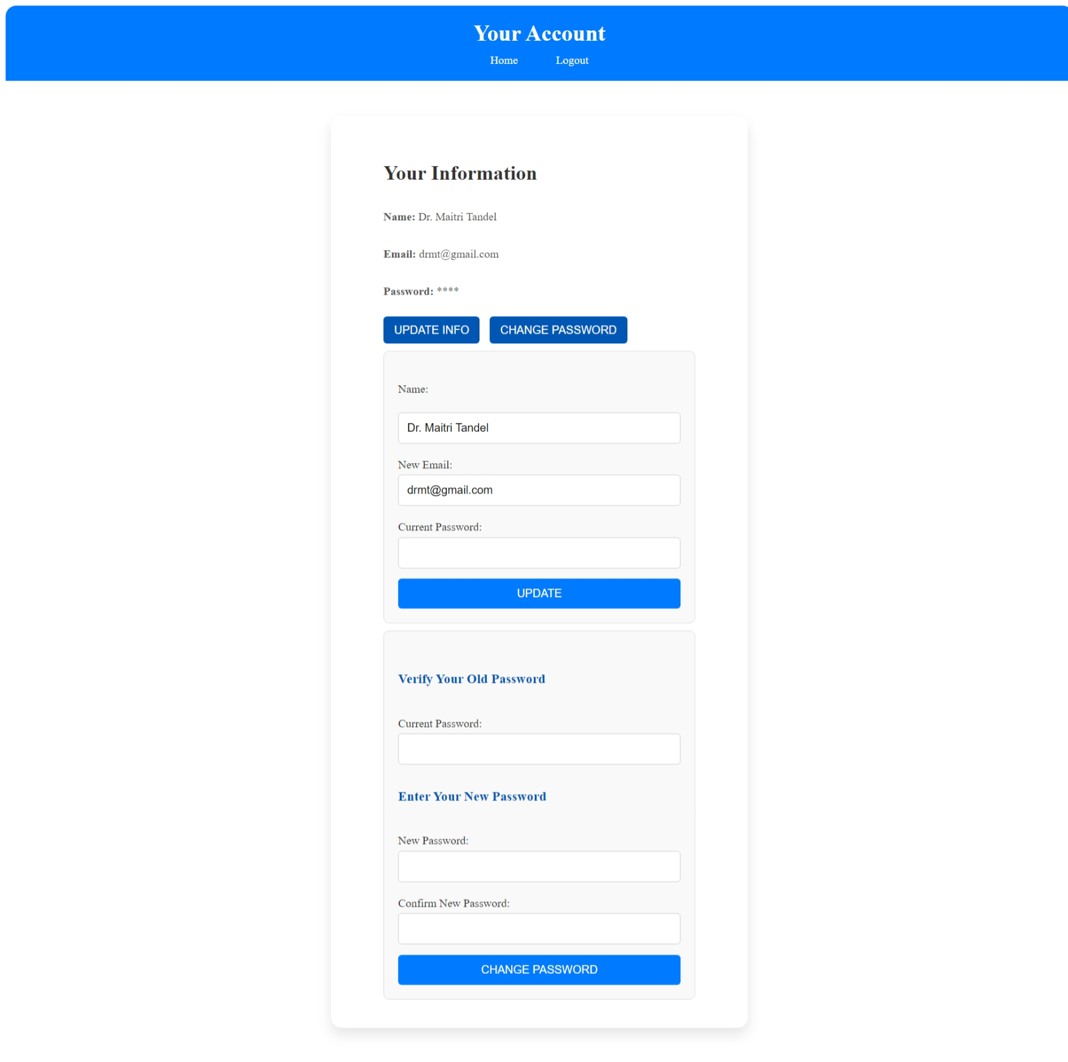<?php

session_start();

include("database.php");

if (!isset($_SESSION['doctor_id'])) {

    header("Location: doctor_login.php");

    exit();

}

$doctor_id = $_SESSION['doctor_id'];

$query = "SELECT * FROM doctor_mast WHERE d_id = '$doctor_id'";

$result = mysqli_query($conn, $query);

if ($result && mysqli_num_rows($result) > 0) {

    $doctor = mysqli_fetch_assoc($result);

} else {

    echo "Admin not found.";

    exit();

}

$message = "";

if ($_SERVER["REQUEST_METHOD"] == "POST" && isset($_POST['update'])) {

    $name = trim($_POST['name']);

    $new_email = trim($_POST['email']);

    $password = trim($_POST['password']);

    $name = mysqli_real_escape_string($conn, $name);

    $new_email = mysqli_real_escape_string($conn, $new_email);

    $password = mysqli_real_escape_string($conn, $password);

    if ($password === $doctor['password']) {

        $update_query = "UPDATE doctor_mast SET name='$name', email='$new_email' WHERE d_id='$doctor_id'";

        if (mysqli_query($conn, $update_query)) {

            $message = "Account details updated successfully!";

            $result = mysqli_query($conn, $query);

            if ($result && mysqli_num_rows($result) > 0) {

                $doctor = mysqli_fetch_assoc($result);

            }

        } else {

            $message = "Error updating account details.";

        }

    } else {

        $message = "Incorrect password. Please try again.";

    }

}

if ($_SERVER["REQUEST_METHOD"] == "POST" && isset($_POST['change_password'])) {

    $password = trim($_POST['password']);

    $new_password = trim($_POST['new_password']);

    $confirm_password = trim($_POST['confirm_password']);

    $password = mysqli_real_escape_string($conn, $password);

    $new_password = mysqli_real_escape_string($conn, $new_password);

    $confirm_password = mysqli_real_escape_string($conn, $confirm_password);

    if ($password === $doctor['password']) {

        if ($new_password === $confirm_password) {

            $update_query = "UPDATE doctor_mast SET password='$new_password' WHERE d_id='$doctor_id'";

            if (mysqli_query($conn, $update_query)) {

                $message = "Password updated successfully!";

            } else {

                $message = "Error updating password.";

            }

        } else {

            $message = "New passwords do not match!";

        }

    } else {

        $message = "Incorrect current password!";

    }

}

?>

<!DOCTYPE html>

<html lang="en">

<head>

    <meta charset="UTF-8">

    <meta name="viewport" content="width=device-width, initial-scale=1.0">

    <title>Account</title>

    <link rel="website icon" href="img/logo1.jpg" type="jpg">

    <link rel="stylesheet" href="css/account_style.css">

</head>

<body>

    <header>

        <h2>Your Account</h2>

        <nav>

            <a href="doctor_index.php">Home</a>&nbsp;&nbsp;&nbsp;&nbsp;&nbsp;

            <a href="logout.php">Logout</a>

        </nav>

    </header>

    <div class="container">

        <section class="sec">

            <h2>Your Information</h2><br>

            <p><strong>Name:</strong> <?php echo htmlspecialchars($doctor['name']); ?></p><br>

            <p><strong>Email:</strong> <?php echo htmlspecialchars($doctor['email']); ?></p><br>

            <p><strong>Password:</strong> <?php echo str_repeat('*', strlen($doctor['password'])); ?></p><br>

            <button class="btn1" onclick="toggleForm('update-info-form')">Update Info</button>

            <button class="btn1" onclick="toggleForm('change-password-form')">Change Password</button>

            <form method="POST" id="update-info-form" class="form-section">

                <br><label for="name">Name:</label><br>

                <input type="text" id="name" name="name" class="ipt1" value="<?php echo htmlspecialchars($doctor['name']); ?>" required><br>

                <label for="email">New Email:</label>

                <input type="email" id="email" name="email" class="email-pass" value="<?php echo htmlspecialchars($doctor['email']); ?>" required><br>

                <label for="password">Current Password:</label>

                <input type="password" id="password" class="email-pass" name="password" required><br>

                <button type="submit" class="btn" name="update">Update</button><br>

            </form>

            <form method="POST" id="change-password-form" class="form-section">

                <br><h3>Verify Your Old Password</h3><br>

                <label for="password">Current Password:</label>

                <input type="password" id="password" class="email-pass" name="password" required><br>

                <h3>Enter Your New Password</h3><br>

                <label for="new_password">New Password:</label>

                <input type="password" id="new_password" class="ipt" name="new_password" required><br>

                <label for="confirm_password">Confirm New Password:</label>

                <input type="password" id="confirm_password" class="ipt" name="confirm_password" required><br>

                <button type="submit" class="btn" name="change_password">Change Password</button>

            </form>

        </section>

    </div>

    <?php

    if($message){

        echo "<script type='text/javascript'>alert('$message');</script>";

    }

    ?>

    <script>

        function toggleForm(formId) {

            var form = document.getElementById(formId);

            if (form.style.display === "none" || form.style.display === "") {

                form.style.display = "block";

            } else {

                form.style.display = "none";

            }

        }

    </script>

</body>

</html>

**Doctor Header**

<?php

    session_start();

    include('database.php');

    if (!isset($_SESSION['doctor_id'])) {

        header('Location: doctor_login.php');

        exit;

    }

    $doctor_name = $_SESSION['doctor_name'];

?>

<!DOCTYPE html>

<html lang="en">

<head>

    <meta charset="UTF-8">

    <meta name="viewport" content="width=device-width, initial-scale=1.0">

    <title>Hospital Management System</title>

    <link rel="website icon" href="img/logo1.jpg" type="jpg">

    <link href="https://cdnjs.cloudflare.com/ajax/libs/font-awesome/5.15.4/css/all.min.css" rel="stylesheet">

    <link rel="stylesheet" href="css/style.css">

    <style>

        * {

        margin: 0;

        padding: 0;

        box-sizing: border-box;

        font-family: Arial, sans-serif;

        }

        body {

            display: flex;

            background-color: #f0f8ff;

        }

        .sidebar {

            width: 250px;

            height: 100vh;

            background:rgb(66, 134, 206);

            color: white;

            padding: 20px;

        }

        .sidebar h2 {

            text-align: center;

            margin-bottom: 20px;

        }

        .sidebar ul {

            list-style: none;

            padding: 0;

        }

        .sidebar ul li {

            padding: 15px;

        }

        .sidebar ul li a {

            color: white;

            text-decoration: none;

            display: block;

        }

        .sidebar ul li a:hover {

            background:rgb(94, 142, 193);

            border-radius: 5px;

        }

        .main-content {

            flex: 1;

            padding:5px;

        }

        header {

            display: flex;

            justify-content: space-between;

            align-items: center;

            background: white;

            box-shadow: 0px 2px 10px rgba(0, 0, 0, 0.1);

        }

        .dashboard {

            margin-top: 20px;

        }

        .cards {

            display: flex;

            /*justify-content: space-between;*/

            gap: 20px;

            margin-left: 2%;

        }

        .card {

            background: white;

            padding: 20px;

            text-align: center;

            width: 30%;

            border-radius: 10px;

            box-shadow: 0px 4px 10px rgba(0, 0, 0, 0.1);

        }

        .card img {

            width: 50px;

            margin-bottom: 10px;

        }

        .card a {

            display: block;

            margin-top: 10px;

            color:rgb(50, 128, 210);

            text-decoration: none;

        }

        .card a:hover {

            text-decoration: underline;

        }

        .dropdown {

            position: relative;

            display: inline-block;

        }

        .dropbtn {

            margin-left: -19%;

            margin-top: -10%;

            margin-bottom: -10%;

            padding: 10px 20px;

            font-size: 16px;

            border: none;

            cursor: pointer;

        }

        .dropdown-content {

            display: none;

            position: absolute;

            background-color:rgb(255, 255, 255);

            min-width: 160px;

            box-shadow: 0px 8px 16px rgba(0, 0, 0, 0.2);

            z-index: 1;

        }

        .dropdown-content a {

            color:black;

            padding: 6px 16px;

            text-decoration: none;

            display: block;

        }

        .dropdown:hover .dropdown-content {

            display: block;

        }

    </style>

</head>

<body>

<div class="sidebar">

    <ul>

        <li><a href="doctor_index.php">Dashboard</a></li>

        <li><a href="dr_appointment_history.php">Appointment History</a></li>

        <li class="dropdown">

            <a href="#" class="dropbtn">Patients <i class="fas fa-caret-down"></i></a>

            <div class="dropdown-content">

                <a href="add_patient.php" style="color: black; border-radius:0;">Add Patient</a>

                <a href="manage_patient.php" style="color: black; border-radius:0;">Manage Patient</a>

            </div>

        </li>

        <li><a href="search_patient.php">Search</a></li>

        <li><a href="logout.php" onclick="return confirmLogout()">Logout</a>

            <script>

                function confirmLogout() {

                    return confirm("Are you sure you want to log out?");

                }

            </script>

        </li>

    </ul>

</div>

    <div class="main-content">

        <header>

            <h2>&nbsp;&nbsp;Hospital Management System</h2>

            <div class="user-info" style="font-weight: bold; margin-right:1%;">

            <i class="fas fa-user"></i>&nbsp;&nbsp;<?php echo $doctor_name; ?>

            </div>

        </header>

**Doctor Dashboard**

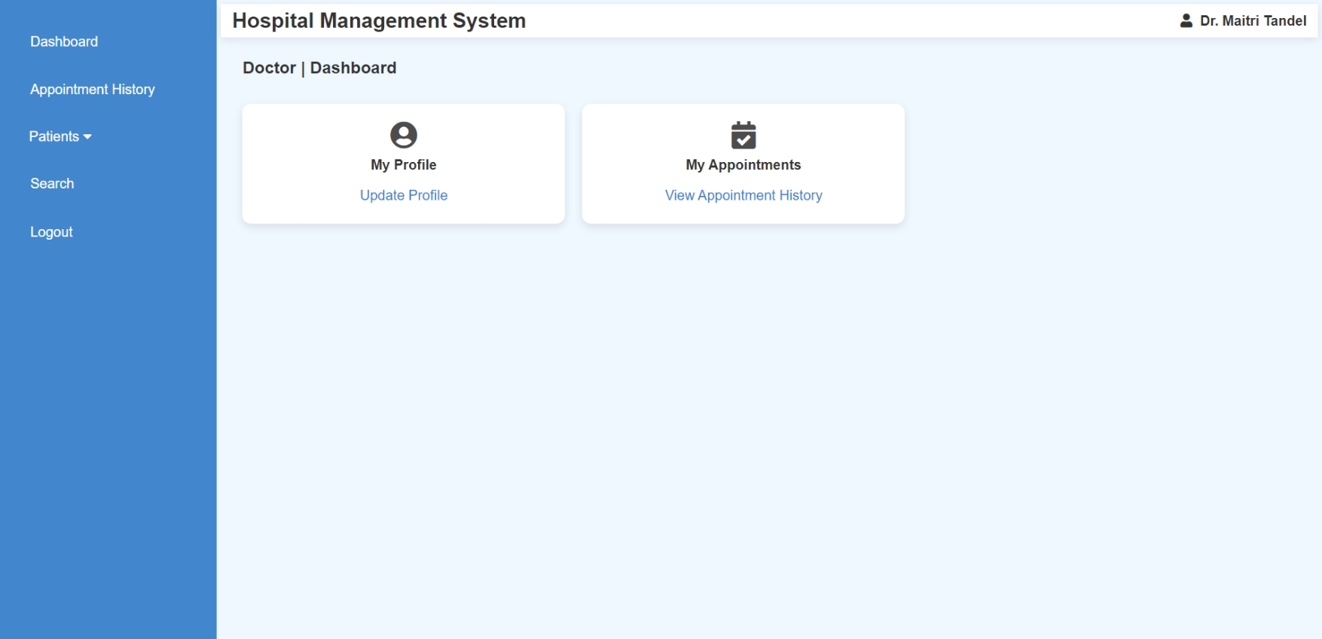<?php

    include("doctor_header.php");

    include("database.php");

    $doctor_id = $_SESSION['doctor_id'];

    $current_date = date('Y-m-d');

    $query = "SELECT COUNT(*) AS pending_count FROM appointment WHERE d_id = $doctor_id AND a_date = '$current_date' AND d_status = 0";

    $result = mysqli_query($conn, $query);

    $row = mysqli_fetch_assoc($result);

    $pending_count = $row['pending_count'];

?>

<section class="dashboard">

    <h3 style="font-size:larger; margin-left:2%;">Doctor | Dashboard</h3><br>

    <div class="cards">

        <div class="card">

            <i class="fas fa-user-circle fa-2x" style="opacity: 0.9;"></i><br>

            <h4 style="margin-top:0.8%;">My Profile</h4>

            <a href="doctor_account.php">Update Profile</a>

        </div>

        <div class="card">

            <i class="fas fa-calendar-check fa-2x" style="opacity: 0.9;"></i>

            <h4 style="margin-top:0.8%;">My Appointments</h4>

            <a href="dr_appointment_history.php">

                View Appointment History

                <?php if ($pending_count > 0) { ?>

                    <span style="color: red; font-weight: bold;">(<?= $pending_count ?> pending)</span>

                <?php } ?>

            </a>

        </div>

    </div>

</section>

**Doctor View Appointment History**

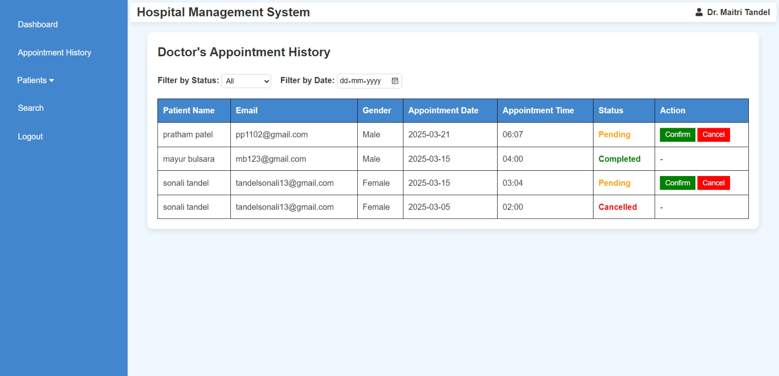<?php

ob_start();

include("doctor_header.php");

include('database.php');

if (!isset($_SESSION['doctor_id'])) {

    header('Location: doctor_login.php');

    exit;

}

$doctor_id = intval($_SESSION['doctor_id']);

if (isset($_POST['confirm_id'])) {

    $confirm_id = intval($_POST['confirm_id']);

    $update_confirm_query = "UPDATE appointment SET d_status = 1 WHERE a_id = $confirm_id AND d_id = $doctor_id";

    mysqli_query($conn, $update_confirm_query);

    header("Location: " . $_SERVER['PHP_SELF']);

    exit;

}

if (isset($_POST['cancel_id'])) {

    $cancel_id = intval($_POST['cancel_id']);

    $update_cancel_query = "UPDATE appointment SET d_status = 2 WHERE a_id = $cancel_id AND d_id = $doctor_id";

    mysqli_query($conn, $update_cancel_query);

    header("Location: " . $_SERVER['PHP_SELF']);

    exit;

}

$status_filter = isset($_GET['status']) ? intval($_GET['status']) : -1; // Default: Show all

$date_filter = isset($_GET['date']) ? $_GET['date'] : '';

$query = "SELECT a.a_id, p.fullname AS patient_name, p.email, p.gender, a.a_date, a.a_time, a.d_status

          FROM appointment a

          INNER JOIN patient_mast p ON a.p_id = p.p_id

          WHERE a.d_id = $doctor_id";

if ($status_filter >= 0) {

    $query .= " AND a.d_status = $status_filter";

}

if (!empty($date_filter)) {

    $query .= " AND a.a_date = '$date_filter'";

}

$query .= " ORDER BY a.a_date DESC";

$result = mysqli_query($conn, $query);

ob_end_flush();

?>

<!DOCTYPE html>

<html lang="en">

<head>

    <meta charset="UTF-8">

    <meta name="viewport" content="width=device-width, initial-scale=1.0">

    <title>Doctor's Appointment History</title>

    <style>

         body {

            font-family: Arial, sans-serif;

            background-color: #f0f8ff;

        }

        .container {

            width: 98%;

            margin: 20px auto;

            background: white;

            padding: 20px;

            border-radius: 10px;

            box-shadow: 0px 4px 10px rgba(0, 0, 0, 0.1);

        }

        table {

            width: 100%;

            border-collapse: collapse;

            margin-top: 20px;

        }

        table, th, td {

            border: 1px solid black;

        }

        th, td {

            padding: 10px;

            text-align: left;

        }

        th {

            background-color: rgb(66, 134, 206);

            color: white;

        }

        .status {

            font-weight: bold;

        }

        .completed { color: green; }

        .pending { color: orange; }

        .cancelled { color: red; }

        .confirm-btn, .cancel-btn {

            color: white;

            padding: 5px 10px;

            border: none;

            cursor: pointer;

            text-decoration: none;

        }

        .confirm-btn { background-color: green; }

        .confirm-btn:hover { background-color: darkgreen; }

        .cancel-btn { background-color: red; }

        .cancel-btn:hover { background-color: darkred; }

        .filter-container {

            margin-bottom: 10px;

        }

        select, button, input {

            padding: 8px;

            font-size: 14px;

        }

        .filter-container {

            margin-top: 2%;

            margin-bottom: 10px;

        }

        select, input {

            padding: 4px;

            font-size: 14px;

            border: 1px solid #ccc;

            border-radius: 4px;

        }

    </style>

    <script>

        function confirmAppointment(a_id) {

            if (confirm("Are you sure you want to confirm this appointment?")) {

                let form = document.createElement("form");

                form.method = "POST";

                form.action = "";

                let input = document.createElement("input");

                input.type = "hidden";

                input.name = "confirm_id";

                input.value = a_id;

                form.appendChild(input);

                document.body.appendChild(form);

                form.submit();

            }

        }

        function cancelAppointment(a_id) {

            if (confirm("Are you sure you want to cancel this appointment?")) {

                let form = document.createElement("form");

                form.method = "POST";

                form.action = "";

                let input = document.createElement("input");

                input.type = "hidden";

                input.name = "cancel_id";

                input.value = a_id;

                form.appendChild(input);

                document.body.appendChild(form);

                form.submit();

            }

        }

        function filterAppointments() {

            let status = document.getElementById("status-filter").value;

            let date = document.getElementById("date-filter").value;

            let url = "?status=" + status;

            if (date) {

                url += "&date=" + date;

            }

            window.location.href = url;

        }

    </script>

</head>

<body>

    <div class="container">

        <h2>Doctor's Appointment History</h2>

        <div class="filter-container">

            <label for="status-filter"><b>Filter by Status:</b></label>

            <select id="status-filter" onchange="filterAppointments()">

                <option value="-1" <?php if ($status_filter == -1) echo 'selected'; ?>>All</option>

                <option value="0" <?php if ($status_filter == 0) echo 'selected'; ?>>Pending</option>

                <option value="1" <?php if ($status_filter == 1) echo 'selected'; ?>>Completed</option>

                <option value="2" <?php if ($status_filter == 2) echo 'selected'; ?>>Cancelled</option>

            </select>

            <label for="date-filter"><b>&nbsp;&nbsp;&nbsp;Filter by Date:</b></label>

            <input type="date" id="date-filter" value="<?php echo isset($_GET['date']) ? $_GET['date'] : ''; ?>" onchange="filterAppointments()">

        </div>

        <table>

            <tr>

                <th>Patient Name</th>

                <th>Email</th>

                <th>Gender</th>

                <th>Appointment Date</th>

                <th>Appointment Time</th>

                <th>Status</th>

                <th>Action</th>

            </tr>

            <?php if ($result && mysqli_num_rows($result) > 0) {

                while ($row = mysqli_fetch_assoc($result)) { ?>

                    <tr>

                        <td><?php echo htmlspecialchars($row['patient_name']); ?></td>

                        <td><?php echo htmlspecialchars($row['email']); ?></td>

                        <td><?php echo htmlspecialchars($row['gender']); ?></td>

                        <td><?php echo htmlspecialchars($row['a_date']); ?></td>

                        <td><?php echo htmlspecialchars($row['a_time']); ?></td>

                        <td class="status <?php echo ($row['d_status'] == 1) ? 'completed' : (($row['d_status'] == 0) ? 'pending' : 'cancelled'); ?>">

                            <?php echo ($row['d_status'] == 1) ? 'Completed' : (($row['d_status'] == 0) ? 'Pending' : 'Cancelled'); ?>

                        </td>

                        <td>

                            <?php if ($row['d_status'] == 0) { ?>

                                <button class="confirm-btn" onclick="confirmAppointment(<?php echo $row['a_id']; ?>)">Confirm</button>

                                <button class="cancel-btn" onclick="cancelAppointment(<?php echo $row['a_id']; ?>)">Cancel</button>

                            <?php } else { echo "-"; } ?>

                        </td>

                    </tr>

                <?php }

            } else { ?>

                <tr><td colspan="7" style="text-align: center; font-weight: bold;">No appointments found.</td></tr>

            <?php } ?>

        </table>

    </div>

</body>

</html>

**Doctor (Manage Patients)**

* **Add Patient**

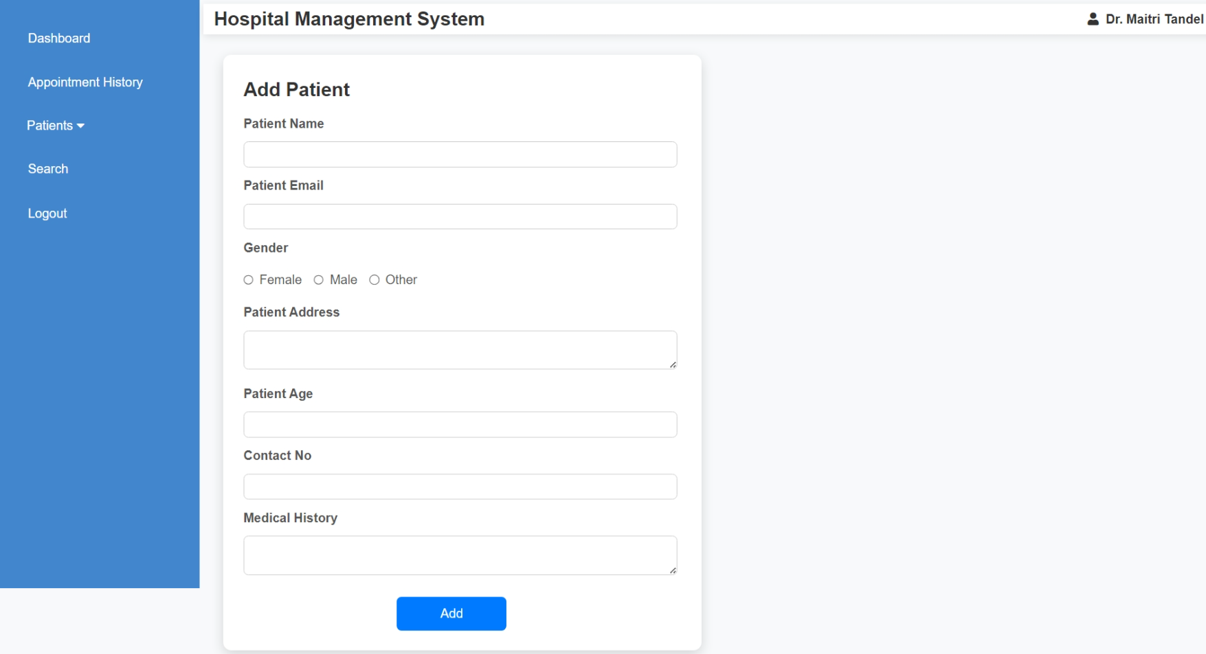<?php

include('doctor_header.php');

include('database.php');

if (!isset($_SESSION['doctor_id'])) {

    echo "<script>alert('Unauthorized access!'); window.location.href='login.php';</script>";

    exit;

}

$doctor_id = $_SESSION['doctor_id'];

if ($_SERVER["REQUEST_METHOD"] == "POST") {

    $fullname = mysqli_real_escape_string($conn, $_POST['fullname']);

    $email = mysqli_real_escape_string($conn, $_POST['email']);

    $gender = mysqli_real_escape_string($conn, $_POST['gender']);

    $address = mysqli_real_escape_string($conn, $_POST['address']);

    $age = mysqli_real_escape_string($conn, $_POST['age']);

    $contact_no = mysqli_real_escape_string($conn, $_POST['contact_no']);

    $medhis = mysqli_real_escape_string($conn, $_POST['medhis']);

    $sql = "INSERT INTO patient_detail (d_id, p_name, p_email, p_gender, p_add, p_age, p_contact, p_medhis)

            VALUES ('$doctor_id', '$fullname', '$email', '$gender', '$address', '$age', '$contact_no', '$medhis')";

    if ($conn->query($sql) === TRUE) {

        echo "<script>alert('Patient added successfully!'); window.location.href='manage_patient.php';</script>";

    } else {

        echo "Error: " . $sql . "<br>" . $conn->error;

    }

    $conn->close();

}

?>

<!DOCTYPE html>

<html lang="en">

<head>

    <meta charset="UTF-8">

    <meta name="viewport" content="width=device-width, initial-scale=1.0">

    <title>Add Patient</title>

    <style>

        body {

            font-family: Arial, sans-serif;

            background-color: #f8f9fa;

            margin: 0;

            padding: 0;

        }

        .container {

            width: 100%;

            max-width: 600px;

            background: white;

            padding: 25px;

            border-radius: 10px;

            box-shadow: 0px 5px 15px rgba(0, 0, 0, 0.15);

            margin-top: 2%;

            margin-left: 2%;

        }

        label {

            font-weight: bold;

            display: block;

            margin: 10px 0 5px;

            color: #555;

        }

        input, textarea {

            width: 99%;

            padding: 7px;

            margin-top: 5px;

            border: 1px solid #ccc;

            border-radius: 6px;

            font-size: 14px;

            transition: 0.3s;

        }

        input:focus, textarea:focus {

            border-color: #007bff;

            outline: none;

        }

        .radio-group {

            display: flex;

            align-items: center;

            gap: 15px;

        }

        .radio-group label {

            display: flex;

            align-items: center;

            gap: 7px;

            cursor: pointer;

            font-weight: lighter;

        }

        .radio-group input {

            margin: 0;

        }

        .btn-submit {

            background-color: #007bff;

            color: white;

            border: none;

            padding: 12px;

            margin-top: 20px;

            border-radius: 6px;

            cursor: pointer;

            font-size: 16px;

            width:25%;

            transition: background 0.3s;

            margin-left: 35%;

        }

        .btn-submit:hover {

            background-color: #0056b3;

        }

        @media (max-width: 600px) {

            .container {

                width: 95%;

                padding: 20px;

            }

        }

    </style>

</head>

<body>

    <div class="container">

        <h2>Add Patient</h2>

        <form method="post">

            <label>Patient Name</label>

            <input type="text" name="fullname" required>

            <label>Patient Email</label>

            <input type="email" name="email" required>

            <label>Gender</label>

            <div class="radio-group">

                <label><input type="radio" name="gender" value="Female" required> Female</label>

                <label><input type="radio" name="gender" value="Male" required> Male</label>

                <label><input type="radio" name="gender" value="Other" required> Other</label>

            </div>

            <label>Patient Address</label>

            <textarea name="address" required></textarea>

            <label>Patient Age</label>

            <input type="number" name="age" required>

            <label>Contact No</label>

            <input type="text" name="contact_no" required>

            <label>Medical History</label>

            <textarea name="medhis"></textarea>

            <button type="submit" class="btn-submit">Add</button>

        </form>

    </div>

</body>

</html>

* **Manage Patient (View & Edit Patient Details)**

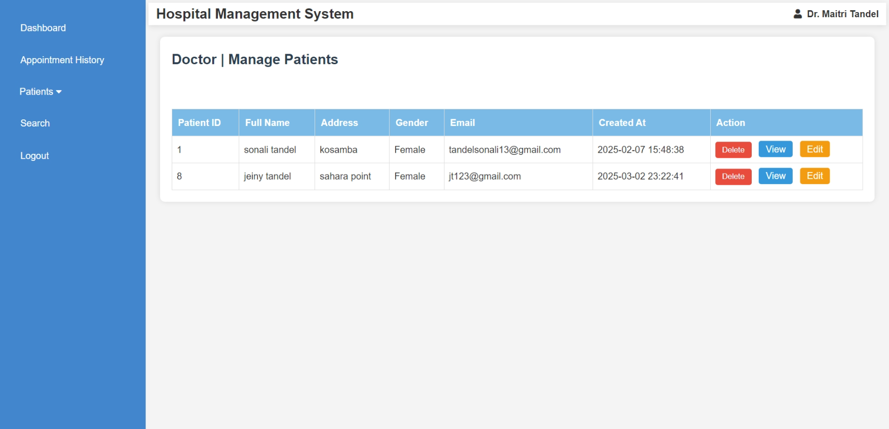

<?php

include("doctor_header.php");

include('database.php');

if (!isset($_SESSION['doctor_id'])) {

header('Location: doctor_login.php');

exit;

}

doctor_id = intval($_SESSION['doctor_id']);

if (isset($_POST['delete']) && isset($_POST['p_detail_id'])) {

$p_detail_id = intval($_POST['p_detail_id']);

$query = "DELETE FROM patient_detail WHERE p_detail_id = '$p_detail_id' AND d_id = '$doctor_id'";

$result = mysqli_query($conn, $query);

if ($result) {

echo "<script>alert('Patient deleted successfully.'); window.location.href='manage_patient.php';</script>";

} else {

echo "<script>alert('Error deleting patient: " . mysqli_error($conn) . "'); window.location.href='manage_patient.php';</script>";

}

}

$query = "SELECT DISTINCT p_detail_id, p_name, p_add, p_email, p_gender, created_at FROM patient_detail WHERE d_id = '$doctor_id'";

$result = mysqli_query($conn, $query);

?>

<!DOCTYPE html>

<html lang="en">

<head>

<meta charset="UTF-8">

<meta name="viewport" content="width=device-width, initial-scale=1.0">

<title>Manage Patients</title>

<style>

body {

font-family: Arial, sans-serif;

background-color: #f4f4f4;

margin: 0;

padding: 0;

}

section.dashboard {

margin: 20px;

padding: 20px;

background-color: #fff;

border-radius: 8px;

box-shadow: 0 0 10px rgba(0, 0, 0, 0.1);

}

h3 {

color: #2c3e50;

font-size: 24px;

margin-bottom: 20px;

}

table {

width: 100%;

border-collapse: collapse;

margin-top: 20px;

}

table, th, td {

border: 1px solid #ddd;

}

th {

background-color: rgb(121, 187, 230);

color: white;

padding: 10px;

text-align: left;

}

td {

padding: 8px;

text-align: left;

}

td input[type="submit"] {

background-color: #e74c3c;

color: white;

border: none;

padding: 6px 12px;

cursor: pointer;

border-radius: 4px;

transition: background-color 0.3s ease;

}

td input[type="submit"]:hover {

background-color: #c0392b;

}

.view-btn, .edit-btn {

background-color: #3498db;

color: white;

padding: 1px 12px;

text-decoration: none;

border-radius: 4px;

margin-left: 8px;

display: inline-block;

}

.edit-btn {

background-color: #f39c12;

}

@media screen and (max-width: 768px) {

table, th, td {

font-size: 14px;

}

td input[type="submit"] {

padding: 4px 8px;

}

}

</style>

</head>

<body>

<section class="dashboard">

<h3>Doctor | Manage Patients</h3><br>

<table border="1">

<thead>

<tr>

<th>Patient ID</th>

<th>Full Name</th>

<th>Address</th>

<th>Gender</th>

<th>Email</th>

<th>Created At</th>

<th>Action</th>

</tr>

</thead>

<tbody>

<?php

if ($result && mysqli_num_rows($result) > 0) {

while ($row = mysqli_fetch_assoc($result)) {

echo "<tr>

<td>{$row['p_detail_id']}</td>

<td>{$row['p_name']}</td>

<td>{$row['p_add']}</td>

<td>{$row['p_gender']}</td>

<td>{$row['p_email']}</td>

<td>{$row['created_at']}</td>

<td>

<form method='POST' action='' onsubmit='return confirmDelete()' style='display:inline;'>

<input type='hidden' name='p_detail_id' value='{$row['p_detail_id']}'>

<input type='submit' name='delete' value='Delete'>

</form>

<a href='view_patient.php?p_detail_id={$row['p_detail_id']}' class='view-btn'>View</a>

<a href='edit_patient.php?p_detail_id={$row['p_detail_id']}' class='edit-btn'>Edit</a>

</td>

</tr>";

}

} else {

echo "<tr><td colspan='7'>No patients found.</td></tr>";

}

?>

</tbody>

</table>

</section>

<script>

function confirmDelete() {

return confirm('Are you sure you want to delete this patient?');

}

</script>

</body>

</html>

* + **View Patient Details**

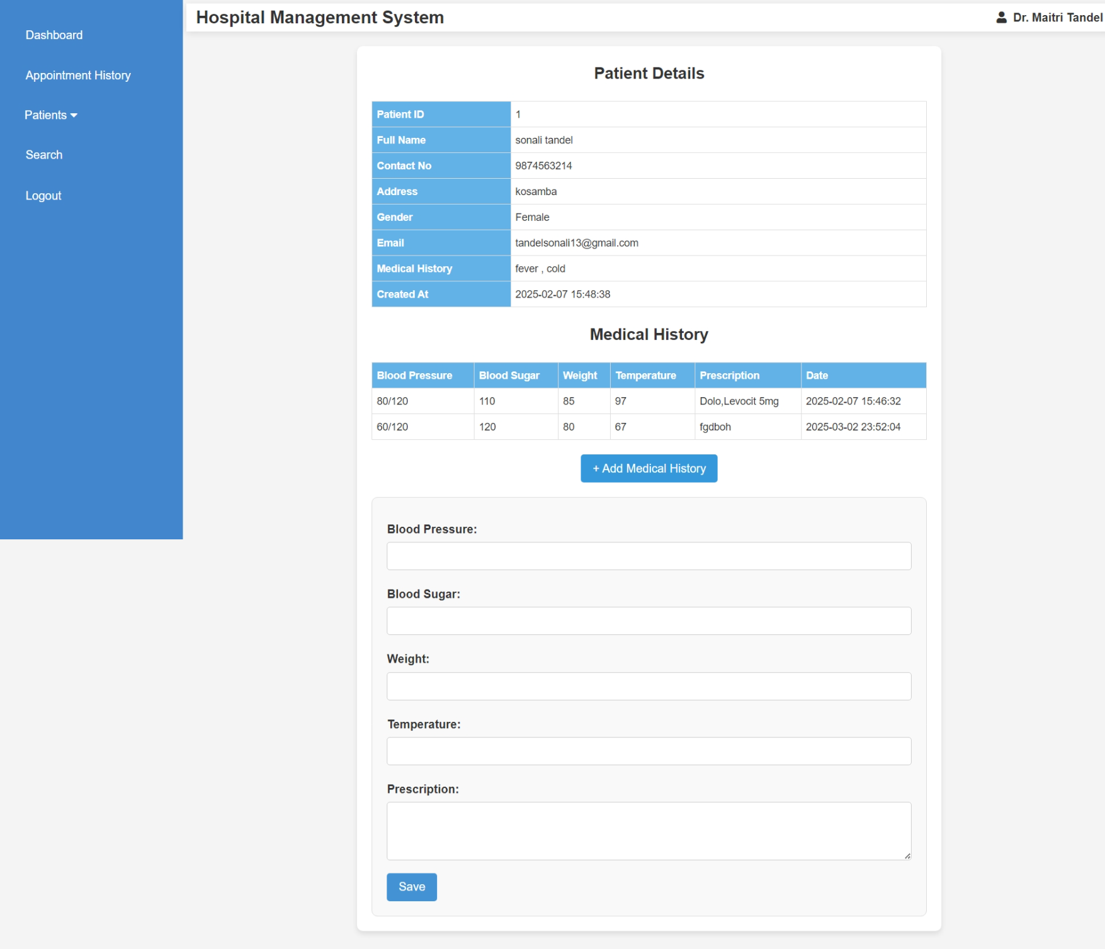

<?php

ob_start();

include("doctor_header.php");

include('database.php');

if (!isset($_SESSION['doctor_id'])) {

    header('Location: doctor_login.php');

    exit;

}

$doctor_id = intval($_SESSION['doctor_id']);

if (isset($_GET['p_detail_id'])) {

    $p_detail_id = intval($_GET['p_detail_id']);

    $query = "SELECT * FROM patient_detail WHERE p_detail_id = '$p_detail_id' AND d_id = '$doctor_id'";

    $result = mysqli_query($conn, $query);

    if ($result && mysqli_num_rows($result) > 0) {

        $row = mysqli_fetch_assoc($result);

    } else {

        echo "<p>Patient not found or access denied.</p>";

        exit;

    }

} else {

    echo "<p>Invalid request.</p>";

    exit;

}

if ($_SERVER['REQUEST_METHOD'] == 'POST') {

    if (isset($_POST['update_medical'])) {

        $bp = mysqli_real_escape_string($conn, $_POST['bp']);

        $bs = mysqli_real_escape_string($conn, $_POST['bs']);

        $weight = mysqli_real_escape_string($conn, $_POST['weight']);

        $temperature = mysqli_real_escape_string($conn, $_POST['temperature']);

        $m_prescription = mysqli_real_escape_string($conn, $_POST['m_prescription']);

        $med_update_query = "INSERT INTO medical_history (p_detail_id, bp, bs, weight, temperature, m_prescription, created_at)

                             VALUES ('$p_detail_id', '$bp', '$bs', '$weight', '$temperature', '$m_prescription', NOW())";

        mysqli_query($conn, $med_update_query);

        header("Location: view_patient.php?p_detail_id=$p_detail_id");

        exit;

    }

}

ob_end_flush();

?>

<!DOCTYPE html>

<html lang="en">

<head>

    <meta charset="UTF-8">

    <meta name="viewport" content="width=device-width, initial-scale=1.0">

    <title>Patient Details</title>

    <style>

        body {

            font-family: Arial, sans-serif;

            background-color: #f4f4f4;

            margin: 0;

            padding: 0;

        }

        .container {

            background: #fff;

            padding: 20px;

            border-radius: 8px;

            box-shadow: 0 4px 8px rgba(0, 0, 0, 0.1);

            max-width: 800px;

            width: 100%;

            margin: 20px auto;

        }

        h3 {

            text-align: center;

            color: #333;

            font-size: 22px;

            margin-bottom: 20px;

        }

        table {

            width: 100%;

            border-collapse: collapse;

            margin-bottom: 20px;

        }

        th, td {

            border: 1px solid #ddd;

            padding: 6px;

            font-size: 14px;

            text-align: left;

        }

        th {

            background-color: rgb(99, 178, 231);

            color: white;

            font-weight: bold;

        }

        .toggle-btn {

            display: block;

            margin: 20px auto;

            padding: 10px 16px;

            background-color: #3498db;

            color: white;

            border: none;

            border-radius: 4px;

            cursor: pointer;

            font-size: 16px;

            transition: 0.3s;

        }

        .toggle-btn:hover {

            background-color: #2980b9;

        }

        .form-container {

            display: none;

            background-color: #f9f9f9;

            padding: 20px;

            border-radius: 8px;

            border: 1px solid #ddd;

            margin-top: 20px;

        }

        .form-container label {

            display: block;

            font-weight: bold;

            margin: 10px 0 5px;

            color: #333;

        }

        .form-container input,

        .form-container textarea {

            width: 100%;

            padding: 10px;

            margin-bottom: 10px;

            border: 1px solid #ccc;

            border-radius: 4px;

            font-size: 14px;

        }

        .form-container textarea {

            resize: vertical;

            height: 80px;

        }

        button[type="submit"] {

            background-color: rgb(67, 146, 211);

            color: white;

            padding: 10px 16px;

            border: none;

            border-radius: 4px;

            cursor: pointer;

            font-size: 16px;

            transition: 0.3s;

        }

        button[type="submit"]:hover {

            background-color: rgb(73, 130, 190);

        }

        @media (max-width: 600px) {

            .container {

                padding: 15px;

            }

            th, td {

                padding: 8px;

            }

            .toggle-btn, button[type="submit"] {

                width: 100%;

            }

        }

    </style>

</head>

<body>

<div class="container">

    <h3>Patient Details</h3>

    <table>

        <tr><th style="width: 25%;">Patient ID</th><td><?php echo $row['p_detail_id']; ?></td></tr>

        <tr><th>Full Name</th><td><?php echo $row['p_name']; ?></td></tr>

        <tr><th>Contact No</th><td><?php echo $row['contact_no']; ?></td></tr>

        <tr><th>Address</th><td><?php echo $row['p_add']; ?></td></tr>

        <tr><th>Gender</th><td><?php echo $row['p_gender']; ?></td></tr>

        <tr><th>Email</th><td><?php echo $row['p_email']; ?></td></tr>

        <tr><th>Medical History</th><td><?php echo $row['p_medhis']; ?></td></tr>

        <tr><th>Created At</th><td><?php echo $row['created_at']; ?></td></tr>

    </table>

    <h3>Medical History</h3>

    <?php

    $medical_query = "SELECT * FROM medical_history WHERE p_detail_id = '$p_detail_id'";

    $medical_result = mysqli_query($conn, $medical_query);

    if (mysqli_num_rows($medical_result) > 0) { ?>

        <table>

            <tr>

                <th>Blood Pressure</th>

                <th>Blood Sugar</th>

                <th>Weight</th>

                <th>Temperature</th>

                <th>Prescription</th>

                <th>Date</th>

            </tr>

            <?php while ($med_row = mysqli_fetch_assoc($medical_result)) { ?>

                <tr>

                    <td><?php echo $med_row['bp']; ?></td>

                    <td><?php echo $med_row['bs']; ?></td>

                    <td><?php echo $med_row['weight']; ?></td>

                    <td><?php echo $med_row['temperature']; ?></td>

                    <td><?php echo $med_row['m_prescription']; ?></td>

                    <td><?php echo $med_row['created_at']; ?></td>

                </tr>

            <?php } ?>

        </table>

    <?php } else { echo "<p>No medical history available.</p>"; } ?>

    <button class="toggle-btn" onclick="toggleForm('medicalForm')">+ Add Medical History</button>

    <div id="medicalForm" class="form-container">

        <form method="POST" action="">

            <label>Blood Pressure:</label><input type="text" name="bp" required>

            <label>Blood Sugar:</label><input type="text" name="bs" required>

            <label>Weight:</label><input type="text" name="weight" required>

            <label>Temperature:</label><input type="text" name="temperature" required>

            <label>Prescription:</label><textarea name="m_prescription" required></textarea>

            <button type="submit" name="update_medical">Save</button>

        </form>

    </div>

</div>

<script>

function toggleForm(id) {

    var form = document.getElementById(id);

    form.style.display = (form.style.display === "none" || form.style.display === "") ? "block" : "none";

}

</script>

</body>

</html>

* + **Edit Patients Details**

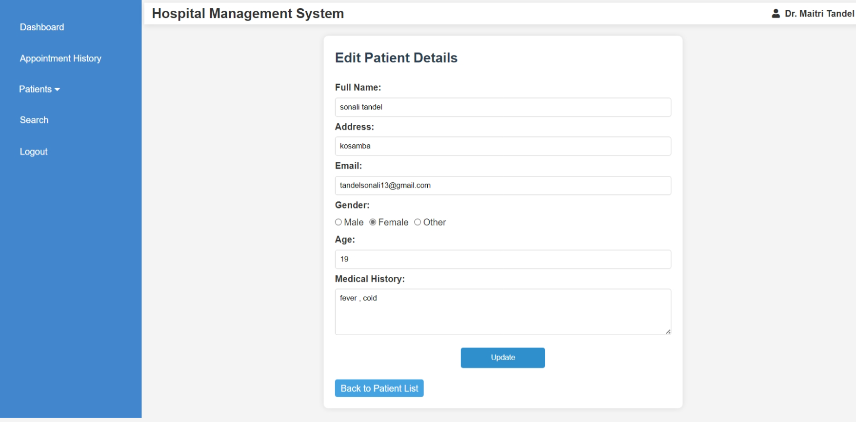

<?php

include("doctor_header.php");

include('database.php');

if (!isset($_SESSION['doctor_id'])) {

    header('Location: doctor_login.php');

    exit;

}

$doctor_id = intval($_SESSION['doctor_id']);

if (!isset($_GET['p_detail_id']) || empty($_GET['p_detail_id'])) {

    echo "<script>alert('Invalid patient ID.'); window.location.href='doctor_dashboard.php';</script>";

    exit;

}

$p_detail_id = intval($_GET['p_detail_id']);

$query = "SELECT * FROM patient_detail WHERE p_detail_id = '$p_detail_id' AND d_id = '$doctor_id'";

$result = mysqli_query($conn, $query);

if (!$result || mysqli_num_rows($result) == 0) {

    echo "<script>alert('Patient not found.'); window.location.href='doctor_dashboard.php';</script>";

    exit;

}

$patient = mysqli_fetch_assoc($result);

if ($_SERVER['REQUEST_METHOD'] == 'POST') {

    $p_name = mysqli_real_escape_string($conn, $_POST['p_name']);

    $p_add = mysqli_real_escape_string($conn, $_POST['p_add']);

    $p_email = mysqli_real_escape_string($conn, $_POST['p_email']);

    $p_gender = mysqli_real_escape_string($conn, $_POST['p_gender']);

    $p_age = intval($_POST['p_age']);

    $p_medhis = mysqli_real_escape_string($conn, $_POST['p_medhis']);

    $update_query = "UPDATE patient_detail SET

                        p_name='$p_name',

                        p_add='$p_add',

                        p_email='$p_email',

                        p_gender='$p_gender',

                        p_age='$p_age',

                        p_medhis='$p_medhis'

                    WHERE p_detail_id='$p_detail_id' AND d_id='$doctor_id'";

    if (mysqli_query($conn, $update_query)) {

        echo "<script>alert('Patient details updated successfully.'); window.location.href='view_patient.php?p_detail_id=$p_detail_id';</script>";

        exit;

    } else {

        echo "<script>alert('Error updating details: " . mysqli_error($conn) . "');</script>";

    }

}

?>

<!DOCTYPE html>

<html lang="en">

<head>

    <meta charset="UTF-8">

    <meta name="viewport" content="width=device-width, initial-scale=1.0">

    <title>Edit Patient</title>

    <style>

        body {

            font-family: Arial, sans-serif;

            background-color: #f4f4f4;

            margin: 0;

            padding: 0;

        }

        section.edit-form {

            width: 50%;

            margin: 20px auto;

            padding: 20px;

            background-color: #fff;

            border-radius: 8px;

            box-shadow: 0 0 10px rgba(0, 0, 0, 0.1);

        }

        h3 {

            color: #2c3e50;

            font-size: 24px;

            margin-bottom: 20px;

        }

        label {

            font-weight: bold;

        }

        input, select, textarea {

            width: 100%;

            padding: 8px;

            margin: 5px 0;

            border: 1px solid #ccc;

            border-radius: 4px;

        }

        input[type="submit"] {

            background-color: rgb(46, 143, 204);

            color: white;

            border: none;

            padding: 10px;

            cursor: pointer;

            border-radius: 4px;

            width: 25%;

            display: block;

            margin: 10px auto; /* Centers the button horizontally */

            text-align: center;

        }

        input[type="submit"]:hover {

            background-color:rgb(39, 118, 174);

        }

        .back-btn {

            display: inline-block;

            background-color:rgb(69, 163, 226);

            color: white;

            padding: 3px 10px;

            text-decoration: none;

            border-radius: 4px;

            margin-top: 10px;

        }

        .gender-options {

            display: flex;

            gap: 10px;

            margin: 5px 0;

            align-items: center;

        }

        .gender-options label {

            display: flex;

            align-items: center;

            font-weight: normal;

        }

        .gender-options input {

            margin-right: 3px;

        }

    </style>

</head>

<body>

<section class="edit-form">

    <h3>Edit Patient Details</h3>

    <form method="POST" action="">

        <label>Full Name:</label>

        <input type="text" name="p_name" value="<?php echo htmlspecialchars($patient['p_name']); ?>" required>

        <label>Address:</label>

        <input type="text" name="p_add" value="<?php echo htmlspecialchars($patient['p_add']); ?>" required>

        <label>Email:</label>

        <input type="email" name="p_email" value="<?php echo htmlspecialchars($patient['p_email']); ?>" required>

        <label>Gender:</label>

        <div class="gender-options">

            <label><input type="radio" name="p_gender" value="Male" <?php if ($patient['p_gender'] == 'Male') echo 'checked'; ?>> Male</label>

            <label><input type="radio" name="p_gender" value="Female" <?php if ($patient['p_gender'] == 'Female') echo 'checked'; ?>> Female</label>

            <label><input type="radio" name="p_gender" value="Other" <?php if ($patient['p_gender'] == 'Other') echo 'checked'; ?>> Other</label>

        </div>

        <label>Age:</label>

        <input type="number" name="p_age" value="<?php echo htmlspecialchars($patient['p_age']); ?>" required>

        <label>Medical History:</label>

        <textarea name="p_medhis" rows="4" required><?php echo htmlspecialchars($patient['p_medhis']); ?></textarea>

        <input type="submit" value="Update">

    </form>

    <a href="manage_patient.php" class="back-btn">Back to Patient List</a>

</section>

</body>

</html>

**Doctor Search Patient**

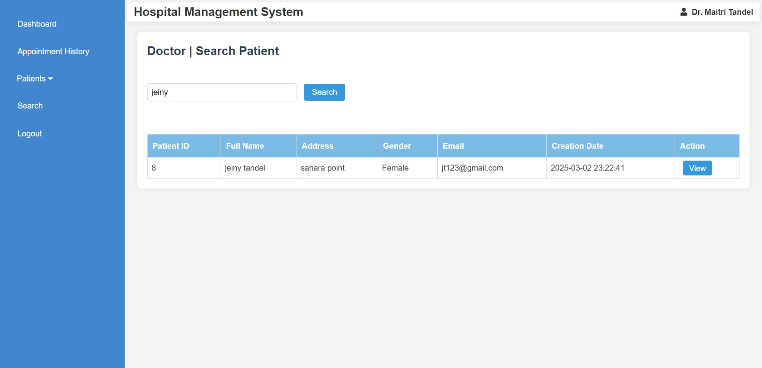<?php

    include("doctor_header.php");

    include('database.php');

    $searchQuery = '';

    if (isset($_POST['search'])) {

        $searchQuery = mysqli_real_escape_string($conn, $_POST['search_query']);

    }

    $query = "SELECT * FROM patient_detail WHERE p_name LIKE '%$searchQuery%' OR p_email LIKE '%$searchQuery%'";

    $result = mysqli_query($conn, $query);

?>

<style>

    body {

        font-family: Arial, sans-serif;

        background-color: #f4f4f4;

        margin: 0;

        padding: 0;

    }

    section.dashboard {

        margin: 20px;

        padding: 20px;

        background-color: #fff;

        border-radius: 8px;

        box-shadow: 0 0 10px rgba(0, 0, 0, 0.1);

    }

    h3 {

        color: #2c3e50;

        font-size: 24px;

        margin-bottom: 20px;

    }

    form {

        margin-bottom: 20px;

    }

    form input[type="text"] {

        padding: 8px;

        font-size: 16px;

        width: 300px;

        margin-right: 10px;

        border: 1px solid #ddd;

        border-radius: 4px;

    }

    form input[type="submit"] {

        padding: 8px 16px;

        background-color: #3498db;

        color: white;

        border: none;

        border-radius: 4px;

        cursor: pointer;

        font-size: 16px;

    }

    form input[type="submit"]:hover {

        background-color: #2980b9;

    }

    table {

        width: 100%;

        border-collapse: collapse;

        margin-top: 20px;

    }

    table, th, td {

        border: 1px solid #ddd;

    }

    th {

        background-color:rgb(121, 187, 230);

        color: white;

        padding: 10px;

        text-align: left;

    }

    td {

        padding: 8px;

        text-align: left;

    }

    td input[type="submit"] {

        background-color: #e74c3c;

        color: white;

        border: none;

        padding: 6px 12px;

        cursor: pointer;

        border-radius: 4px;

        transition: background-color 0.3s ease;

    }

    td input[type="submit"]:hover {

        background-color: #c0392b;

    }

    @media screen and (max-width: 768px) {

        table, th, td {

            font-size: 14px;

        }

        td input[type="submit"] {

            padding: 4px 8px;

        }

    }

</style>

<section class="dashboard">

<h3>Doctor | Search Patient</h3><br>

<form method="POST" action="">

    <input type="text" name="search_query" placeholder="Search by name or email" value="<?php echo $searchQuery; ?>" required>

    <input type="submit" name="search" value="Search">

</form>

<br>

<?php if (isset($_POST['search'])): ?>

    <table border="1">

        <thead>

            <tr>

                <th>Patient ID</th>

                <th>Full Name</th>

                <th>Address</th>

                <th>Gender</th>

                <th>Email</th>

                <th>Creation Date</th>

                <th>Action</th>

            </tr>

        </thead>

        <tbody>

            <?php

            if (mysqli_num_rows($result) > 0) {

                while ($row = mysqli_fetch_assoc($result)) {

                    echo "<tr>

                            <td>{$row['p_detail_id']}</td>

                            <td>{$row['p_name']}</td>

                            <td>{$row['p_add']}</td>

                            <td>{$row['p_gender']}</td>

                            <td>{$row['p_email']}</td>

                            <td>{$row['created_at']}</td>

                            <td>

                                <a href='view_patient.php?p_detail_id={$row['p_detail_id']}' style='background-color: #3498db; color: white; padding: 6px 12px; text-decoration: none; border-radius: 4px; margin-left: 8px;'>View</a>

                            </td>

                        </tr>";

                }

            } else {

                echo "<tr><td colspan='8'>No patients found.</td></tr>";

            }

            ?>

        </tbody>

    </table>

<?php endif; ?>

</section>

</body>

</html>

**Patient Register**

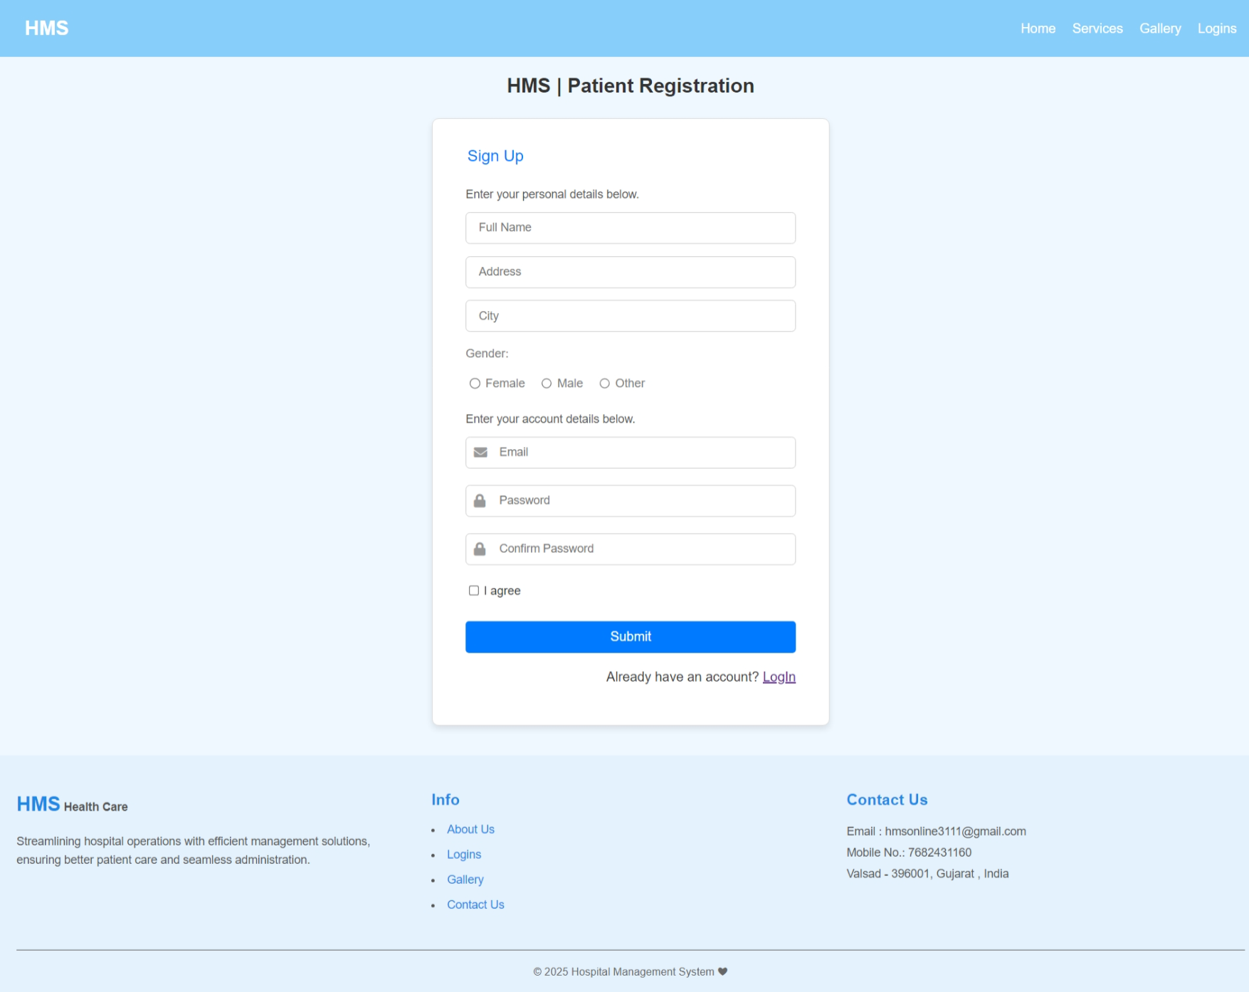

<?php

    session_start();

    include("header.php");

?>

<!DOCTYPE html>

<html lang="en">

<head>

    <meta charset="UTF-8">

    <meta name="viewport" content="width=device-width, initial-scale=1.0">

    <title>HMS | Patient Registration</title>

    <link href="https://cdnjs.cloudflare.com/ajax/libs/font-awesome/5.15.4/css/all.min.css" rel="stylesheet">

    <link rel="stylesheet" href="css/rl_style.css">

</head>

<body>

    <div class="container">

    <h1>HMS | Patient Registration</h1>

        <div class="form-container" style="margin-bottom: 3%;">

            <form action="<?php echo htmlspecialchars($_SERVER["PHP_SELF"])?>" method="POST">

                <fieldset>

                    <legend>Sign Up</legend>

                    <p class="p1">Enter your personal details below.</p>

                    <input type="text" id="fullname" name="fullname" class="input-field" placeholder="Full Name" required>

                    <input type="text" id="address" name="address" class="input-field" placeholder="Address" required>

                    <input type="text" id="city" name="city" class="input-field" placeholder="City" required>

                    <label style="color: grey;">Gender:</label>

                    <div class="radio-group" >

                        <input type="radio" id="female" name="gender" value="Female" required>

                        <label for="female" style="color: grey;">Female</label>

                        <input type="radio" id="male" name="gender" value="Male" required>

                        <label for="male" style="color: grey;">Male</label>

                        <input type="radio" id="other" name="gender" value="Other" required>

                        <label for="other" style="color: grey;">Other</label>

                    </div>

                    <p class="p1">Enter your account details below.</p>

                    <div class="input-group">

                    <label for="email">

                        <i class="fa fa-envelope"></i>

                    </label>

                    <input type="email" id="email" name="email" placeholder="Email" required>

                    </div>

                    <div class="input-group">

                    <label for="password">

                        <i class="fa fa-lock"></i>

                    </label>

                    <input type="password" id="password" name="password" placeholder="Password" required>

                    </div>

                    <div class="input-group">

                        <label for="confirm_password">

                            <i class="fa fa-lock"></i>

                        </label>

                        <input type="password" id="confirm_password" name="confirm_password" placeholder="Confirm Password" required>

                    </div>

                    <div class="checkbox-group">

                        <input type="checkbox" id="agree" name="agree" required>

                        <label for="agree">I agree</label>

                    </div>

                    <button type="submit" class="submit-btn">Submit</button>

                </fieldset>

    <?php

        include("database.php");

        if($_SERVER["REQUEST_METHOD"]=="POST"){

            $fullname =filter_input(INPUT_POST,"fullname",FILTER_SANITIZE_SPECIAL_CHARS);

            $address =filter_input(INPUT_POST,"address",FILTER_SANITIZE_SPECIAL_CHARS);

            $city =filter_input(INPUT_POST,"city",FILTER_SANITIZE_SPECIAL_CHARS);

            $gender =filter_input(INPUT_POST,"gender",FILTER_SANITIZE_SPECIAL_CHARS);

            $email =filter_input(INPUT_POST,"email",FILTER_SANITIZE_SPECIAL_CHARS);

            $password =filter_input(INPUT_POST,"password",FILTER_SANITIZE_SPECIAL_CHARS);

            $password_hash=password_hash($password,PASSWORD_DEFAULT);

            if(empty($_POST["fullname"]) || empty($_POST["email"]) || empty($_POST["address"]) || empty($_POST["city"]) || empty($_POST["gender"]) || empty($_POST["password"])){ echo "";}

            else{

                $sql = "INSERT INTO patient_mast(fullname, address, city, gender, email, password) VALUES ('$fullname', '$address', '$city', '$gender', '$email', '$password_hash')";

                try {

                    mysqli_query($conn, $sql);

                    $patient_id = $conn->insert_id;

                    $_SESSION['patient_id'] = $patient_id;

                    $_SESSION['email'] = $email;

                    $_SESSION['patient_name'] = $fullname;

                    header("Location: index.php");

                } catch (mysqli_sql_exception) {

                    echo "<p style='color:red'>Sign up failed..</p>";

                }

            }

        }

        mysqli_close($conn);

    ?>

    </form>

            <p>Already have an account? <a href="patient_login.php">LogIn</a></p>

        </div>

    </div>

    <?php

        include("footer.php");

    ?>

</body>

</html>

**Patient Login**

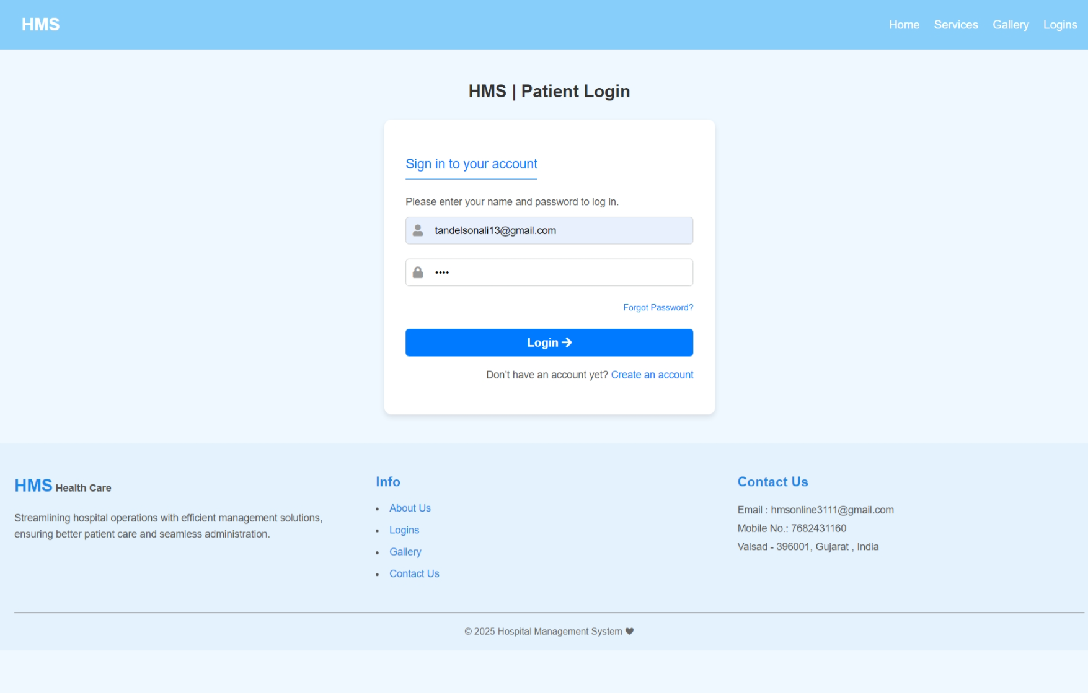<?php

    session_start();

    include("header.php");

?>

<!DOCTYPE html>

<html lang="en">

<head>

    <meta charset="UTF-8">

    <meta name="viewport" content="width=device-width, initial-scale=1.0">

    <title>HMS | Patient Login</title>

    <link href="https://cdnjs.cloudflare.com/ajax/libs/font-awesome/5.15.4/css/all.min.css" rel="stylesheet">

    <link rel="stylesheet" href="css/rl_style.css">

</head>

<body>

    <section class="login-container" style="margin-bottom: -23%;">

    <h1>HMS | Patient Login</h1>

        <div class="login-box" style="margin-bottom: 25%;">

            <form  method="POST" action="<?php echo htmlspecialchars($_SERVER["PHP_SELF"])?>">

                <p class="p2">Sign in to your account</p>

                <p class="p1">Please enter your name and password to log in.</p>

                <div class="input-group">

                    <label for="email">

                        <i class="fa fa-user"></i>

                    </label>

                    <input type="email" id="email" name="email" placeholder="Email" required>

                </div>

                <div class="input-group">

                    <label for="password">

                        <i class="fa fa-lock"></i>

                    </label>

                    <input type="password" id="password" name="password" placeholder="Password" required>

                </div>

                <a href="otp.php" class="forgot-password">Forgot Password?</a>

                <button type="submit" class="login-btn">Login <i class="fa fa-arrow-right"></i></button>

                <p class="register-link">

                    Don’t have an account yet? <a href="patient_register.php">Create an account</a>

                </p>

                <?php

                    include("database.php");

                    if($_SERVER["REQUEST_METHOD"]=="POST")

                    {

                        $email = filter_input(INPUT_POST,"email",FILTER_SANITIZE_SPECIAL_CHARS);

                        $password = filter_input(INPUT_POST,"password",FILTER_SANITIZE_SPECIAL_CHARS);

                        if(!empty($email) && !empty($password))

                        {

                            $sql = "SELECT * FROM patient_mast WHERE email = '$email'";

                            $result = mysqli_query($conn, $sql);

                            if (mysqli_num_rows($result) > 0) {

                                $user = mysqli_fetch_assoc($result);

                                if (password_verify($password, $user["password"])) {

                                    $_SESSION['patient_id']=$user['p_id'];

                                    $_SESSION['email']=$email;

                                    $_SESSION['patient_name']=$user['fullname'];

                                    header("Location:patient_index.php");

                                    exit;

                                } else {

                                    echo "<p style='color:red'>Incorrect password..!</p>";

                                }

                            } else {

                                echo "<p style='color:red'>Invalid email..!</p>";

                            }

                        }

                    }

                    mysqli_close($conn);

                ?>

            </form>

        </div>

    </section>

    <?php

        include("footer.php");

    ?>

</body>

</html>

**Patient Forget Password (OTP on email & Change Password)**

* **Otp**

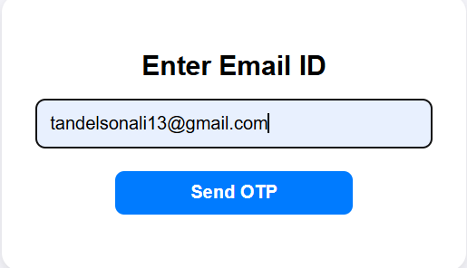 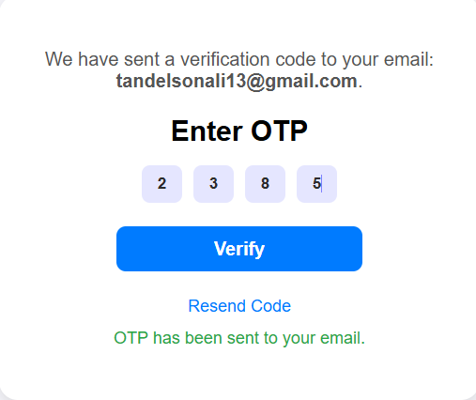 

<?php

include("database.php");

session_start();

use PHPMailer\PHPMailer\PHPMailer;

use PHPMailer\PHPMailer\Exception;

require('./PHPMailer-master/src/Exception.php');

require('./PHPMailer-master/src/PHPMailer.php');

require('./PHPMailer-master/src/SMTP.php');

function sendOtp($email,$otp){

    $mail=new PHPMailer(true);

    try{

        $mail->isSMTP();

        $mail->Host = 'smtp.gmail.com';

        $mail->SMTPAuth = true;

        $mail->Username = 'hmsonline3111@gmail.com';

        $mail->Password = 'qjcqkyuggdcmksbk';

        $mail->SMTPSecure = PHPMailer::ENCRYPTION_STARTTLS;

        $mail->Port = 587;

        $mail->setFrom('hmsonline3111@gmail.com', 'HMS');

        $mail->addAddress($email);

        $mail->isHTML(true);

        $mail->Subject='Recovery Password';

        $mail->Body="OTP: <b>$otp</b>";

        $mail->send();

        return true;

    }catch(Exception $e){

        return false;

    }

}

if ($_SERVER['REQUEST_METHOD'] === 'POST' && isset($_POST['send_otp'])) {

    $email = $_POST['email'];

    if (filter_var($email, FILTER_VALIDATE_EMAIL)) {

        $stmt = $conn->prepare("SELECT email FROM patient_mast WHERE email = ?");

        $stmt->bind_param("s", $email);

        $stmt->execute();

        $result = $stmt->get_result();

        if ($result->num_rows > 0) {

            $_SESSION['email'] = $email;

            $_SESSION['otp'] = rand(1000, 9999);

            if (sendOtp($email, $_SESSION['otp'])) {

                $otp_sent = "OTP has been sent to your email.";

            } else {

                $error = "Failed to send OTP.";

            }

        } else {

            echo "<script>

                    alert('Email not found in our records. Please try again.');

                    window.location.href = 'otp.php';

                  </script>";

            exit;

        }

        $stmt->close();

    } else {

        $error = "Invalid email address. Please try again.";

    }

}

if ($_SERVER['REQUEST_METHOD'] === 'POST' && isset($_POST['verify_otp'])) {

    $enteredOtp = $_POST['otp'];

    if ($enteredOtp == $_SESSION['otp']) {

        unset($_SESSION['otp']);

        header('Location: change_password.php');

        exit;

    } else {

        $error = "Invalid OTP. Please try again.";

    }

}

?>

<!DOCTYPE html>

<html lang="en">

<head>

    <meta charset="UTF-8">

    <meta name="viewport" content="width=device-width, initial-scale=1.0">

    <title>OTP Verification</title>

    <style>

        body {

            font-family: Arial, sans-serif;

            background-color: #f4f4f9;

            margin: 0;

            display: flex;

            justify-content: center;

            align-items: center;

            height: 100vh;

        }

        .otp-modal {

            background-color: #fff;

            border-radius: 16px;

            padding: 30px;

            box-shadow: 0 4px 10px rgba(0, 0, 0, 0.1);

            text-align: center;

            width: 100%;

            max-width: 350px;

            position: relative;

        }

        .otp-close {

            position: absolute;

            top: 15px;

            right: 15px;

            font-size: 18px;

            background: none;

            border: none;

            cursor: pointer;

        }

        .otp-heading {

            font-size: 1.5rem;

            margin-bottom: 15px;

            font-weight: bold;

        }

        .otp-subheading {

            font-size: 1rem;

            color: #555;

            margin-bottom: 20px;

        }

        .otp-input-container {

            width: 100%;

            display: flex;

            flex-direction: row;

            gap: 10px;

            align-items: center;

            justify-content: center;

            margin-bottom: 20px;

            }

        .otp-input {

            background-color: rgb(228, 228, 228);

            width: 30px;

            height: 30px;

            text-align: center;

            border: none;

            border-radius: 7px;

            caret-color: rgb(127, 129, 255);

            color: rgb(44, 44, 44);

            outline: none;

            font-weight: 600;

            }

        .otp-input:focus,

        .otp-input:valid {

            background-color: rgba(127, 129, 255, 0.199);

            transition-duration: .3s;

        }

        .otp-email {

                width: 100%;

                padding: 12px;

                font-size: 1rem;

                border: 1px solid #ccc;

                border-radius: 8px;

        }

        .otp-button {

                width: 60%;

                padding: 10px;

                background-color:#007bff;

                color: #fff;

                border: none;

                border-radius: 8px;

                font-size: 1rem;

                font-weight: bold;

                cursor: pointer;

                transition: background-color 0.3s ease;

                margin-bottom: 20px;

        }

        .otp-button:hover {

                background-color:#0056b3;

        }

        .otp-resend {

                margin-top: 15px;

                font-size: 0.9rem;

                color: #007bff;

                text-decoration: none;

                cursor: pointer;

        }

        .otp-resend:hover {

                text-decoration: underline;

        }

        .otp-error {

                color: #dc3545;

                font-size: 0.9rem;

                margin-top: 10px;

        }

    </style>

</head>

<body>

    <div class="otp-modal">

        <?php if (!isset($_POST['send_otp'])): ?>

            <form method="POST">

                <h2 class="otp-heading">Enter Email ID</h2>

                <div class="otp-input-container">

                    <input type="email" name="email" class="otp-email" placeholder="example@mail.xyz" required>

                </div>

                <button type="submit" name="send_otp" class="otp-button">Send OTP</button>

            </form>

        <?php else: ?>

            <p class="otp-subheading">We have sent a verification code to your email: <strong><?php echo htmlspecialchars($_SESSION['email']); ?></strong>.</p>

            <form method="POST">

                <h2 class="otp-heading">Enter OTP</h2>

                <div class="otp-input-container">

                    <input type="text" maxlength="1" name="otp_digit[]" class="otp-input" required>

                    <input type="text" maxlength="1" name="otp_digit[]" class="otp-input" required>

                    <input type="text" maxlength="1" name="otp_digit[]" class="otp-input" required>

                    <input type="text" maxlength="1" name="otp_digit[]" class="otp-input" required>

                </div>

                <input type="hidden" name="otp" id="otp" value="">

                <button type="submit" name="verify_otp" class="otp-button" onclick="combineOtp()">Verify</button>

            </form>

            <a href="#" class="otp-resend">Resend Code</a>

        <?php endif; ?>

        <?php if (isset($error)): ?>

            <p class="otp-error"><?php echo $error; ?></p>

        <?php elseif (isset($otp_sent)): ?>

            <p class="otp-error" style="color: #28a745;"><?php echo $otp_sent; ?></p>

        <?php endif; ?>

    </div>

    <script>

        function combineOtp() {

            const inputs = document.querySelectorAll('.otp-input');

            const otpField = document.getElementById('otp');

            otpField.value = Array.from(inputs).map(input => input.value).join('');

        }

    </script>

</body>

</html>

* **Change Password**

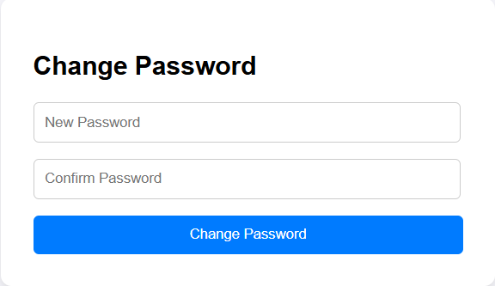

<?php

session_start();

if (!isset($_SESSION['email'])) {

    header('Location: otp.php');

    exit;

}

if ($_SERVER['REQUEST_METHOD'] === 'POST' && isset($_POST['change_password'])) {

    $new_password = $_POST['new_password'];

    $confirm_password = $_POST['confirm_password'];

    if ($new_password === $confirm_password) {

        $hashed_password = password_hash($new_password, PASSWORD_BCRYPT);

        $email = $_SESSION['email'];

        include("database.php");

        $stmt = $conn->prepare("UPDATE patient_mast SET password = ? WHERE email = ?");

        $stmt->bind_param('ss', $hashed_password, $email);

        if ($stmt->execute()) {

            unset($_SESSION['email']);

            $success = "Password changed successfully. You can now <a href='logins.php'>log in</a>";

        } else {

            $error = "Failed to update password.";

        }

        $stmt->close();

        $conn->close();

    } else {

        $error = "Passwords do not match.";

    }

}

?>

<!DOCTYPE html>

<html lang="en">

<head>

    <meta charset="UTF-8">

    <meta name="viewport" content="width=device-width, initial-scale=1.0">

    <title>Change Password</title>

    <style>

        body {

            font-family: Arial, sans-serif;

            display: flex;

            justify-content: center;

            align-items: center;

            height: 100vh;

            background-color: #f4f4f9;

        }

        .form-container {

            background: white;

            padding: 30px;

            border-radius: 10px;

            box-shadow: 0 4px 8px rgba(0, 0, 0, 0.1);

            width: 100%;

            max-width: 400px;

        }

        .form-container h2 {

            margin-bottom: 20px;

        }

        .form-container input {

            width: 94%;

            padding: 10px;

            margin-bottom: 15px;

            border: 1px solid #ccc;

            border-radius: 5px;

        }

        .form-container button {

            width: 100%;

            padding: 10px;

            background-color: #007bff;;

            color: white;

            border: none;

            border-radius: 5px;

            cursor: pointer;

        }

        .form-container button:hover {

            background-color:rgb(67, 72, 177);

        }

        .error, .success {

            color: red;

            font-size: 0.9rem;

        }

        .success {

            color: green;

        }

    </style>

</head>

<body>

    <div class="form-container">

        <h2>Change Password</h2>

        <form method="POST">

            <input type="password" name="new_password" placeholder="New Password" required>

            <input type="password" name="confirm_password" placeholder="Confirm Password" required>

            <button type="submit" name="change_password">Change Password</button>

        </form>

        <?php if (isset($error)): ?>

            <p class="error"><?php echo $error; ?></p>

        <?php elseif (isset($success)): ?>

            <p class="success"><?php echo $success; ?></p>

        <?php endif; ?>

    </div>

</body>

</html>

**Patient Account**

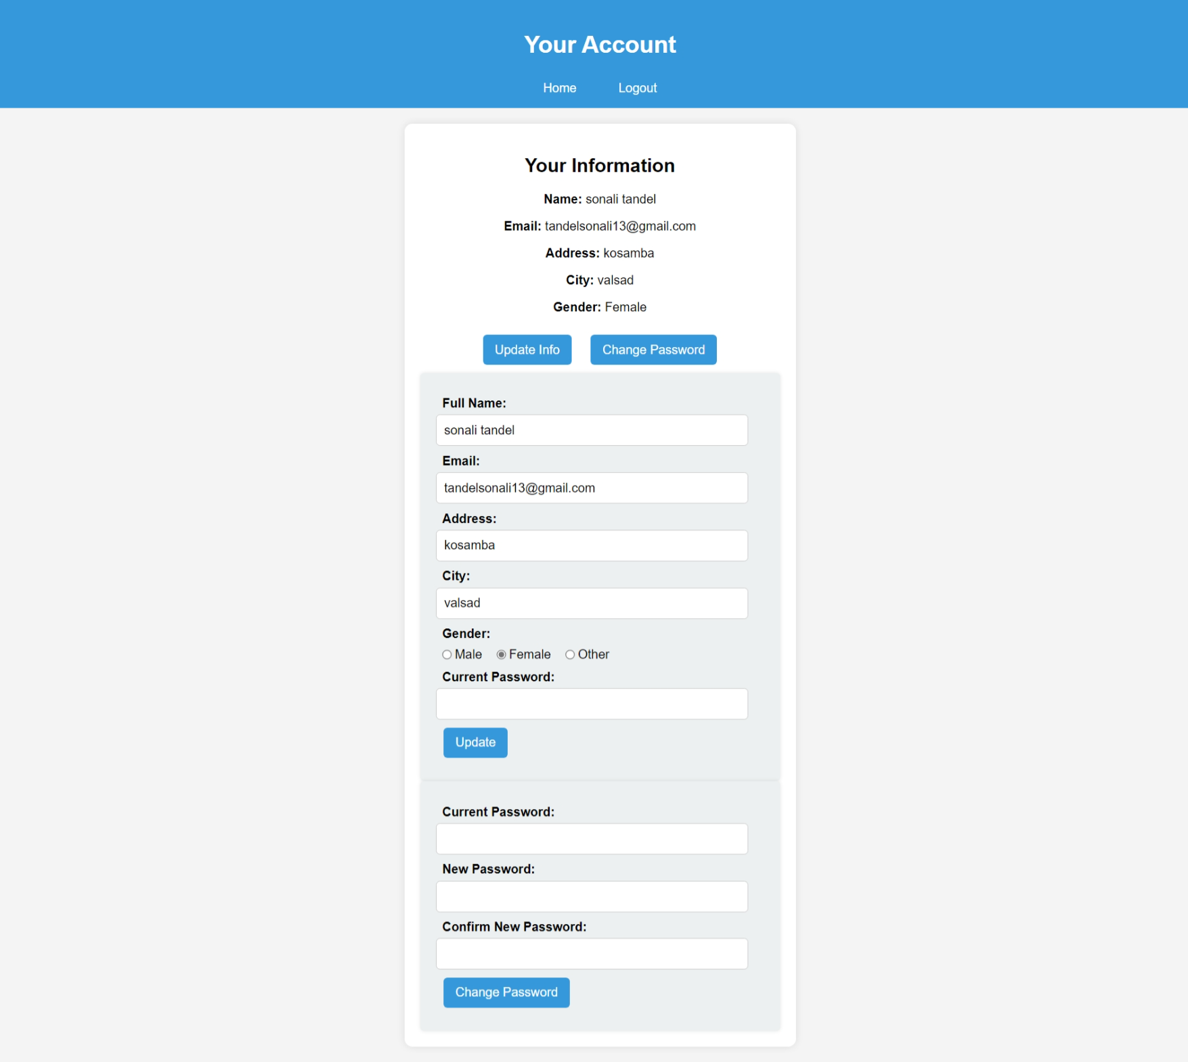

<?php

session_start();

include("database.php");

if (!isset($_SESSION['patient_id'])) {

    header("Location: patient_login.php");

    exit();

}

$patient_id = $_SESSION['patient_id'];

$query = "SELECT * FROM patient_mast WHERE p_id = '$patient_id'";

$result = mysqli_query($conn, $query);

if ($result && mysqli_num_rows($result) > 0) {

    $patient = mysqli_fetch_assoc($result);

} else {

    die("Patient not found.");

}

$message = "";

if ($_SERVER["REQUEST_METHOD"] == "POST" && isset($_POST['update'])) {

    $name = trim($_POST['fullname']);

    $new_email = trim($_POST['email']);

    $password = trim($_POST['password']);

    $address = trim($_POST['address']);

    $city = trim($_POST['city']);

    $gender = trim($_POST['gender']);

    $name = mysqli_real_escape_string($conn, $name);

    $new_email = mysqli_real_escape_string($conn, $new_email);

    $password = mysqli_real_escape_string($conn, $password);

    $address = mysqli_real_escape_string($conn, $address);

    $city = mysqli_real_escape_string($conn, $city);

    $gender = mysqli_real_escape_string($conn, $gender);

    if (password_verify($password, $patient['password'])) {

        $update_query = "UPDATE patient_mast SET fullname='$name', email='$new_email', address='$address', city='$city', gender='$gender' WHERE p_id='$patient_id'";

        if (mysqli_query($conn, $update_query)) {

            echo "<script>alert('Account details updated successfully!'); window.location.href='patient_account.php';</script>";

            exit();

        } else {

            echo "<script>alert('Error updating account details.');</script>";

        }

    } else {

        echo "<script>alert('Incorrect password. Please try again.');</script>";

    }

}

if ($_SERVER["REQUEST_METHOD"] == "POST" && isset($_POST['change_password'])) {

    $password = trim($_POST['password']);

    $new_password = trim($_POST['new_password']);

    $confirm_password = trim($_POST['confirm_password']);

    if (password_verify($password, $patient['password'])) {

        if ($new_password === $confirm_password) {

            $hashed_new_password = password_hash($new_password, PASSWORD_DEFAULT);

            $update_query = "UPDATE patient_mast SET password='$hashed_new_password' WHERE p_id='$patient_id'";

            if (mysqli_query($conn, $update_query)) {

                echo "<script>alert('Password updated successfully!'); window.location.href='patient_account.php';</script>";

                exit();

            } else {

                echo "<script>alert('Error updating password.');</script>";

            }

        } else {

            echo "<script>alert('New passwords do not match!');</script>";

        }

    } else {

        echo "<script>alert('Incorrect current password!');</script>";

    }

}

?>

<!DOCTYPE html>

<html lang="en">

<head>

    <meta charset="UTF-8">

    <meta name="viewport" content="width=device-width, initial-scale=1.0">

    <title>Patient Account</title>

    <style>

        body {

            font-family: Arial, sans-serif;

            background-color: #f4f4f4;

            margin: 0;

            padding: 0;

        }

        header {

            background-color: #3498db;

            color: white;

            padding: 15px;

            text-align: center;

            font-size: 20px;

        }

        nav {

            margin-top: 10px;

        }

        nav a {

            color: white;

            text-decoration: none;

            margin: 0 10px;

            font-size: 16px;

        }

        .container {

            width: 30%;

            background-color: white;

            margin: 20px auto;

            padding: 20px;

            border-radius: 10px;

            box-shadow: 0 0 10px rgba(0, 0, 0, 0.1);

        }

        .sec {

            text-align: center;

        }

        .btn {

            background-color: #3498db;

            color: white;

            border: none;

            padding: 10px 15px;

            border-radius: 5px;

            cursor: pointer;

            font-size: 16px;

            margin: 10px;

        }

        .btn:hover {

            background-color: #2980b9;

        }

        .form-section {

            display: none;

            padding: 20px;

            background-color: #ecf0f1;

            border-radius: 5px;

            box-shadow: 0 0 5px rgba(0, 0, 0, 0.1);

            text-align: left;

        }

        .form-section label {

            display: block;

            text-align: left;

            font-weight: bold;

            margin-top: 10px;

            margin-left: 2%;

        }

        .radio-group {

            display: flex;

            align-items: center;

            gap:10px; /* Space between Male and Female */

        }

        .radio-group label {

            display: flex;

            align-items: center;

            gap: 3px;

            margin: 0;

            margin-left: 2%;

            margin-top: 2%;

            font-weight: lighter;

        }

        .radio-group input[type="radio"] {

            margin: 0;

            padding: 0;

        }

        input, select {

            width: 90%;

            padding: 10px;

            margin-top: 5px;

            border: 1px solid #ccc;

            border-radius: 5px;

            font-size: 16px;

        }

    </style>

</head>

<body>

    <header>

        <h2>Your Account</h2>

        <nav>

            <a href="patient_index.php">Home</a>&nbsp;&nbsp;&nbsp;&nbsp;&nbsp;

            <a href="logout.php">Logout</a>

        </nav>

    </header>

    <div class="container">

        <section class="sec">

            <h2>Your Information</h2>

            <p><strong>Name:</strong> <?php echo htmlspecialchars($patient['fullname']); ?></p>

            <p><strong>Email:</strong> <?php echo htmlspecialchars($patient['email']); ?></p>

            <p><strong>Address:</strong> <?php echo htmlspecialchars($patient['address']); ?></p>

            <p><strong>City:</strong> <?php echo htmlspecialchars($patient['city']); ?></p>

            <p><strong>Gender:</strong> <?php echo htmlspecialchars($patient['gender']); ?></p>

            <?php if ($message): ?>

                <p style="color: red;"><?php echo $message; ?></p>

            <?php endif; ?>

            <button class="btn" onclick="toggleForm('update-info-form')">Update Info</button>

            <button class="btn" onclick="toggleForm('change-password-form')">Change Password</button>

            <form method="POST" id="update-info-form" class="form-section">

                <label>Full Name:</label>

                <input type="text" name="fullname" value="<?php echo htmlspecialchars($patient['fullname']); ?>" required>

                <label>Email:</label>

                <input type="email" name="email" value="<?php echo htmlspecialchars($patient['email']); ?>" required>

                <label>Address:</label>

                <input type="text" name="address" value="<?php echo htmlspecialchars($patient['address']); ?>" required>

                <label>City:</label>

                <input type="text" name="city" value="<?php echo htmlspecialchars($patient['city']); ?>" required>

                <label>Gender:</label>

                <div class="radio-group">

                    <label><input type="radio" name="gender" value="Male" <?php if ($patient['gender'] == 'Male') echo 'checked'; ?>>Male</label>

                    <label><input type="radio" name="gender" value="Female" <?php if ($patient['gender'] == 'Female') echo 'checked'; ?>>Female</label>

                    <label><input type="radio" name="gender" value="Other" <?php if ($patient['gender'] == 'Other') echo 'checked'; ?>>Other</label>

                </div>

                <label>Current Password:</label>

                <input type="password" name="password" required>

                <button type="submit" class="btn" name="update">Update</button>

            </form>

            <form method="POST" id="change-password-form" class="form-section">

                <label>Current Password:</label>

                <input type="password" name="password" required>

                <label>New Password:</label>

                <input type="password" name="new_password" required>

                <label>Confirm New Password:</label>

                <input type="password" name="confirm_password" required>

                <button type="submit" class="btn" name="change_password">Change Password</button>

            </form>

        </section>

    </div>

    <script>

        function toggleForm(formId) {

            var form = document.getElementById(formId);

            form.style.display = form.style.display === "block" ? "none" : "block";

        }

    </script>

</body>

</html>

**Patient Header**

<?php

    include('database.php');

    if (!isset($_SESSION['patient_id'])) {

        header('Location: patient_login.php');

        exit;

    }

    $patient_name = $_SESSION['patient_name'];

?>

<!DOCTYPE html>

<html lang="en">

<head>

    <meta charset="UTF-8">

    <meta name="viewport" content="width=device-width, initial-scale=1.0">

    <title>Hospital Management System</title>

    <link rel="website icon" href="img/logo1.jpg" type="jpg">

    <link href="https://cdnjs.cloudflare.com/ajax/libs/font-awesome/5.15.4/css/all.min.css" rel="stylesheet">

    <link rel="stylesheet" href="css/style.css">

    <style>

        * {

        margin: 0;

        padding: 0;

        box-sizing: border-box;

        font-family: Arial, sans-serif;

        }

        body {

            display: flex;

            background-color: #f0f8ff;

        }

        .sidebar {

            width: 250px;

            height: 100vh;

            background:rgb(66, 134, 206);

            color: white;

            padding: 20px;

        }

        .sidebar h2 {

            text-align: center;

            margin-bottom: 20px;

        }

        .sidebar ul {

            list-style: none;

            padding: 0;

        }

        .sidebar ul li {

            padding: 15px;

        }

        .sidebar ul li a {

            color: white;

            text-decoration: none;

            display: block;

        }

        .sidebar ul li a:hover {

            background:rgb(94, 142, 193);

            border-radius: 5px;

        }

        .main-content {

            flex: 1;

            padding:5px;

        }

        header {

            display: flex;

            justify-content: space-between;

            align-items: center;

            background: white;

            box-shadow: 0px 2px 10px rgba(0, 0, 0, 0.1);

        }

        .dashboard {

            margin-top: 20px;

        }

        .cards {

            display: flex;

            justify-content: space-evenly;

            gap: 15px;

        }

        .card {

            background: white;

            padding: 20px;

            text-align: center;

            width: 30%;

            border-radius: 10px;

            box-shadow: 0px 4px 10px rgba(0, 0, 0, 0.1);

        }

        .card img {

            width: 50px;

            margin-bottom: 10px;

        }

        .card a {

            display: block;

            margin-top: 10px;

            color:rgb(50, 128, 210);

            text-decoration: none;

        }

        .card a:hover {

            text-decoration: underline;

        }

    </style>

</head>

<body>

    <div class="sidebar">

        <ul>

            <li><a href="patient_index.php">Dashboard</a></li>

            <li><a href="book_appointment.php">Book Appointment</a></li>

            <li><a href="appointment_history.php">Appointment History</a></li>

            <li><a href="medical_history.php">Medical History</a></li>

            <li><a href="logout.php" onclick="confirmLogout()">Logout</a></li>

            <script>

                function confirmLogout() {

                    if (confirm("Are you sure you want to log out?")) {

                        window.location.href = "logout.php";

                    }

                }

            </script>

        </ul>

    </div>

    <div class="main-content">

        <header>

            <h2>&nbsp;&nbsp;Hospital Management System</h2>

            <div class="user-info" style="font-weight: bold; margin-right:1%;">

            <i class="fas fa-user"></i>&nbsp;&nbsp;<?php echo $patient_name; ?>

            </div>

        </header>

**Patient Dashboard**

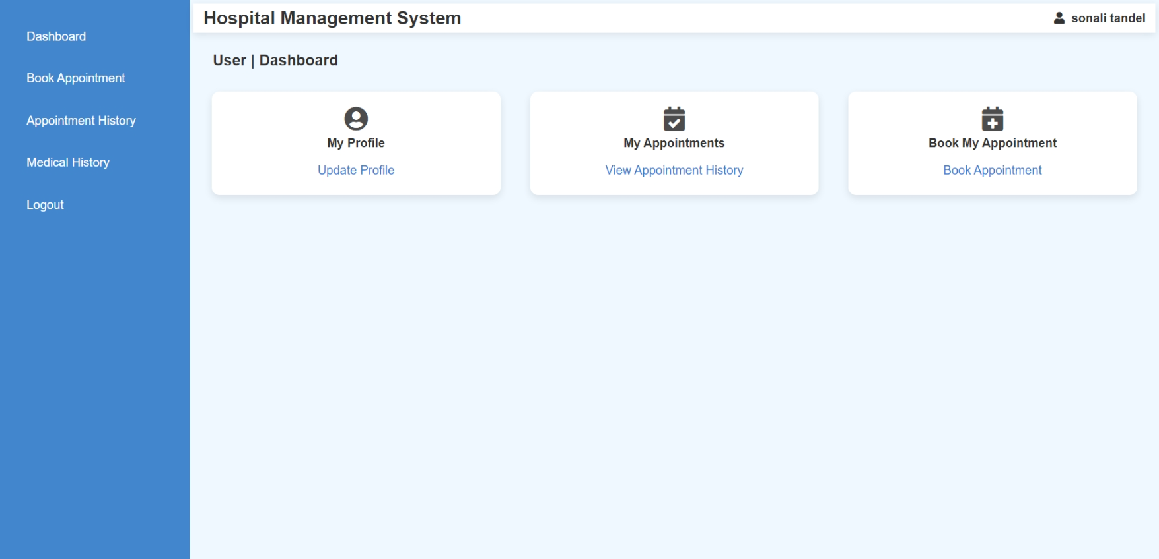

<?php

    session_start();

    include('database.php');

    if(isset($_SESSION['patient_name'])){

        $patient_name = $_SESSION['patient_name'];

    }

    else{

        header('location:patient_login.php');

    }

?>

<?php

    include("patient_header.php");

?>

            <section class="dashboard">

            <h3 style="margin-left: 2%; font-size:20px;">User | Dashboard</h3><br>

            <div class="cards">

                <div class="card">

                    <i class="fas fa-user-circle fa-2x" style="opacity: 0.9;"></i><br>

                    <h4>My Profile</h4>

                    <a href="patient_account.php">Update Profile</a>

                </div>

                <div class="card">

                    <i class="fas fa-calendar-check fa-2x" style="opacity: 0.9;"></i>

                    <h4>My Appointments</h4>

                    <a href="appointment_history.php">View Appointment History</a>

                </div>

                <div class="card">

                    <i class="fas fa-calendar-plus fa-2x" style="opacity: 0.9;"></i>

                    <h4>Book My Appointment</h4>

                    <a href="book_appointment.php">Book Appointment</a>

                </div>

            </div>

        </section>

    </div>

</body>

</html>

**Patient Book Appointment**

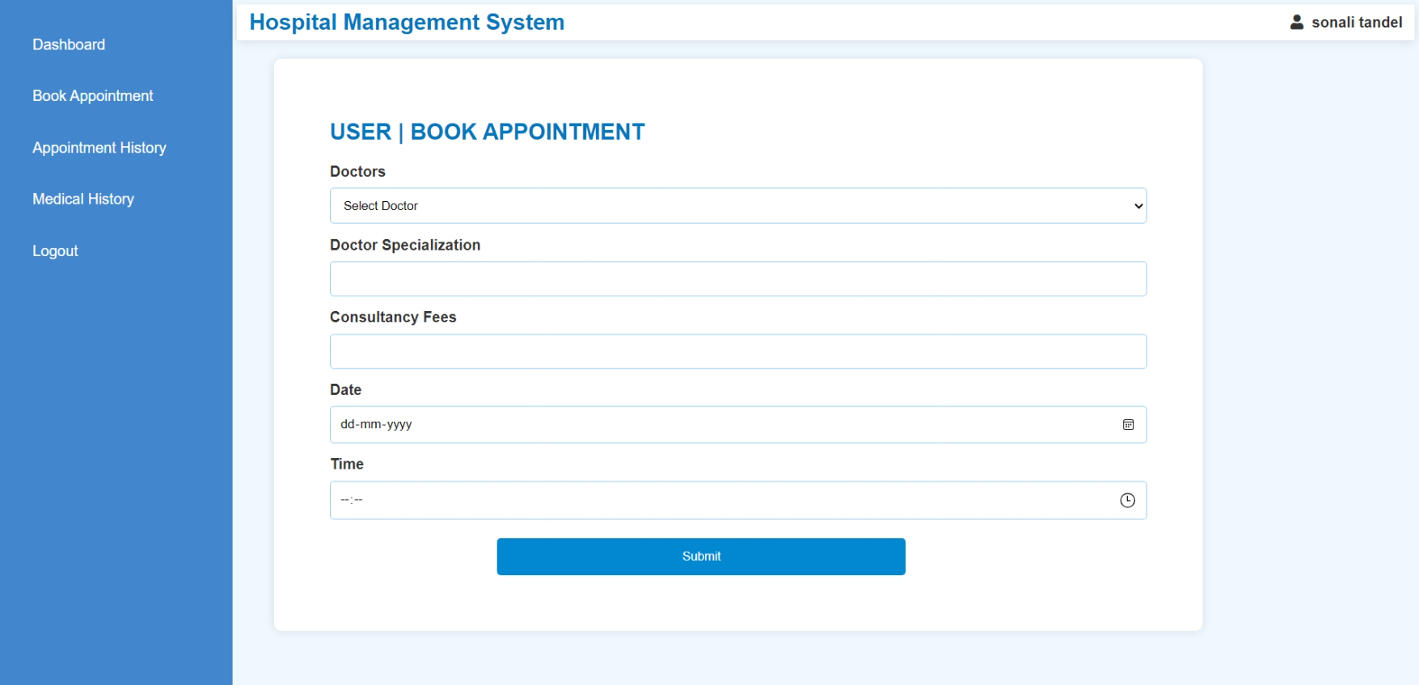

<?php

session_start();

include('database.php');

if (!isset($_SESSION['patient_id'])) {

    header('location:patient_login.php');

    exit;

}

$patient_id = $_SESSION['patient_id'];

$message = "";

if ($_SERVER['REQUEST_METHOD'] === 'POST') {

    $doctor_id = mysqli_real_escape_string($conn, $_POST['doctor']);

    $specialization = mysqli_real_escape_string($conn, $_POST['specialization']);

    $docfees = mysqli_real_escape_string($conn, $_POST['docfees']);

    $date = mysqli_real_escape_string($conn, $_POST['date']);

    $time = mysqli_real_escape_string($conn, $_POST['time']);

    if (!empty($doctor_id) && !empty($specialization) && !empty($docfees) && !empty($date) && !empty($time)) {

        $min_time = "10:00";

        $max_time = "17:00";

        if ($time < $min_time || $time > $max_time) {

            $message = "<p style='color: red; text-align: center;'>Appointments can only be booked between 10:00 AM and 5:00 PM.</p>";

        } else {

            $checkQuery = "SELECT * FROM appointment

                           WHERE d_id='$doctor_id'

                           AND a_date='$date'

                           AND ABS(TIMESTAMPDIFF(MINUTE, STR_TO_DATE(a_time, '%H:%i'), STR_TO_DATE('$time', '%H:%i'))) < 15";

            $result = mysqli_query($conn, $checkQuery);

            if (mysqli_num_rows($result) > 0) {

                $message = "<p style='color: red; text-align: center;'>This doctor is already booked within 15 minutes of the selected time. Please choose another time.</p>";

            } else {

                $insertQuery = "INSERT INTO appointment (specilization, d_id, p_id, fees, a_date, a_time, userstatus, d_status)

                                VALUES ('$specialization', '$doctor_id', '$patient_id', '$docfees', '$date', '$time', 1, 0)";

                if (mysqli_query($conn, $insertQuery)) {

                    $message = "<p style='color: green; text-align: center;'>Appointment successfully booked.</p>";

                } else {

                    $message = "<p style='color: red; text-align: center;'>Error booking appointment: " . mysqli_error($conn) . "</p>";

                }

            }

        }

    } else {

        $message = "<p style='color: red; text-align: center;'>All fields are required.</p>";

    }

}

?>

<!DOCTYPE html>

<html lang="en">

<head>

    <meta charset="UTF-8">

    <meta name="viewport" content="width=device-width, initial-scale=1.0">

    <title>Book Appointment</title>

    <link rel="stylesheet" href="styles.css">

    <style>

        .form-container {

            margin-left: 40px;

            margin-top: 20px;

            background: white;

            padding: 60px;

            border-radius: 8px;

            box-shadow: 0px 0px 10px rgba(0, 0, 0, 0.1);

            width: 1000px;

        }

        h2 {

            color: #0277bd;

        }

        label {

            display: block;

            margin-top: 10px;

            font-weight: bold;

            text-align: left;

        }

        select, input {

            width: 100%;

            padding: 10px;

            margin-top: 5px;

            border: 1px solid #90caf9;

            border-radius: 4px;

        }

        button {

            width: 50%;

            padding: 12px;

            background: #0288d1;

            color: white;

            border: none;

            border-radius: 4px;

            margin-left: 20.50%;

            margin-top: 20px;

            cursor: pointer;

        }

        button:hover {

            background: #01579b;

        }

        .message {

            text-align: center;

            font-size: 16px;

            margin-top: 10px;

        }

    </style>

</head>

<body>

<?php include("patient_header.php"); ?>

<div class="form-container">

    <h2>USER | BOOK APPOINTMENT</h2>

    <?php echo $message; ?>

    <form method="POST" action="" onsubmit="return validateTime()">

        <label>Doctors</label>

        <select name="doctor" id="doctor" required>

            <option value="">Select Doctor</option>

            <?php

            $doctorQuery = "SELECT d_id, name, specilization, docfees FROM doctor_mast";

            $doctorResult = mysqli_query($conn, $doctorQuery);

            if ($doctorResult && mysqli_num_rows($doctorResult) > 0) {

                while ($row = mysqli_fetch_assoc($doctorResult)) {

                    echo "<option value='{$row['d_id']}' data-specialization='{$row['specilization']}' data-fees='{$row['docfees']}'>{$row['name']}</option>";

                }

            } else {

                echo "<option disabled>No doctors available</option>";

            }

            ?>

        </select>

        <label>Doctor Specialization</label>

        <input type="text" id="specialization" name="specialization" readonly>

        <label>Consultancy Fees</label>

        <input type="text" id="docfees" name="docfees" readonly>

        <label>Date</label>

        <input type="date" name="date" required min="<?php echo date('Y-m-d'); ?>">

        <label>Time</label>

        <input type="time" name="time" id="time" required min="10:00" max="17:00">

        <button type="submit">Submit</button>

    </form>

</div>

<script>

    document.getElementById("doctor").addEventListener("change", function() {

        let selectedDoctor = this.options[this.selectedIndex];

        document.getElementById("specialization").value = selectedDoctor.getAttribute("data-specialization") || "";

        document.getElementById("docfees").value = selectedDoctor.getAttribute("data-fees") || "";

    });

    function validateTime() {

        let timeInput = document.getElementById("time").value;

        let minTime = "10:00";

        let maxTime = "17:00";

        if (timeInput < minTime || timeInput > maxTime) {

            alert("Appointments can only be booked between 10:00 AM and 5:00 PM.");

            return false;

        }

        return true;

    }

</script>

</body>

</html>

**Patient Appointment History**

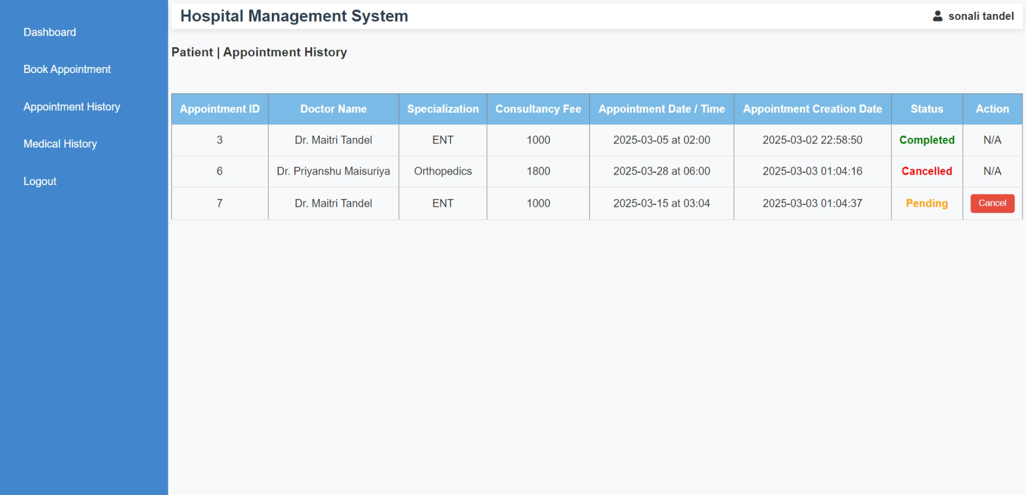

<?php

session_start();

include('database.php');

if (!isset($_SESSION['patient_id'])) {

    echo "<p>Error: Patient ID not found in session.</p>";

    exit;

}

$p_id = $_SESSION['patient_id'];

if (isset($_POST['cancel']) && isset($_POST['a_id'])) {

    $a_id = mysqli_real_escape_string($conn, $_POST['a_id']);

    $query = "UPDATE appointment SET d_status = 2 WHERE a_id = '$a_id' AND p_id = '$p_id'";

    $result = mysqli_query($conn, $query);

    if ($result) {

        echo "<script>alert('Appointment cancelled successfully.'); window.location.href='appointment_history.php';</script>";

    } else {

        echo "<p>Error cancelling appointment: " . mysqli_error($conn) . "</p>";

    }

}

$query = "SELECT a.a_id, d.name AS doctor_name, d.specilization AS specialization, d.docfees AS fees,

                 a.a_date, a.a_time, a.postingdate AS created_at, a.d_status

          FROM appointment a

          JOIN doctor_mast d ON a.d_id = d.d_id

          WHERE a.p_id = '$p_id'";

$result = mysqli_query($conn, $query);

?>

<?php include("patient_header.php"); ?>

<!DOCTYPE html>

<html lang="en">

<head>

    <meta charset="UTF-8">

    <meta name="viewport" content="width=device-width, initial-scale=1.0">

    <title>Appointment History</title>

    <link rel="stylesheet" href="styles.css">

    <style>

        body {

            font-family: Arial, sans-serif;

            background-color: #f8f9fa;

            margin: 0;

            padding: 0;

        }

        .container {

            width: 80%;

            margin: 20px auto;

            background: white;

            padding: 20px;

            border-radius: 8px;

            box-shadow: 0 0 10px rgba(0, 0, 0, 0.1);

        }

        h2 {

            color: #2c3e50;

            text-align: center;

        }

        table {

            width: 100%;

            border-collapse: collapse;

            margin-top: 20px;

        }

        th, td {

            padding: 10px;

            text-align: center;

            border-bottom: 1px solid #ddd;

        }

        th {

            background-color: rgb(121, 187, 230);

            color: white;

        }

        .cancel-btn {

            background-color: #e74c3c;

            color: white;

            border: none;

            padding: 6px 12px;

            cursor: pointer;

            border-radius: 4px;

            transition: background-color 0.3s ease;

            text-decoration: none;

        }

        .cancel-btn:hover {

            background-color: #c0392b;

        }

        .status-pending {

            color: orange;

            font-weight: bold;

        }

        .status-completed {

            color: green;

            font-weight: bold;

        }

        .status-cancelled {

            color: red;

            font-weight: bold;

        }

    </style>

</head>

<body>

<section class="dashboard">

<h3>Patient | Appointment History</h3><br>

<table border="1">

    <thead>

        <tr>

            <th>Appointment ID</th>

            <th>Doctor Name</th>

            <th>Specialization</th>

            <th>Consultancy Fee</th>

            <th>Appointment Date / Time</th>

            <th>Appointment Creation Date</th>

            <th>Status</th>

            <th>Action</th>

        </tr>

    </thead>

    <tbody>

        <?php

        if (mysqli_num_rows($result) > 0) {

            while ($row = mysqli_fetch_assoc($result)) {

                $status = "";

                $status_class = "";

                if ($row['d_status'] == 0) {

                    $status = "Pending";

                    $status_class = "status-pending";

                } elseif ($row['d_status'] == 1) {

                    $status = "Completed";

                    $status_class = "status-completed";

                } elseif ($row['d_status'] == 2) {

                    $status = "Cancelled";

                    $status_class = "status-cancelled";

                }

                echo "<tr>

                        <td>{$row['a_id']}</td>

                        <td>{$row['doctor_name']}</td>

                        <td>{$row['specialization']}</td>

                        <td>{$row['fees']}</td>

                        <td>{$row['a_date']} at {$row['a_time']}</td>

                        <td>{$row['created_at']}</td>

                        <td class='{$status_class}'>{$status}</td>

                        <td>";

                if ($row['d_status'] == 0) {

                    echo "<form method='POST' action='' onsubmit='return confirmDelete()'>

                              <input type='hidden' name='a_id' value='{$row['a_id']}'>

                              <input type='submit' class='cancel-btn' name='cancel' value='Cancel'>

                          </form>";

                } else {

                    echo "N/A";

                }

                echo "</td></tr>";

            }

        } else {

            echo "<tr><td colspan='8'>No Appointment Found.</td></tr>";

        }

        ?>

    </tbody>

</table>

</section>

<script>

    function confirmDelete() {

        return confirm('Are you sure you want to cancel this appointment?');

    }

</script>

</body>

</html>

**Patient Medical History**

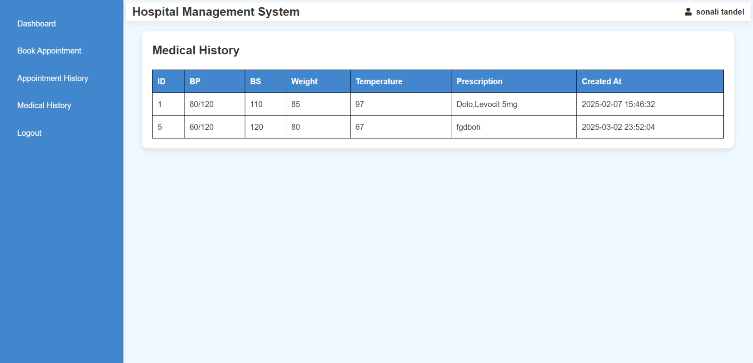

<?php

session_start();

include("database.php");

$p_id = (int)$_SESSION['patient_id'];

$sql_history = "SELECT * FROM medical_history WHERE p_detail_id = $p_id";

$result_history = $conn->query($sql_history);

?>

<?php

include("patient_header.php");

?>

<!DOCTYPE html>

<html lang="en">

<head>

    <meta charset="UTF-8">

    <meta name="viewport" content="width=device-width, initial-scale=1.0">

    <title>Medical History</title>

    <style>

        body {

            font-family: Arial, sans-serif;

            background-color: #f0f8ff;

            margin: 0;

            padding: 0;

        }

        .container {

            width: 98%;

            margin: 20px auto;

            background: white;

            padding: 20px;

            border-radius: 10px;

            box-shadow: 0px 4px 10px rgba(0, 0, 0, 0.1);

        }

        table {

            width: 100%;

            border-collapse: collapse;

            margin-top: 20px;

        }

        table, th, td {

            border: 1px solid black;

        }

        th, td {

            padding: 10px;

            text-align: left;

        }

        th {

            background-color: rgb(66, 134, 206);

            color: white;

        }

        .status {

            font-weight: bold;

        }

        .completed { color: green; }

        .pending { color: orange; }

        .cancelled { color: red; }

        .status-form select {

            padding: 5px;

        }

        .status-form button {

            padding: 5px 10px;

            background-color: #4CAF50;

            color: white;

            border: none;

            cursor: pointer;

        }

        .status-form button:hover {

            background-color: #45a049;

        }

    </style>

</head>

<body>

<div class="container">

    <h2>Medical History</h2>

    <table>

        <tr>

            <th>ID</th>

            <th>BP</th>

            <th>BS</th>

            <th>Weight</th>

            <th>Temperature</th>

            <th>Prescription</th>

            <th>Created At</th>

        </tr>

        <?php

        if ($result_history->num_rows > 0) {

            while ($row = $result_history->fetch_assoc()) {

                echo "<tr>

                    <td>{$row['m_id']}</td>

                    <td>{$row['bp']}</td>

                    <td>{$row['bs']}</td>

                    <td>{$row['weight']}</td>

                    <td>{$row['temperature']}</td>

                    <td>{$row['m_prescription']}</td>

                    <td>{$row['created_at']}</td>

                </tr>";

            }

        } else {

            echo "<tr><td colspan='7'>No medical history found.</td></tr>";

        }

        ?>

    </table>

</div>

</body>

</html>

<?php

$conn->close();

?>

**Logout**

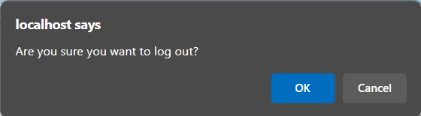

<?php

    session_start();

    session_unset();

    session_destroy();

    header("Location: index.php?message=logged_out");

    exit();

?>

**CSS:**

* **style.css**

body {

    font-family: "Arial", sans-serif;

    margin: 0;

    padding: 0;

    color: #333;

    background-color: #f0f8ff;

    line-height: 1.6;

}

.container {

    width: 90%;

    max-width: 1200px;

    margin: 0 auto;

}

.header {

    display: flex;

    justify-content: space-between;

    align-items: center;

    padding: 15px 30px;

    background: #87cefa;

    color: white;

    position: sticky;

    top: 0;

    z-index: 1000;

}

.header .logo {

    font-size: 24px;

    font-weight: bold;

    text-transform: uppercase;

}

.header nav ul {

    list-style: none;

    display: flex;

    gap: 20px;

    margin: 0;

    padding: 0;

}

.header nav ul li a {

    text-decoration: none;

    color: white;

    font-size: 16px;

    transition: color 0.3s;

}

.header nav ul li a:hover {

    color: #4682b4;

}

.header .btn {

    background: #4682b4;

    color: white;

    padding: 10px 20px;

    text-decoration: none;

    font-weight: bold;

    border-radius: 5px;

    transition: background 0.3s, color 0.3s;

}

.header .btn:hover {

    background: white;

    color: #4682b4;

}

.hero-section {

    position: relative;

    text-align: center;

}

.hero-image {

    width: 100%;

    height:auto;

    margin: 0 auto;

    display: block;

}

.hero-overlay {

    position: absolute;

    top: 50%;

    left: 50%;

    transform: translate(-50%, -50%);

    color: white;

    font-size: 35px;

    font-weight: bold;

    text-shadow: 2px 2px 4px rgba(0, 0, 0, 0.7);

    z-index: 1;

}

.log {

    font-family: 'Arial', 'Helvetica', sans-serif;

    font-size: 1.5em;

    color: #4682b4;

    font-weight: bold;

    margin-top: 3px;

    text-align: center;

    margin-bottom: 4%;

}

.logins-section {

    padding: 60px 30px;

    background: linear-gradient(135deg, #d8e9f5, #f0f8ff);

    text-align: center;

}

.logins-section h2 {

    font-size: 2.8em;

    color: #4682b4;

    margin-bottom: 25px;

    font-family: 'Arial', sans-serif;

    text-transform: uppercase;

}

.login-cards {

    display: flex;

    justify-content: center;

    gap: 30px;

    flex-wrap: wrap;

    align-items: stretch;

}

.login-card {

    background: #ffffff;

    box-shadow: 0 4px 10px rgba(0, 0, 0, 0.15);

    padding: 20px;

    border-radius: 15px;

    width: 240px;

    text-align: center;

    transition: all 0.4s ease;

    font-size: 1em;

    font-weight: 600;

    color: #333;

    cursor: pointer;

    border: 2px solid transparent;

}

.login-card img {

    width: 230px;

    height: 150px;

    margin-bottom: 10px;

    border-radius: 10px;

    transition: transform 0.3s, box-shadow 0.3s;

    object-fit: cover;

}

.login-card:hover img {

    transform: scale(1.1);

    box-shadow: 0 8px 15px rgba(30, 144, 255, 0.4);

}

.login-card:hover {

    transform: translateY(-6px);

    background:#87cefa;

    color: #fff;

    border: 2px solid #87cefa;

    box-shadow: 0 8px 15px rgba(30, 144, 255, 0.4);

}

.logBtn {

    background-color: #1e90ff;

    color: #ffffff;

    border: none;

    padding: 9px 5px;

    font-size: 14px;

    font-weight: bold;

    border-radius: 4px;

    cursor: pointer;

    transition: all 0.3s ease;

    box-shadow: 0 4px 6px rgba(0, 0, 0, 0.1);

    margin-top: -5%;

}

.logBtn:hover {

    background-color: #4682b4;

    box-shadow: 0 6px 10px rgba(0, 0, 0, 0.15);

    transform: translateY(-2px);

}

.logBtn:active {

    background-color: #1c75d8;

    box-shadow: 0 2px 4px rgba(0, 0, 0, 0.2);

    transform: translateY(0);

}

.features-section {

    padding: 40px 20px;

    background: white;

    text-align: center;

}

.features-section h2 {

    font-size: 2.5em;

    color: #4682b4;

    margin-bottom: 20px;

}

.features-section i {

    font-size: 2.1em;

    margin-bottom: 18px;

}

.features-section p {

    font-size: 20px;

    margin-bottom: 2px;

}

.feature-list {

    display: flex;

    justify-content: center;

    flex-wrap: wrap;

    gap: 30px;

    max-width: 900px;

    margin: 0 auto;

}

.feature-item {

    background: #e6f7ff;

    box-shadow: 0 2px 5px rgba(0, 0, 0, 0.1);

    padding: 20px 20px;

    border-radius: 10px;

    font-size: 18px;

    font-weight: bold;

    color: #333;

    text-align: center;

    width: calc(33.333% - 20px);

    flex: 1 1 calc(33.333% - 20px);

    max-width: 180px;

    transition: transform 0.3s, background 0.3s, color 0.3s;

}

@media (max-width: 768px) {

    .feature-item {

        width: calc(50% - 15px);

        flex: 1 1 calc(50% - 15px);

    }

}

@media (max-width: 480px) {

    .feature-item {

        width: 100%;

        flex: 1 1 100%;

    }

}

.about-section {

    padding: 50px 20px;

    background: #f0f8ff;

    text-align: center;

}

.about-section h2 {

    font-size: 2.5em;

    color: #4682b4;

    margin-bottom: 20px;

}

.about-section p {

    font-size: 16px;

    line-height: 1.8;

    color: #555;

    max-width: 800px;

    margin: auto;

}

.gallery-section {

    padding: 50px 20px;

    background: white;

    text-align: center;

}

.gallery-section h2 {

    font-size: 2.5em;

    color: #4682b4;

    margin-bottom: 20px;

}

.gallery-grid {

    display: grid;

    grid-template-columns: repeat(auto-fit, minmax(150px, 1fr));

    gap: 20px;

    max-width: 900px;

    margin: auto;

}

.gallery-image {

    width: 100%;

    border-radius: 10px;

    box-shadow: 0 2px 5px rgba(0, 0, 0, 0.1);

    transition: transform 0.3s, box-shadow 0.3s;

}

.gallery-image:hover {

    transform: scale(1.05);

    box-shadow: 0 4px 10px rgba(0, 0, 0, 0.2);

}

.contact-section {

    padding: 50px 20px;

    text-align: center;

}

.contact-section h2 {

    font-size: 2.5em;

    color: #4682b4;

    margin-bottom: 20px;

}

.contact-form {

    display: flex;

    flex-direction: column;

    gap: 15px;

    max-width: 400px;

    margin: auto;

}

.contact-form input, .contact-form textarea {

    width: 100%;

    padding: 10px;

    border: 1px solid #ccc;

    border-radius: 5px;

    font-size: 16px;

}

.contact-form button {

    background: #4682b4;

    color: white;

    padding: 10px 15px;

    border: none;

    border-radius: 5px;

    font-size: 18px;

    font-weight: bold;

    cursor: pointer;

    transition: background 0.3s, transform 0.3s;

}

.contact-form button:hover {

    background: #0056b3;

    transform: scale(1.05);

}

.feature-item img {

    width: 80px;

    height: 80px;

    margin-bottom: 10px;

}

.gallery-image {

    width: 100%;

    height: auto;

    border-radius: 8px;

    margin: 5px;

}

.about-image {

    width: 100%;

    height: auto;

    margin-top: 20px;

    border-radius: 8px;

}

.log{

    color: black;

}

.footer {

    background: #e3f2fd;

    color: #333;

    padding: 20px;

    display: flex;

    flex-wrap: wrap;

    justify-content: flex-start;

    gap: 20px;

}

.footer-box {

    flex: 1 1 250px;

}

.footer-box h2, .footer-box h3 {

    color: #1e88e5;

    margin-bottom: 10px;

}

.footer-box p, .footer-box span, .footer-box li {

    font-size: 14px;

    color: #555;

    margin-bottom: 8px;

}

.footer-box a {

    color: #1e88e5;

    text-decoration: none;

    transition: 0.3s;

}

.footer-box a:hover {

    color: #1565c0;

}

.social a {

    color: #2196f3;

    margin-right: 10px;

    font-size: 18px;

}

.copyright {

    text-align: center;

    font-size: 13px;

    margin-top: 15px;

    color: #666;

    width: 100%;

    border-top: 1px solid #555;

}

.hospital-gallery-container {

    max-width: 1200px;

    margin: 0 auto;

    padding: 20px;

    text-align: center;

}

.gallery-title {

    color: #2c3e50;

    margin-bottom: 20px;

}

.hospital-gallery {

    display: grid;

    grid-template-columns: repeat(auto-fill, minmax(300px, 1fr));

    gap: 20px;

}

.gallery-item-doctor,

.gallery-item-patient,

.gallery-item-medical-image {

    background-color: #fff;

    border-radius: 8px;

    box-shadow: 0 4px 8px rgba(0, 0, 0, 0.1);

    overflow: hidden;

    transition: transform 0.3s ease-in-out;

}

.gallery-item-doctor img,

.gallery-item-patient img,

.gallery-item-medical-image img {

    width: 100%;

    height: auto;

    display: block;

    object-fit: cover;

}

.gallery-item-doctor p,

.gallery-item-patient p,

.gallery-item-medical-image p {

    padding: 10px;

    background-color: #ecf0f1;

    font-size: 16px;

    color: #2c3e50;

}

.gallery-item-doctor:hover,

.gallery-item-patient:hover,

.gallery-item-medical-image:hover {

    transform: scale(1.05);

}

.about-section {

    padding: 10px;

    background-color: #f9f9f9;

}

.about-container {

    display: flex;

    align-items: center;

    gap: 10px;

}

.about-image {

    width: 40%;

    max-width: 400px;

    border-radius: 3px;

}

.about-content {

    flex: 1;

}

.about-title {

    font-size: 1.8rem;

    color: #333;

}

.about-description {

    font-size: 1rem;

    color: #555;

}

.gallery-section {

    padding: 2rem;

    background-color: #f9f9f9;

    text-align: center;

}

.gallery-section h2 {

    font-size: 2rem;

    color: #333;

    margin-bottom: 1.5rem;

}

.gallery-grid {

    display: grid;

    grid-template-columns: repeat(auto-fit, minmax(300px, 1fr));

    gap: 2.5rem;

    justify-items: center;

}

.gallery-grid img {

    width: 100%;

    max-width: 400px;

    height: auto;

    box-shadow: 0 4px 8px rgba(0, 0, 0, 0.1);

    transition: transform 0.3s ease, box-shadow 0.3s ease;

}

.gallery-grid img:hover {

    transform: scale(1.05);

    box-shadow: 0 8px 16px rgba(0, 0, 0, 0.2);

}

* **rl-style.php**

.container {

    display: flex;

    justify-content: center;

    align-items: center;

    min-height: 100vh;

    flex-direction: column;

}

.form-container {

    background: #fff;

    border: 1px solid #ddd;

    border-radius: 8px;

    padding: 30px 40px;

    box-shadow: 0 4px 8px rgba(0, 0, 0, 0.1);

    width: 100%;

    max-width: 400px;

    text-align: center;

}

.form-container h2 {

    margin-bottom: 20px;

    color: #007bff;

    font-size: 1.5rem;

}

form {

    width: 100%;

    text-align: left;

}

fieldset {

    border: none;

    margin: 0;

    padding: 0;

}

.form-container legend {

    font-size: 1.2em;

    color: #007bff;

    margin-bottom: 10px;

    display: inline-block;

}

.form-container label {

    display: block;

    font-size: 0.9em;

    color: #333;

    margin-bottom: 5px;

}

.input-field {

    width: 100%;

    margin-bottom: 15px;

    padding: 10px 10px 10px 15px;

    font-size: 14px;

    border: 1px solid #ccc;

    border-radius: 5px;

    box-sizing: border-box;

    outline: none;

}

.radio-group {

    margin-bottom: 15px;

    display: flex;

}

.radio-group input {

    margin-right: 6px;

}

.radio-group label {

    margin-right: 15px;

    margin-top: 8px;

}

.checkbox-group {

    margin-bottom: 20px;

    display: flex;

}

.checkbox-group input {

    margin-right: 5px;

    margin-top: -3px;

}

.submit-btn {

    background: #007bff;

    color: #fff;

    padding: 10px 20px;

    border: none;

    border-radius: 4px;

    cursor: pointer;

    font-size: 1em;

    width: 100%;

    transition: background 0.3s;

}

.submit-btn:hover {

    background: #0056b3;

}

p{

    text-align: right;

}

.login-container {

    display: flex;

    flex-direction: column;

    align-items: center;

    justify-content: center;

    min-height: 100vh;

    padding: 20px;

}

.login-box {

    background-color: #fff;

    border-radius: 10px;

    box-shadow: 0px 4px 8px rgba(0, 0, 0, 0.1);

    padding: 30px;

    width: 100%;

    max-width: 400px;

    text-align: center;

}

h1 {

    font-size: 24px;

    margin-bottom: 20px;

    color: #333;

}

.p2 {

    font-size: 18px;

    margin-bottom: 10px;

    color: #007bff;

    border-bottom: 1px solid #007bff;

    display: inline-block;

    padding-bottom: 5px;

}

.p1 {

    margin: 10px 0;

    font-size: 14px;

    color: #555;

    text-align: left;

}

.input-group {

    position: relative;

    margin-bottom: 20px;

}

.input-group label {

    position: absolute;

    top: 50%;

    left: 10px;

    transform: translateY(-50%);

    color: #999;

    font-size: 16px;

}

.input-group input {

    width: 100%;

    padding: 10px 10px 10px 40px;

    font-size: 14px;

    border: 1px solid #ccc;

    border-radius: 5px;

    box-sizing: border-box;

    outline: none;

    transition: all 0.3s;

}

.input-group input:focus {

    border-color: #007bff;

    box-shadow: 0 0 5px rgba(0, 123, 255, 0.5);

}

.forgot-password {

    display: block;

    text-align: right;

    font-size: 12px;

    color: #007bff;

    text-decoration: none;

    margin-bottom: 20px;

}

.forgot-password:hover {

    text-decoration: underline;

}

.login-btn {

    width: 100%;

    padding: 10px;

    font-size: 16px;

    font-weight: bold;

    color: #fff;

    background-color: #007bff;

    border: none;

    border-radius: 5px;

    cursor: pointer;

    transition: background-color 0.3s;

}

.login-btn:hover {

    background-color: #0056b3;

}

.register-link {

    font-size: 14px;

    color: #555;

}

.register-link a {

    color: #007bff;

    text-decoration: none;

}

.register-link a:hover {

    text-decoration: underline;

}

* **account_style.css**

  .container {

    max-width: 550px;

    margin: 50px auto;

    padding: 20px;

    background: #ffffff;

    border-radius: 15px;

    box-shadow: 0px 10px 20px rgba(0, 0, 0, 0.1);

    justify-items: center;

}

header {

    text-align: center;

    background-color: #007bff;

    color: white;

    padding: 20px;

    border-radius: 15px 15px 0 0;

}

header h2 {

    margin: 0;

    font-size: 2rem;

}

nav {

    margin-top: 10px;

}

nav a {

    color: #ffffff;

    text-decoration: none;

    font-size: 1rem;

    margin: 0 15px;

}

nav a:hover {

    text-decoration: underline;

}

.sec {

    padding: 20px 0;

}

.sec h2 {

    font-size: 1.8rem;

    color: #333;

    margin-bottom: 10px;

}

.sec p {

    color: #555;

    margin: 8px 0;

}

.btn1 {

    display: inline-block;

    background: #0056b3;

    color: white;

    padding: 10px 15px;

    border: none;

    border-radius: 5px;

    font-size: 1rem;

    margin-right: 10px;

    cursor: pointer;

    text-transform: uppercase;

}

.btn1:hover {

    background: #004494;

}

.form-section {

    width: 400px;

    display: none;

    padding: 20px;

    background: #f9f9f9;

    border: 1px solid #ddd;

    border-radius: 8px;

    margin-top: 10px;

}

.form-section label {

    display: block;

    font-size: 1rem;

    color: #333;

    margin: 6px 0 5px;

}

.ipt1,

.email-pass,

.ipt {

    width: 100%;

    padding: 12px;

    font-size: 1rem;

    border: 1px solid #ccc;

    border-radius: 5px;

    margin-bottom: 15px;

    box-sizing: border-box;

    outline: none;

}

.ipt1:focus,

.email-pass:focus,

.ipt:focus {

    border-color: #007bff;

    box-shadow: 0px 0px 5px rgba(0, 123, 255, 0.5);

}

.btn {

    background: #007bff;

    color: white;

    padding: 12px;

    border: none;

    border-radius: 5px;

    font-size: 1rem;

    cursor: pointer;

    width: 100%;

    text-transform: uppercase;

}

.btn:hover {

    background: #0056b3;

}

h3 {

    color: #0056b3;

}

**4.2 Testing Approach**

**4.2.1 Types of Testing**

To ensure the **Hospital Management System (HMS)** works properly, we used the following testing types:

**Unit Testing:** Tests individual functions or components to ensure they work correctly.

**Module Testing:** Checks if a group of related units function properly as a module.

**Sub-System Testing:** Combines multiple modules to test their interaction before full system testing.

**System Testing:** Tests the entire system to ensure all components work together as per requirements.

**4.2.2 Use Case**

A **use case** defines how users interact with the system. It helps to:

Identify and organize system requirements.

Show different possible interactions between users and the system.

Detect potential errors in system behavior.

**4.2.3 Test Case**

A **test case** is a set of conditions to verify if the system works correctly. It helps in:

Ensuring the software meets requirements.

Identifying problems in design or functionality.

Improving software quality before deployment.

**CHAPTER 5**

**Results and Discussion**

**5.1 Future Scope**

Hospitals and healthcare centers have improved significantly with the use of technology. Many healthcare administrators are now using **hospital management software** to better manage operations and provide improved patient care.

**Key Features of Hospital Management Software**

**User-Friendly Interface:** The software is designed with a **simple and easy-to-use interface**, making it convenient for hospital staff to access and operate different modules efficiently.

**Multiple Functional Modules:** The software consists of **several modules** that can be used for different hospital functions, allowing staff to manage processes without difficulty.

**Customizable Solutions:** Every hospital has unique needs, so IT companies offer **customized hospital management software** to meet specific requirements. This flexibility ensures that hospitals can **tailor the system** to fit their needs perfectly.

**CHAPTER 6**

**Conclusion**

The **Hospital Management System (HMS)** is an essential tool that helps hospitals and healthcare centers manage their daily operations efficiently. It simplifies tasks like **patient registration, record-keeping, appointment scheduling** ensuring smooth hospital workflow.

With HMS, **patient records are stored digitally**, making it easy to access medical histories and treatment details. The system improves **hospital efficiency, reduces paperwork, and minimizes errors**, leading to **better patient care**. Its **user-friendly interface** allows staff to operate it easily, while strict security measures ensure that only **authorized personnel** can modify data.

Additionally, HMS can be **customized** to meet the specific needs of different hospitals, making it suitable for **multi-specialty hospitals and small clinics**. By automating various processes, the system helps hospitals **save time, improve accuracy, and enhance the overall patient experience**.